ISLG Subject Navigator

- Search Screen : 1

- User can enter keyword in search text box and apply dtsearch relevant parameter and click on search button to populate result.

- User click on reset button to clear search and data will reload again.

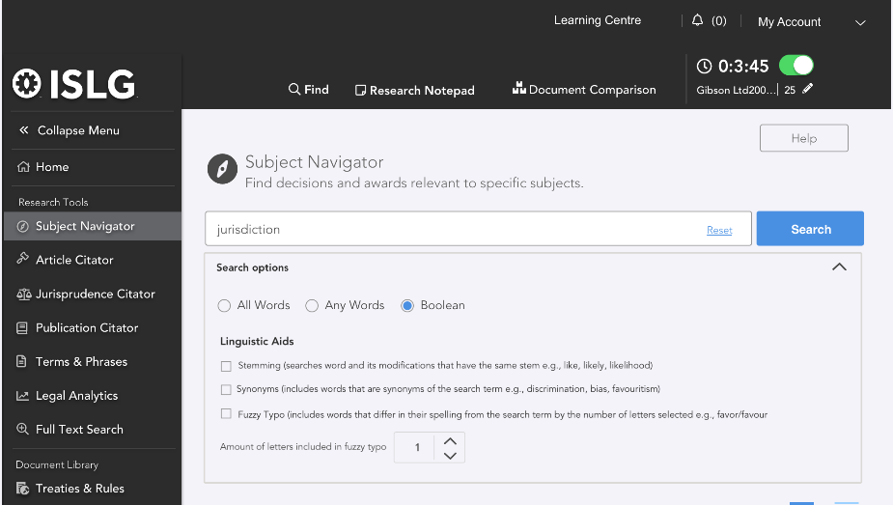

- Screen :- 2
The Search result will be populated in following manner with highlighted the word.
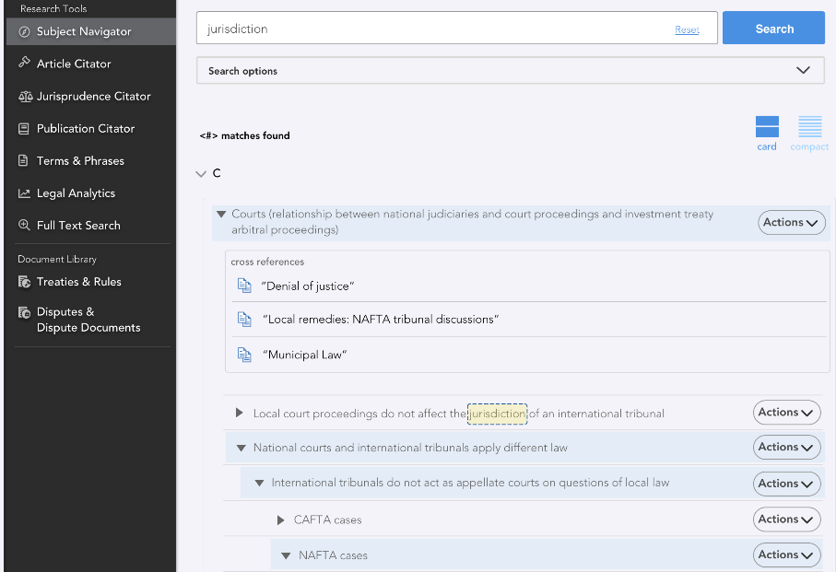

Database Structure:

- Master Tree Table : To populate branches of Subject text and cross reference text
- DocumentValue : To Populate reference Paragraph
- DocumentTypeMatsre : To display document reference branch name

