ISLG HTML CODING MANUAL

The following is a manual for converting PDF documents into HTML coded documents that be uploaded to the ISLG database.

Only select specific class n standards (rules) should be used for coding HTML files from PDF to maintain consistency so that further operations can be performed by programmer.

INSTRUCTIONS OVERVIEW

The complete and formatted file saved in an .html format should contain the HTML Document coding specific to the PDF, and saved with the .html extension,

A predefine standard of HTML is applied to each HTML file that is converted from PDF, which includes the following components:

- <DOCTYPE>
- <html>
- <head>
- <link>
- <body>
- <div>
- <span>
- <table>
- <p>

Above tags must be closed respectively.

COMMON STRUCTURE

Every element in the HTML should contain the attribute name “data-key” and its value will start from 0 and increment it by 1. This value should be unique for all the element. For example

<div data-key='29' class='tocdiv' id='_TOC'>
<div data-key='30' class='middletext paratag'>TABLE OF CONTENTS</div>
<div data-key='31' class='toc1lvl toc paratag tocdots maintitlefirst'>
<a data-key='32' href='#h_paI'>
<span data-key='33' class='tocbullet'>I. </span>
<span data-key='34' class='tocstring'>INTRODUCTION</span>
<span data-key='35' class='tocpageno'>3</span>
</a>
</div>
<div data-key='36' class='toc1lvl toc paratag tocdots maintitlefirst'>
<a data-key='37' href='#h_paII'>
<span data-key='38' class='tocbullet'>II. </span>
<span data-key='39' class='tocstring'>THE PARTIES</span>
<span data-key='40' class='tocpageno'>4</span>
</a>
</div>
<div data-key='41' class='toc1lvl toc paratag tocdots maintitlefirst'>
<a data-key='42' href='#h_paIII'>
<span data-key='43' class='tocbullet'>III. </span>
<span data-key='44' class='tocstring'>PROCEDURAL HISTORY</span>
<span data-key='45' class='tocpageno'>5</span></a></div></div>
- Every html tag which contains text for example div, span should have “paratag” class. <strong>, <a> will not contain such class.

<div data-key='95' class='para paralvl1' id='_pa1'>
<div data-key='96' class='paraBullet paratag'>1. </div><div data-key='97' class='ParaText paratag'>
Fireman’s Fund Insurance Company has brought a claim against the United
Mexican States, alleging that Mexico has breached its obligations under the North
American Free Trade Agreement (NAFTA), more specifically under Article 1102
(National Treatment), Article 1105 (Minimum Standard of Treatment), Article
1110 (Expropriation and Compensation) and Article 1405 (National Treatment) of
<div data-key='98' style='padding-top:11.0400138109922px;padding-bottom:14.9599603675306px;' class='linespace paratag'>
the NAFTA, with the result that Claimant has suffered damages.
</div>
</div>

Below is the general format required for each HTML file.

- Main ‘div;’ tag inside body tag must have class='html-container Art' as it maintains the whole PDF structure in HTML.

- Every main Container having class='html-container Art' must have Id 'IC030202_Title' where 'IC030202' is the UIN number assigned to the PDF File (e.g., IC-0302-02 - Marfin v. Cyprus - Award - C- TD).

<!DOCTYPE HTML PUBLIC '-//W3C//DTD HTML 4.0 Transitional//EN'>
<html>
<head>
<meta charset="utf-8">
<meta name="viewport" content="width=device-width,initial- scale=1.0">
</head>
<body>
<div class='html-container Art' id='IC030202_Title'>

</div>
</body>
</html>

- Use <em> tag instead of <i> for the italic text format.
- Use <strong> tag instead of <b> for the bold text.
HTML CLASSES

The following are the HTML styles/classes to be converted from PDF parts.

1. Middle alignment 3
2. Title Page (H1 Rules) 5
3. Table of contents: 8
4. Partition wise structure 11
5. Paragraph Heading based on TOC rules: 13
6. Paragraph without bullets: 17
7. Footnote: 18
8. Right-alignment: 23
9. Two-column structure: 23
10. Table structure: 25
11. Provision structure: 27
12. Heading in body text: 29
13. Email and hyperlink 29
14. Image place holder 29

Middle alignment

“middletext” class is used to display text in HTML that has a middle alignment in the PDF.

In old version : <div class='middletext'><strong></strong></div>

<span data-key='8' class='middletext paratag'><strong data-key='6'>FOR THE ADMINISTRATION OF PROCEEDINGS </strong></span>

When you want to display spacing between two lines, you need to specify the style and spacing for the top and bottom padding.

Example of middle alignment HTML code

<span data-key='5' class='middletext paratag' style='padding-top:72.0000185975618px;'><strong data-key='2'>RULES GOVERNING THE ADDITIONAL FACILITY </strong></span>

Note :
Here in the middle text we need to remove “display:block” from the style attribute. As you can see that we have included that in a “middletext” class.

Sample PDF with middle alignment


HTML code of PDF sample with middle alignment

<!DOCTYPE HTML PUBLIC '-//W3C//DTD HTML 4.0 Transitional//EN'>
<html>
<head>
<link rel='stylesheet' type='text/css' href='style.css' />
</head>
<body>
<div class='html-container Art'>
<span class='middletext' style='padding-top:16.8713595512354px;padding- bottom:16.8713595512354px;'><strong>Caso CPA No. 2016-08</strong>
</span>
<span class='middletext'><strong>EN EL CASO DE UN ARBITRAJE DE CONFORMIDAD CON EL ACUERDOENTRE EL</strong> </span>
<span class='middletext'><strong>REINO DE ESPAÑA Y LA REPÚBLICA DE VENEZUELA PARA LA PROMOCIÓN Y LA</strong></span>
<span class='middletext'><strong>PROTECCIÓN RECÍPROCA DE INVERSIONES</strong></span>
<span class='middletext' style='padding-top:0px;padding-bottom:4.27472186893104px;'>-<strong>y-</strong> </span>

</div>
</body>
</html>

Title Page (H1 Rules)

First Page of the any PDF is a title page. In title page apply a <H1> tag to specific text based on the below condition.

The following is the logic to identify the appropriate text for the H1 elements in the title page.

- If page 1 of the document contains a style of cause connector word (more below) and no other text appears on the same line, then the text contained 3 lines above and 3 lines below should be included in the H1 tag. cause connector words are “and”, “et”, “y”, “versus”, “contra”, “contre”, “c”, “vs”, “v”

PDF:
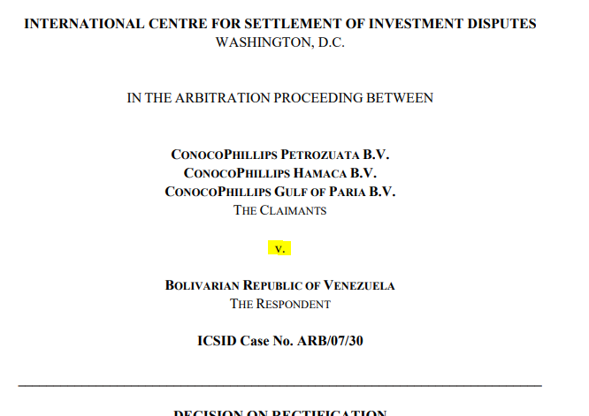

HTML:
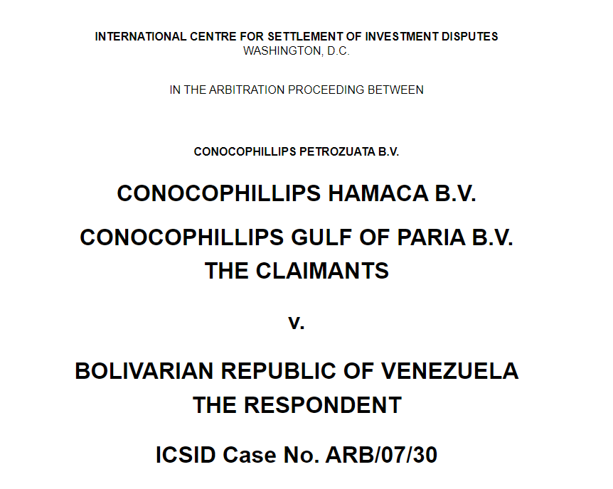

<h1>

<span class="middletext paratag" style="display:block;padding-top:6.3600268629566px;"><strong>CONOCOPHILLIPS HAMACA B.V.</strong></span>
<span style="display:block" class="middletext paratag"><strong>CONOCOPHILLIPS GULF OF PARIA B.V.</strong></span>

<span class="middletext paratag" style="display:block;padding-top:6.3600268629566px;padding-bottom:9.79998722299933px;">THE CLAIMANTS</span>

<span class="middletext paratag" style="display:block;padding-top:19.7999872229993px;padding-bottom:9.67999210581183px;">v.</span>

<span class="middletext paratag" style="display:block;padding-top:19.6799921058118px;padding-bottom:0px;"><strong>BOLIVARIAN REPUBLIC OF VENEZUELA</strong></span>

<span class="middletext paratag" style="display:block;padding-top:6.35999634537848px;padding-bottom:9.82000675424933px;">THE RESPONDENT</span>

<span class="middletext paratag" style="display:block;padding-top:19.8200067542493px;padding-bottom:9.67999210581183px;"><strong>ICSID Case No. ARB/07/30</strong></span>

</h1>

- If first page of the document does not contain the connector word as described above, then compare the terms in the file name with first page of the document. If there is a match for any of the terms in the file name, then include the 3 lines (with spaces and line breaks).

For example Pdf with name “Klockner v. Cameroon - Dissenting Opinion[French] -C.pdf
” and below is the screen shot of the first page. As the first line match with the terms of file name so first three line is considered as heading and wrapped into <h1>.



HTML:
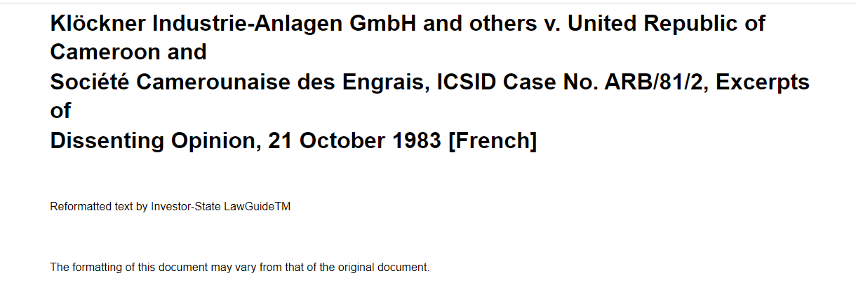

<h1>
<div style="position:relative;left:72.00px;padding-top:0px;padding-bottom:0px;" class="linespace paratag">
<strong>Klöckner Industrie-Anlagen GmbH and others v. United Republic of Cameroon and </strong>
</div>
<div style="position:relative;left:72.00px;padding-top:1.91997084764762px;padding-bottom:0px;" class="linespace paratag">
<strong>Société Camerounaise des Engrais, ICSID Case No. ARB/81/2, Excerpts of </strong>
</div>
<div style="position:relative;left:72.00px;padding-top:1.97999892381949px;padding-bottom:16.5199999362417px;" class="linespace paratag">
<strong>Dissenting Opinion, 21 October 1983 [French]</strong>
</div>
</h1>

- If first page of the document does not contain connector word or terms in the file name match with content of page 1 then any bold text should be wrapped in <h1>.

Table of contents:

'tocdiv' class is used to maintain table of contents (TOC) format throughout the HTML files, and IC030202_TOC' is used to uniquely identify TOC of the page.

Class toc1lvl is for first level of indentation. Similarly toc1lvl is for sub level indentation. So for sub indentation use toc1lvl, toc2lvl, toc3lvl... Infinite for sub level toc.

Class Name | explanation
<div class='tocdiv' id='IC030202_TOC'> | You must be apply tocdiv class in Table of contents.
class='toc1lvl toc tocdots' | This class used to maintain first level and dots
class='tocbullet' | This class is used for roman, alphabetical, etc ordering
class='tocstring | This class is used for text
class=’tocpageno’ | This class is for page number
class='tocpadding' | This class is used before every sublevel

Further:
class='toc1lvl toc tocdots' : Is used to maintain first level and dots,
class='tocbullet': is for roman, alphabetical, etc ordering.
class='tocstring ': is used for text,
class=’tocpageno’ : is for page number,
class='tocpadding': is used before every sublevel.
eg. Tocpadding is used between toc1lvl and toc2lvl.

In toc every anchor tag will have Id in this format : “h_UIN_heading number”. Only toc will contain “h” prefix in anchortag.
E.g. h_ARB0012_paI, h_ARB0012_paII

Example of table of content HTML code

<div data-key='141' class='tocdiv' id='_TOC'>
<DIV data-key='142' class='middletext paratag'>TABLE OF CONTENTS</div>
<div data-key='143' class='toc1lvl toc paratag tocdots maintitlefirst'>
<a data-key='144' href='#hUIN_paI'>
<span data-key='145' class='tocbullet'>I. </span>
<span data-key='146' class='tocstring'>Procedural Background</span>
<span data-key='147' class='tocpageno'>5</span>
</a>
</div>
<div data-key='148' class='toc1lvl toc paratag tocdots maintitlefirst'>
<a data-key='149' href='#h_paII'>
<span data-key='150' class='tocbullet'>II. </span>
<span data-key='151' class='tocstring'>The Parties</span>
<span data-key='152' class='tocpageno'>7</span>
</a>
</div>
<div data-key='153' class='toc1lvl toc paratag tocdots maintitlefirst'>
<a data-key='154' href='#h_paA'>
<span data-key='155' class='tocbullet'>A. </span>
<span data-key='156' class='tocstring'>The Claimants</span>
<span data-key='157' class='tocpageno'>7</span>
</a>
</div>
</div>

Sample PDF with table of contents
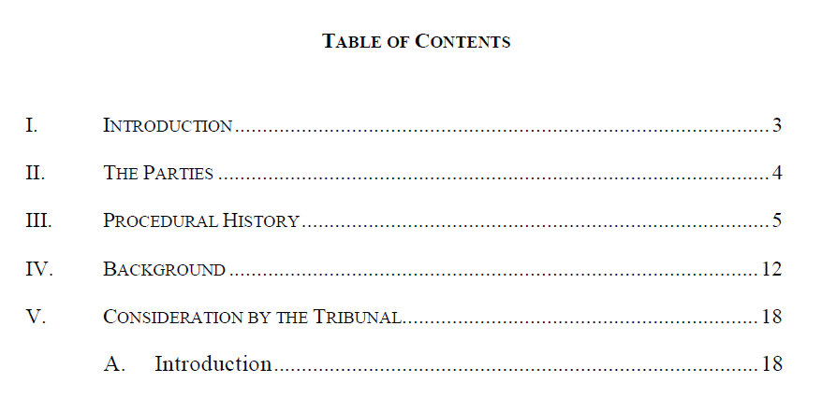

HTML code of same with table of contents

<div data-key='29' class='tocdiv' id='_TOC'>
<div data-key='30' class='middletext paratag'>TABLE OF CONTENTS</div>
<div data-key='31' class='toc1lvl toc paratag tocdots maintitlefirst'>
<a data-key='32' href='#h_IC01640_paI'>
<span data-key='33' class='tocbullet'>I. </span>
<span data-key='34' class='tocstring'>INTRODUCTION</span>
<span data-key='35' class='tocpageno'>3</span>
</a>
</div>
<div data-key='36' class='toc1lvl toc paratag tocdots maintitlefirst'>
<a data-key='37' href='#h_IC01640_paII'>
<span data-key='38' class='tocbullet'>II. </span>
<span data-key='39' class='tocstring'>THE PARTIES</span>
<span data-key='40' class='tocpageno'>4</span>
</a>
</div>
<div data-key='41' class='toc1lvl toc paratag tocdots maintitlefirst'>
<a data-key='42' href='#h_IC01640_paIII'>
<span data-key='43' class='tocbullet'>III. </span>
<span data-key='44' class='tocstring'>PROCEDURAL HISTORY</span>
<span data-key='45' class='tocpageno'>5</span>
</a>
</div>
<div data-key='46' class='toc1lvl toc paratag tocdots maintitlefirst'>
<a data-key='47' href='#h_IC01640_paIV'>
<span data-key='48' class='tocbullet'>IV. </span>
<span data-key='49' class='tocstring'>BACKGROUND</span>
<span data-key='50' class='tocpageno'>12</span>
</a>
</div>
<div data-key='51' class='toc1lvl toc paratag tocdots maintitlefirst'>
<a data-key='52' href='#h_IC01640_paV'>
<span data-key='53' class='tocbullet'>V. </span>
<span data-key='54' class='tocstring'>CONSIDERATION BY THE TRIBUNAL</span>
<span data-key='55' class='tocpageno'>18</span>
</a>
<div data-key='56' class='tocpadding'>
<div data-key='57' class='toc2lvl toc paratag tocdots maintitle'>
<a data-key='58' href='#h_IC01640_paV.A'>
<span data-key='59' class='tocbullet'>A. </span>
<span data-key='60' class='tocstring'>Introduction</span>
<span data-key='61' class='tocpageno'>18</span>
</a>
</div>
</div>
</div>
</div>

Every anchor tag in TOC will have “href” and its value will be the same as id of header in the paragraph header.

Foe example
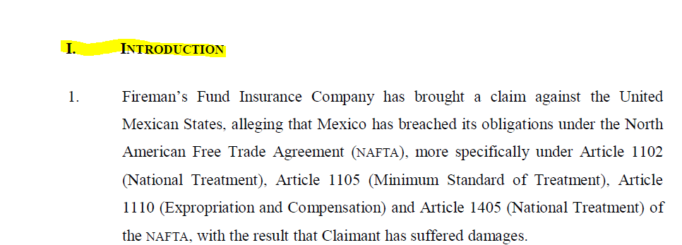
<a data-key='32' href='#h_IC01640_paI'>
<span data-key='33' class='tocbullet'>I. </span>
<span data-key='34' class='tocstring'>INTRODUCTION</span>
<span data-key='35' class='tocpageno'>3</span>
</a>

<div data-key='92' class='para paralvl1 ' id='hIC01640_paI'>
<div data-key='93' class='paraBullet paratag'>
<h2 data-key='90' class='heading'> <strong data-key='89'>I.</strong></h2>
</div>
<div data-key='94' class='ParaText paratag'>
<h2 data-key='91' class='heading'><span data-key='88'>
<strong data-key='87'>INTRODUCTION</strong></span></h2>
</div>
</div>

Partition wise structure

For any partition in the PDF (e.g., Part, Chapter, Section, etc.) a unique id is assigned to the relevant partition: id='UIN_PARTITION#’.

Id | Explanation
id='IC030202_PART II-CHAPTER E' | Denotes a unique id of the Part and Chapter
id='IC030202_ARTICLE II' | Denotes a unique id of the Article
id='IC030202_SECTION II' | Denotes a unique id of the Section

Sample of PDF with partition
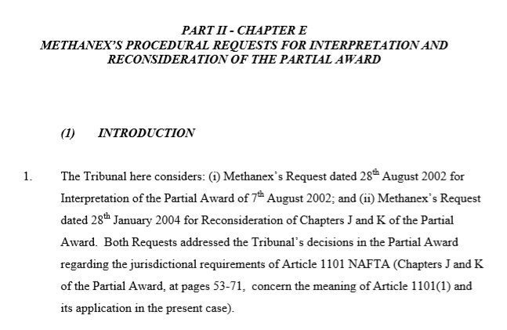
HTML code for sample PDF with partition

<div class='para part' id='IC030202_PARTII.CHAPTERE'>
</div>

- Paragraph text:

Below standard is used for paragraphs in the PDF document.

General format is required for all paragraphs. Class Para is general and paralvl1 is for first element of indentation. Similarly, paralvl2 is for sub level indentation. So, for sub indentation use paralvl1, paralvl2, paralvl3... for sub level paragraphs.

The automated conversion algorithm not used <p> element for paragraph, we have maintained paragraph using <div> element with proper CSS.

Classs Name | Explanation
class='paraBullet' | This class Is used to maintain bullets.
class='ParaText | This class is used for para-text
class='Parapadding’ | This class is used before every sublevel
class='paralvl1’ | This class is for first element of indentation.
class='paralvl2’ | For sub level indentation.

Examples of HTML code for paragraph text

<div class='para paralvl1'>
</div>

Further, class='paraBullet': is used to maintain bullets,
class='ParaText': is used for para-text,
class='Parapadding': is used before every sublevel.
e.g. Parapadding is used between paralvl1 and paralvl2.

Example 1: subparagraphs

As per HTML code below, there is a bullet point “1.” (i.e., main bullet point) with an id determined by UIN_pa1. So, if there is a child “1.1” (i.e Main bullet point of child) then id is set as UIN_pa1.1, UIN_pa.1.2, UIN_pa1.3 as so forth for 1.2, 1.3, 1.3.1, 1.3.2, 1.3.3.

Paragraph Heading based on TOC rules:

As per Table of Content (TOC), there is Paragraph heading “B. HAS BAYINDIR MADE AN INVESTMENT?”
In this scenario, we then must wrap this heading in header tags (i.e., <h2>, <h3>, <h4>) based on the indentation and hierarchy of the heading in the TOC.

For Example:
“B. HAS BAYINDIR MADE AN INVESTMENT?” is in TOC and that is First Level Indentation so that’s why it is wrapped in <h2> tag as mentioned in code below. Now there is Second heading “(b) (Mem. J., p. 1 at (iv)” that is second level Indentation so that’s why it will be wrapped in <h3> tag as mentioned HTML code below. If suppose there is third level Indentation with paragraph heading, then it will wrap in <h4> tag and so on.

HTML Preview

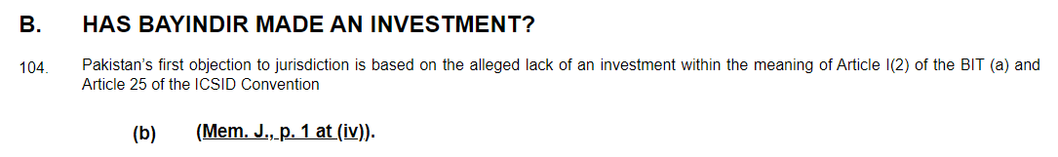

HTML Text

<div class="para paralvl1" id="_paB">
<div class="paraBullet paratag"><h2 class="heading"><strong>B. </strong></h2></div><div class="ParaText paratag">
<h2 class="heading">
<span><strong>HAS BAYINDIR MADE AN INVESTMENT? </strong></span>
</h2>
</div>
</div>
<div class="para paralvl1" id="_pa104">
<div class="paraBullet paratag">104. </div><div class="ParaText paratag">
Pakistan’s first objection to jurisdiction is based on the alleged lack of an investment
within the meaning of Article I(2) of the BIT (a) and Article 25 of the ICSID Convention
<div class="Parapadding">
<div class="para paralvl2" id="_paI.(b)">
<div class="paraBullet paratag"><h3>(b) </h3></div><div class="ParaText paratag">
<h3 class="heading">
<u>(Mem. J., p. 1 at (iv)</u>).
</h3>
</div>
</div>
</div>
</div>
</div>

Example 2: partitioned paragraphs

As per HTML code below, a partition may cause the paragraph numbering to restart, which may require assigning a unique id to the paragraph that includes the partition. We find bullet point “35.”, and partition, and then bullet point “1.”. As a result, the unique id will include UIN_PART_pa1(i.e. 'IC030202_PART II-CHAPTER D_pa35'), and each child of parent unique id will be UIN_PART_pa1.1(i.e. 'IC030202_PART II-CHAPTER D_pa1.1') and sub level of each child like UIN_PART_pa1.1.1(i.e. 'IC030202_PART II-CHAPTER D_pa1.1.1'), UIN_PART_pa1.1.2(i.e. 'IC030202_PART II-CHAPTER D_pa1.1.2').after new partition the unique id will be changed(i.e. 'IC030202_PART II-CHAPTER E_pa1') and so on.

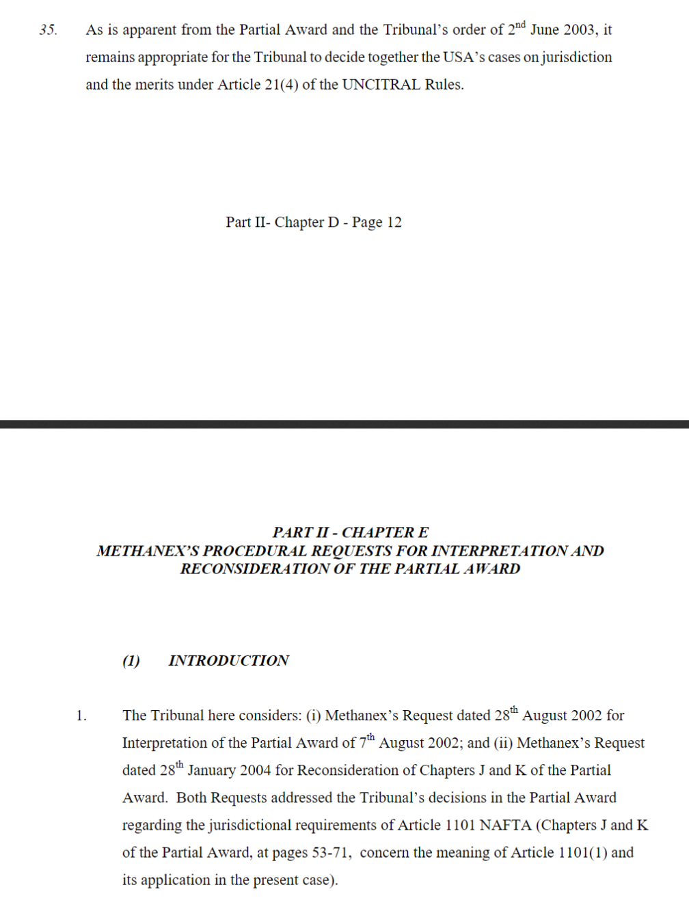

<div class='para paralvl1'>
<div class='para paralvl2' id='IC030202_PART II-CHAPTER D_pa35'>
<div class='ParaText'>
As is apparent from the Partial Award and the Tribunal’s order of 2nd June 2003, it remains appropriate for the Tribunal to decide together the USA’s cases on jurisdiction and the merits under Article 21(4) of the UNCITRAL Rules.
</div>
</div>
</div>
</div>
</div>
</div><div class='para paralvl1'>
<div class='para part' id='IC030202_PART II-CHAPTER E'>
<div class='middletext'><strong>PART II – CHAPTER E</strong></div>
<div class='middletext'><strong>METHANEX’S PROCEDURAL REQUESTS FOR INTERPRETATION AND RECONSIDERATION OF THE PARTIAL AWARD</strong>
<div class='Parapadding'>
<div class='para paralvl2' id='IC030202_ PART II-CHAPTER E'_pa1'>
<div class='paraBullet'>1. </div>
<div class='ParaText'>
The Tribunal here considers: (i) Methanex’s Request dated 28th August 2002 for Interpretation of the Partial Award of 7th August 2002; and (ii) Methanex’s Request dated 28th January 2004 for Reconsideration of Chapters J and K of the Partial Award. Both Requests addressed the Tribunal’s decisions in the Partial Award regarding the jurisdictional requirements of Article 1101 NAFTA (Chapters J and K of the Partial Award, at pages 53-71, concern the meaning of Article 1101(1) and
its application in the present case).
</div>
</div>
</div>
</div>
</div>
</div>

Example 3: paragraph text with bullets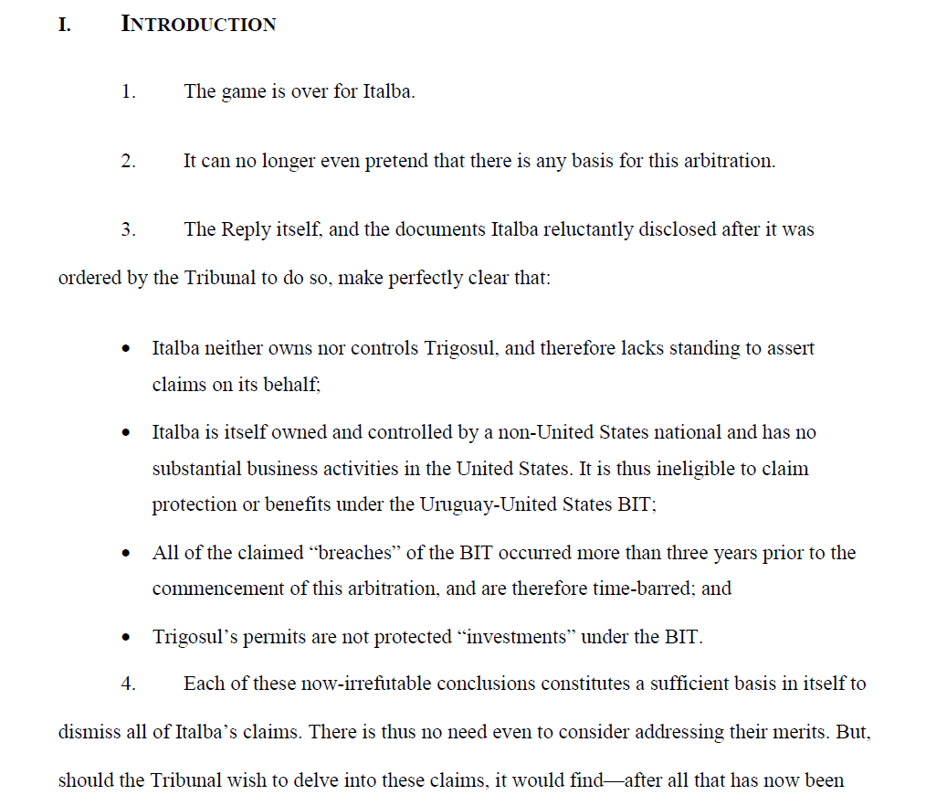

<div class='para paralvl1'>

<div class='paraBullet'><h2 class='heading'><strong>I. </strong></h2> </div><div class='ParaText'>
<h2 class='heading'><span><strong>INTRODUCTION</strong></span></h2> <div class='Parapadding'>

<div class='para paralvl2' id='IC030202_pa1'>
<div class='paraBullet'>1. </div><div class='ParaText'>
The game is over for Italba.
</div>
</div>
<div class='para paralvl2' id='IC030202_pa2'>
<div class='paraBullet'>2. </div><div class='ParaText'>
It can no longer even pretend that there is any basis for this arbitration.
</div>
</div>
<div class='para paralvl2' id='IC030202_pa3'>
<div class='paraBullet'>3. </div><div class='ParaText'>
The Reply itself, and the documents Italba reluctantly disclosed after it was ordered by the Tribunal to do so, make perfectly clear that:
</div>
</div>
<div class='para paralvl2' id='IC030202_pa3.a'>
<div class='paraBullet'>• </div>
<div class='ParaText'>
Italba neither owns nor controls Trigosul, and therefore lacks standing to assert claims on its behalf;
</div>
</div>
<div class='para paralvl2'>
<div class='paraBullet'>• </div><div class='ParaText'>
Italba is itself owned and controlled by a non-United States national and has no substantial business activities in the United States. It is thus ineligible to claim protection or benefits under the Uruguay-United States BIT;
</div>
</div>
<div class='para paralvl2' id='IC030202_pa7'>
<div class='paraBullet'>7. </div><div class='ParaText'>
Italba’s Reply leaves no room for doubt: this Tribunal has no jurisdiction. Claimant has failed to override any of the four jurisdictional objections Uruguay has asserted,
each of which is sufficient to require the dismissal of all claims.
<div class='Parapadding'>
<div class='para paralvl3' id='IC030202_pa7.1'>
<div class='paraBullet'>1. </div>
<div class='ParaText'>
<strong>Italba’s Claimed Ownership of Trigosul</strong>
</div>
</div>
</div>
</div>
</div>
</div>
</div>
</div>

When TOC not there in PDF and heading are there in the body text then we need to apply the same pattern which we apply above but we need to apply “mainTitleFirst” and “mainTitle” class according to level.

Paragraph without bullets:

class='paraPaddingText lineheight' is used when paragraphs are not having bullets.

Below is the example of paragraph without bullets.

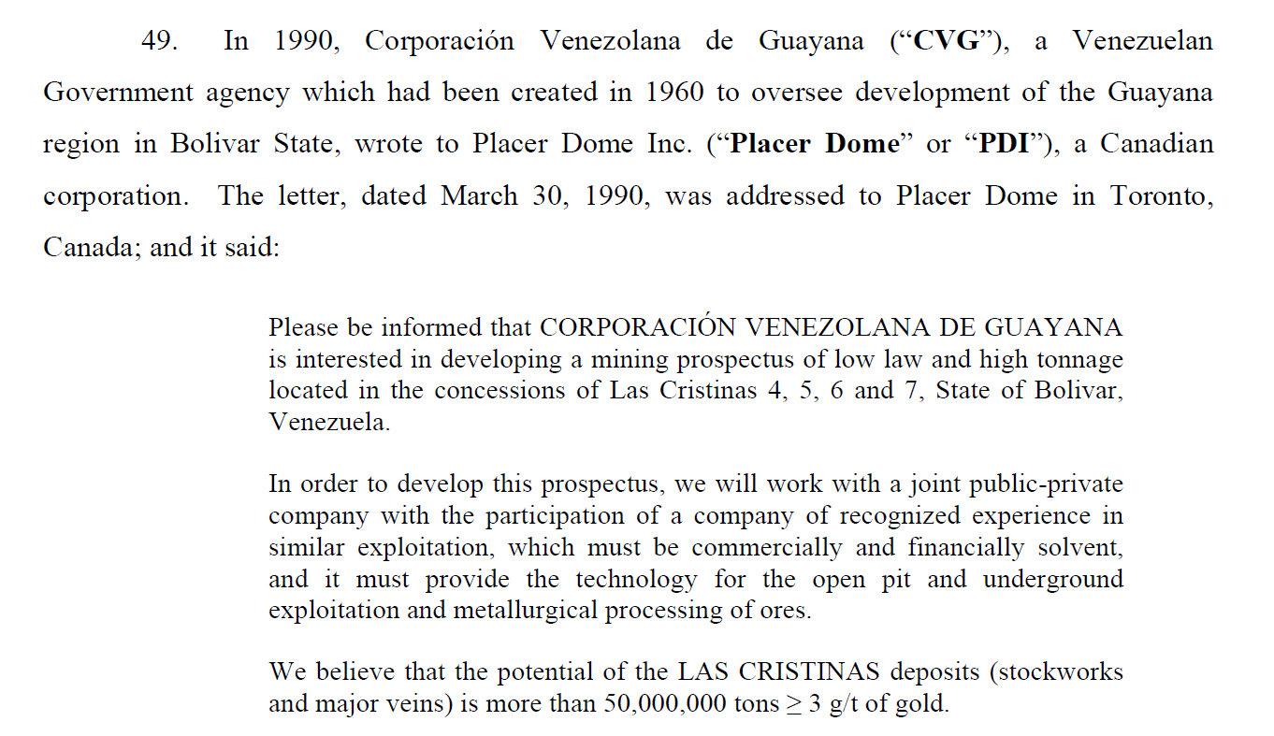

<div class='paraPadding'>
<div class='paraPaddingText lineheight'>
Please be informed that CORPORACIÓN VENEZOLANA DE GUAYANA
is interested in developing a mining prospectus of low law and high tonnage
located in the concessions of Las Cristinas 4, 5, 6 and 7, State of Bolivar,Venezuela.
</div>
</div>

Footnote:

Footnote is created with the use of <div> element, there are also use <span> and <sup> tags in order to get the appropriate number. Footnote unique ID will be UIN_fn#, this ID will also be use in the body text to connect the footnote to body text of the document.

HTML | Explanation
class='pdffootnote' | class is used for any footnote in HTML
<sup> | Tag for footnote numbers.
class='footnoteheight' | This class is used to maintain number height.

Example of footnote

Footnote at bottom of page.
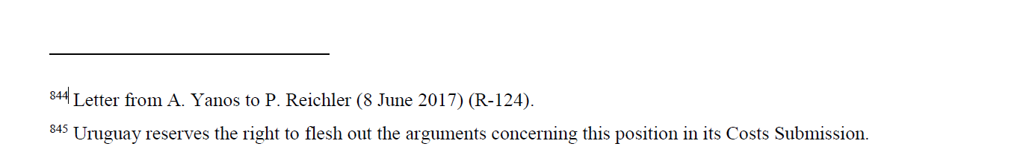
<div data-key='418' class='pdffootnote'>
<br data-key='422'><br data-key='423'>
<hr data-key='424' style='margin-left: 0;width: 200px; color:#000;'>
<div data-key='421' class='paratag'>
<span data-key='419' class='footnoteheight'>&nbsp;</span>
<span data-key='420' class='supertext' id=' IC030202_fn844'>844 </span> Letter from A. Yanos to P. Reichler (8 June 2017) (R-124).
</div>
<div data-key='425' class='paratag'>
<span data-key='426' class='footnoteheight'>&nbsp;</span>
<span data-key='427' class='supertext' id=' IC030202_fn845'>845 </span> Uruguay reserves the right to flesh out the arguments concerning this position in its Costs Submission.
</div>

</div>

Footnote in body text

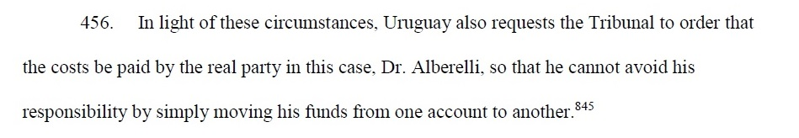

<div class='para paralvl2'>
<div class='paraBullet'>456. </div>
<div class='ParaText'>
In light of these circumstances, Uruguay also requests the Tribunal to order that the costs be paid by the real party in this case, Dr. Alberelli, so that he cannot avoid his responsibility by simply moving his funds from one account to another. <span data-key='561' class='supertext'><a href=' IC030202_fn845'>845 </a></span>
</div>
</div>

Footnote number should have html attribute <span class='supertext'> for super tag display purposes, and it must have child tag <a> with attribute name “href”, because we need to set a unique value as the ID (e.g., <a href='#IC030202_fn845'>). The bottom of the page ID and the href value in body text will be same to connect the body text number to the footnote number.

Following image show how it will work

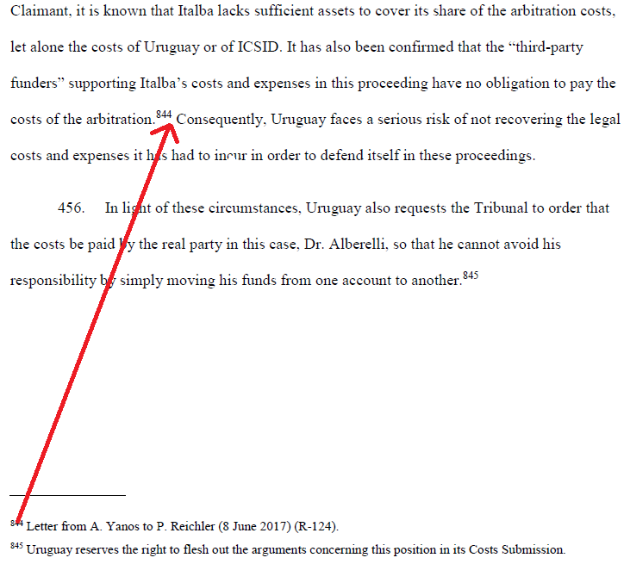

Note: Before footnote all the <div> for paragraph should be closed. And then again need to open the same. Apart from that if paragraph is continuing the next page than that paragraph should complete first and then footnote should be there. Following is the example.

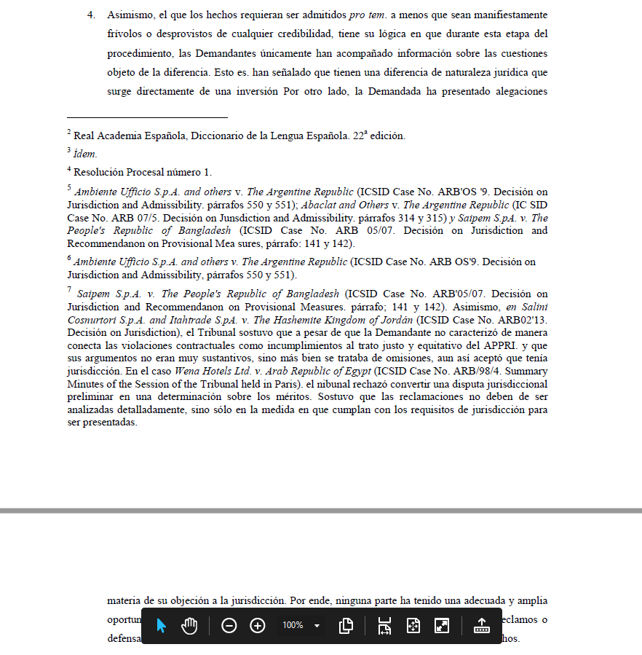

Here is how HTML will display.

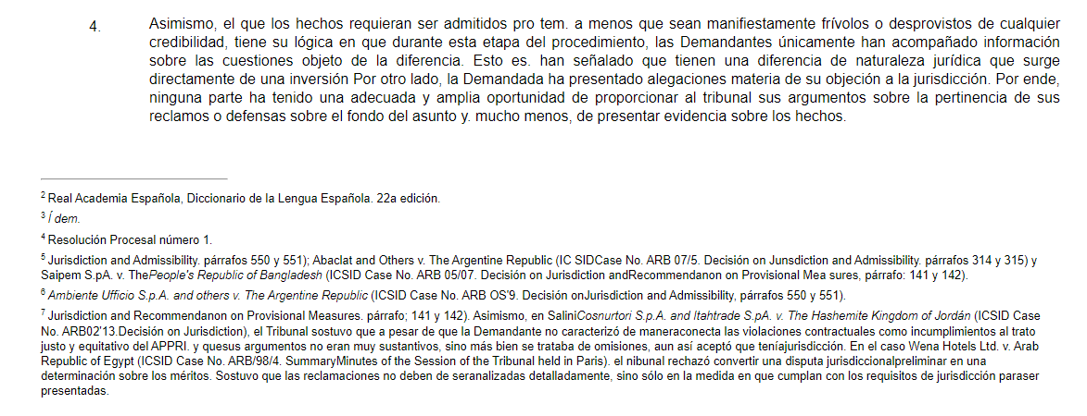

<div class='para paralvl1' id=''>
<div class='paraBullet paratag'>4. </div>
<div class='ParaText paratag'>
Asimismo, el que los hechos requieran ser admitidos pro tem. a menos que sean manifiestamente frívolos o desprovistos de cualquier credibilidad, tiene su lógica en que durante esta etapa del procedimiento, las Demandantes únicamente han acompañado información sobre las cuestiones objeto de la diferencia. Esto es. han señalado que tienen una diferencia de naturaleza jurídica que surge directamente de una inversión Por otro lado, la Demandada ha presentado alegaciones materia de su objeción a la jurisdicción. Por ende, ninguna parte ha tenido una adecuada y amplia oportunidad de proporcionar al tribunal sus argumentos sobre la pertinencia de sus reclamos o defensas sobre el fondo del asunto y. mucho menos, de presentar evidencia sobre los hechos.
</div>
</div>

<div class='pdffootnote'><br><br><hr style='margin-left: 0;width: 200px; color:#000;'><div class='paratag'><span class='footnoteheight'>&nbsp;</span><span class='supertext' id='_fn2'>2 </span> Real Academia Española, Diccionario de la Lengua Española. 22a edición.</div><div class='paratag'><span class='footnoteheight'>&nbsp;</span><span class='supertext' id='_fn3'>3 </span> <em>Í dem.</em> </div><div class='paratag'><span class='footnoteheight'>&nbsp;</span><span class='supertext' id='_fn4'>4 </span> Resolución Procesal número 1.</div><div class='paratag'><span class='footnoteheight'>&nbsp;</span><span class='supertext' id='_fn5'>5 </span> Jurisdiction and Admissibility. párrafos 550 y 551); Abaclat and Others v. The Argentine Republic (IC SIDCase No. ARB 07/5. Decisión on Junsdiction and Admissibility. párrafos 314 y 315) y Saipem S.pA. v. The<em>People's Republic of Bangladesh </em> (ICSID Case No. ARB 05/07. Decisión on Jurisdiction andRecommendanon on Provisional Mea sures, párrafo: 141 y 142).</div>div></div>

Below is the more example of how footnote and number in paragraph are connecting to each other.

This a code snippet from paragraph

<div data-key="187" class="ParaText paratag">
Indeed, CEMSA received rebates for several periods, and was denied rebatesfor other periods as a result of a formally issued resolution of the tax authorities.The Claimant asserts that the Poblano Group companies—
<i data-key="188">which are presumably in like circumstances and owned by Mexican investors</i>—
were also given rebates for several periods and denied them for others
<span data-key="189" class="supertext"><a data-key="190" href="#AF001405_fn9">9</a></span>.
</div>

Here the <a> tag have href attribute have value with prefix ”#”.
As you can see in below snippet that there is a <span> with the same value in id without prefix “#”. So, whenever user click on the number in paragraph it will redirect to this footnote. This is how footnote and paragraph number are connecting.
This is a code snippet from footnote
<div data-key="296" class="paratag">
<span data-key="297" class="footnoteheight">&nbsp;</span>
<span data-key="298" class="supertext" id="AF001405_fn9">9</span>CEMSA stablishes at pages 54, paragraphs 128, 129 y 130 of English version
and pages 59 and 60, paragraphs 128, 129 and 130 Spanish version as
follows: "128. Around July, 1999, Claimant learned that Hacienda was permitting cigarette exports and making rebates of IEPS
taxes on such exports to at least one company owned by Mexican citizens that, like CEMSA, is not a cigarette producer.
</div>

Right-alignment:

General class for right align text is class='righttext'.

Example of Right-Alignment:
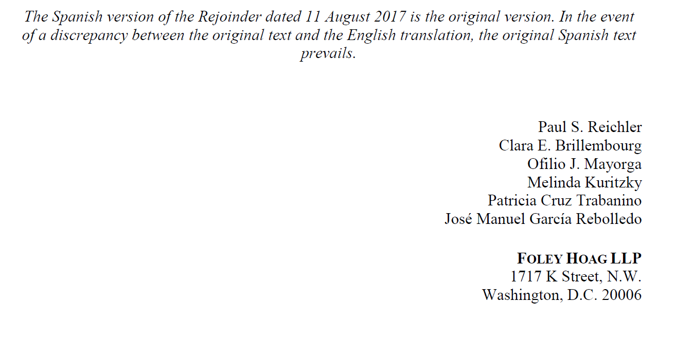

<div class='righttext'>Paul S. Reichler</div>
<div class='righttext'>Clara E. Brillembourg</div>
<div class='righttext'>Ofilio J. Mayorga</div>
<div class='righttext'>Melinda Kuritzky</div>
<div class='righttext'>Patricia Cruz Trabanino</div>
<div class='righttext'>José Manuel García Rebolledo</div>

Two-column structure:

To maintain a two-column structure, div container with id 'columnstruct' is used. This div will divided into two parts having specific style to maintain two-column structure as per PDF. All the content of the first column should be in first <div> and second column data should be in second <div> and same should be follow if for more than two columns. If there is a space between two line than the <br> will be used to maintain that space.

Div for column one:

<div style="width:49%;display:inline-block;vertical-align:top;">

<p style="padding-left:20%;margin-bottom: 0px !important;margin-top: 2px !important;">
<br>
<strong>Representing Corn Products </strong>
<br>
<p>
</div>
Div for column two:

<div style="width:49%;display:inline-block;vertical-align:top;">
<p style="padding-left:20%;margin-bottom: 0px !important;margin-top: 2px !important;">
<br>
<strong>Representing the United Mexican </strong>
<br>
</p>
</div>

Note: all styles must be maintained.

<div id="columnstruct" class="paratag">
<div style="width:49%;display:inline-block;vertical-align:top;">
<p style="padding-left:20%;margin-bottom: 0px !important;margin-top: 2px !important;">
<br>
<strong>Representing Corn Products </strong><br>
<p>
</div>
<div style="width:49%;display:inline-block;vertical-align:top;">
<p style="padding-left:20%;margin-bottom: 0px !important;margin-top: 2px !important;">
<br>
<strong>Representing the United Mexican </strong><br>
</p>
</div>
</div>

Sample of complete HTML code of two- column structure.

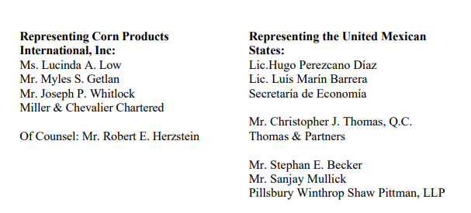

<div id="columnstruct" class="paratag">
<div style="width:49%;display:inline-block;vertical-align:top;">
<p style="padding-left:20%;margin-bottom: 0px !important;margin-top: 2px !important;">
<br> <strong>Representing Corn Products </strong><br>
<strong>International, Inc: </strong><br>
Ms. Lucinda A. Low<br>
Mr. Myles S. Getlan<br>
Mr. Joseph P. Whitlock<br>
Miller &amp; Chevalier Chartered<br>
<br>
Of Counsel: Mr. Robert E. Herzstein<br>
</p>
</div>
<div style="width:49%;display:inline-block;vertical-align:top;">
<p style="padding-left:20%;margin-bottom: 0px !important;margin-top: 2px !important;">
<br> <strong>Representing the United Mexican </strong><br>
<strong>States: </strong><br>
Lic.Hugo Perezcano Díaz<br>
Lic. Luís Marín Barrera<br>
Secretaría de Economía<br>
<br>
Mr. Christopher J. Thomas, Q.C.<br>
Thomas &amp; Partners<br>Mr. Stephan E. Becker<br>
Mr. Sanjay Mullick<br>
Pillsbury Winthrop Shaw Pittman, LLP<br>
</p>
</div>
</div>

Table structure:

general class=’table’ is used for table format.

Example of table structure

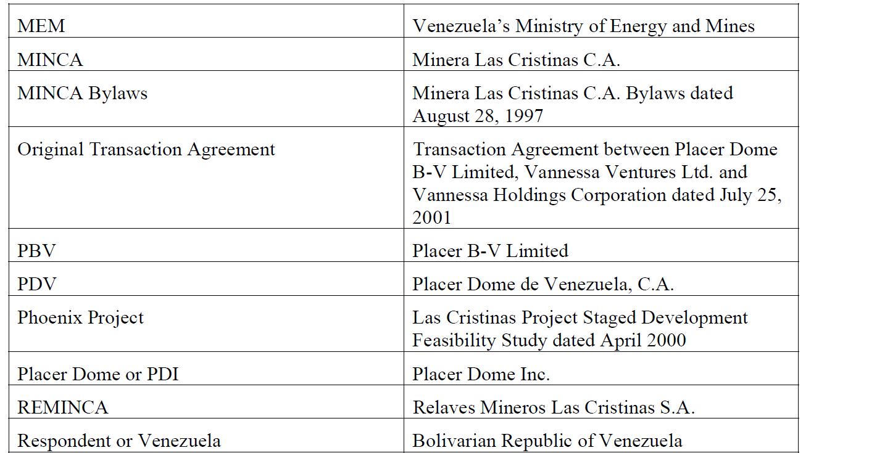

<table class='table'>
<tr>
<td> MEM </td>
<td> Venezuela’s Ministry of Energy and Mines</td>
</tr>
<tr>
<td> MINCA</td>
<td> Minera Las Cristinas C. A.</td>
</tr>
</table>

Provision structure:

This structure is used for Arbitration and Treaties document. You will see this kind of structure in these documents.
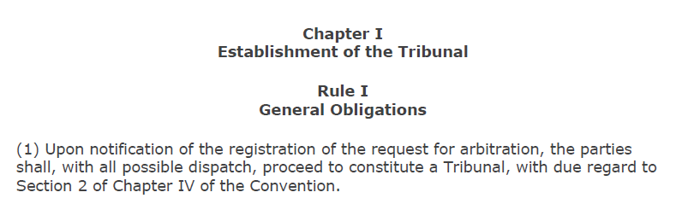

This kind of heading will be considered as Provision. So here Chapert I and Its heading, Rule I and its heading are Provision.

Here two concept are there.
- Provision Title
- Provision Defination

In the above snap,
Provision Title are : “Chapter I” & “Rule I”
Provision Definition are : “Establishment of the Tribunal” & “General Obligations”

<div data-key='5' id='CHAPI' class='provision'>
<span data-key='6' class='middletext paratag provisionTitle' style='padding-top:17.1599917420931px;'>
<strong data-key='3'>Chapter I </strong>
</span>
<span data-key='9' class='middletext paratag provisionDefination'>
<strong data-key='7'>Establishment of the Tribunal</strong>
</span>
</div>
<div data-key='12' id='RULEI' class='provision'>
<span data-key='13' class='middletext paratag provisionTitle' style='padding-top:16.1402165404711px;'>
<strong data-key='10'>Rule I </strong>
</span>
<span data-key='16' class='middletext paratag provisionDefination'>
<strong data-key='14'>General Obligations</strong>
</span>
</div>

Here you have to give “id” based on the Provision title.
Here for title “Chapter I” it will be “CHAPI”, for “Rule I” it will be “RULEI”.
Id format = “Short Form” + particular number
Here it is the list of possible title and it’s short form which you can see in different documents.

Provision Title | Short Form | Example
Provision Title | Short Form | Provision Title | Value of ID
ARTICLE | ART | ARTICLE 1 | ART1
ARTICOLO | ART | ARTICOLO I | ARTI
ART. | ART | ART. A | ARTA
ARTICULO | ART | ARTICULO 1 | ART1
SECTION | SEC | SECTION 1 | SEC1
CHAPTER | CHAP | CHAPTER A | CHAPA
PART | PART | PART I | PARTI
RULE | RULE | RULE I | RULEI
ANEXO AL ARTICULO | ANEX | ANEXO AL ARTICULO 1 | ANEX1
REGULATION | REG | REGULATION 1 | REG1

So Basic structure is here :

<div data-key='5' id='ShortForm+number' class='provision'>
<span data-key='6' class='middletext paratag provisionTitle'>
<strong data-key='3'>Provision_Title</strong></span>
<span data-key='9' class='middletext paratag provisionDefination'>
<strong data-key='7'>Provision_Defination</strong></span>
</div>

And paragraph id of this Provision will be as below.

<div data-key='23' id='RULE2' class='provision'>
<span id=d ata-key='24' class='middletext paratag provisionTitle'>
<strong data-key='22'>Rule 2 </strong></span>
<span id=d ata-key='26' class='middletext paratag provisionDefination'>
<strong data-key='25'>Method of Constituting the Tribunal </strong></span>
</div>
<div data-key='29' class='para paralvl1' id='ARB0012_paRULE2.1'>
<div data-key='30' class='paraBullet paratag'>(1) </div>
<div data-key='31' class='ParaText paratag'>Paragraph_TEXT
<div data-key='32' class='Parapadding'>
<div data-key='33' class='para paralvl2' id='ARB0012_paRULE2.1.a'>
<div data-key='34' class='paraBullet paratag'>(a) </div>
<div data-key='35' class='ParaText paratag'>Paragraph_TEXT</div>
</div>
</div>
</div>
</div>
If you can come over any other Provision Title, which is not there in above table then do let us know.

Heading in body text:

Apply ID to Heading – We need to add prefix “h” when we apply id. Weather TOC is there or not.
For Example.
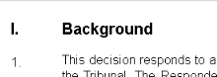
Here Id should be "hIC003810_paI".

Apart from that, as in TOC we apply ‘maintitlefirst’ and ‘maintitle’, So this we need to apply in heading also but we need to apply only if TOC is not there in document. For level 1 heading, we need to add class ‘maintitlefirst’ and for all another headings add class “maintitle’”

For example :
<div data-key="37" class="para paralvl1 maintitlefirst" id="hAF000106_paI">
<div data-key="38" class="paraBullet paratag">
<h2 data-key="35" class="heading">I. </h2>
</div>
<div data-key="39" class="ParaText paratag">
<h2 data-key="36" class="heading"><span data-key="33">FACTS</span></h2>
</div>
</div>

Note: Please refer document ISLG Style.css (attached here) for all the definition of classes. We need to add this css in the <head> part.

Email and hyperlink
When email link is there we need to add in anchor tag as below so if user will click on that it will open default mail app.
<a style='cursor: pointer;' href='mailto:ajana@bmaj.cl'>ajana@bmaj.cl</a>

When any URL is there we need to add anchor tag as below so that it will open that URL in new tab.
<a target='_blank' style='cursor: pointer;' href='http://www.pca-cpa.org'>www.pca-cpa.org</a>

Image place holder
When there is Image like logo, stamp, signature, flow chart or any such diagram we need put place holder instead of that. This Image place holder will always display in centre. Below is the sample code for that.

<div style="height: 46px; margin-top: 23px">
<span class="middletext paratag">[IMAGE UNAVAILABLE - SEE ORIGINAL PDF]</span>
</div>

