PART 1. – HTML CODING MANUAL

The following is an instruction of converting HTML from pdf that are uploaded within a Client database.

It is our recommendation to only select specific class n standards (rules) we are using for developing html files from pdf. to maintain consistency so that further operations can be performed by programmer.

INSTRUCTIONS OVERVIEW

- The complete and formatted file saved in an .html format will then contain the HTML Document coding specific to the pdf, and is saved with the .html extension,

- Following is a predefine standard of html that is applied to each HTML file which are converted from PDF, outlining the following components below:

  - <DOCTYPE>
  - <html>
  - <head>
  - <link>
  - <body>
  - <div>
  - <span>
  - <table>
  - <p>

Above tags must be closed respectively.

SAMPLE: HTML CODING STEPS

Below is the general format require to use in each html file.

Main ‘div;’ tag inside body tag must have class='html-container Art'. As it maintains the whole pdf structure in HTML.
<!DOCTYPE HTML PUBLIC '-//W3C//DTD HTML 4.0 Transitional//EN'>
<html>
<head>
<link rel='stylesheet' type='text/css' href='style.css' />
</head>
<body>
<div class='html-container Art'>
</div>
</body>
</html>

Following are the HTML style/class which is converted from PDF parts.

- CENTER TEXT: This class is used when any text in pdf page is in middle.

EXAMPLE 1:

<div class='middletext'><b></b></div>

Example 2: This class is used along with specific style to maintain space between two sentences specially the first sentence of page. As you can see in below image, there is space between two sentences.

<div class='middletext' style='padding-top:16.8713595512354px;padding- bottom:16.8713595512354px;'>
<b>Caso CPA No. 2016-08</b>
</div>

Example 3: This class is used along with specific style to maintain space between any two sentences in middle of page.

<div class='middletext' style='padding-top:0px;padding- bottom:4.27472186893104px;'>
-<b>y-</b>
</div>

Please refer following image and code for understanding MIDDLE TEXT class.
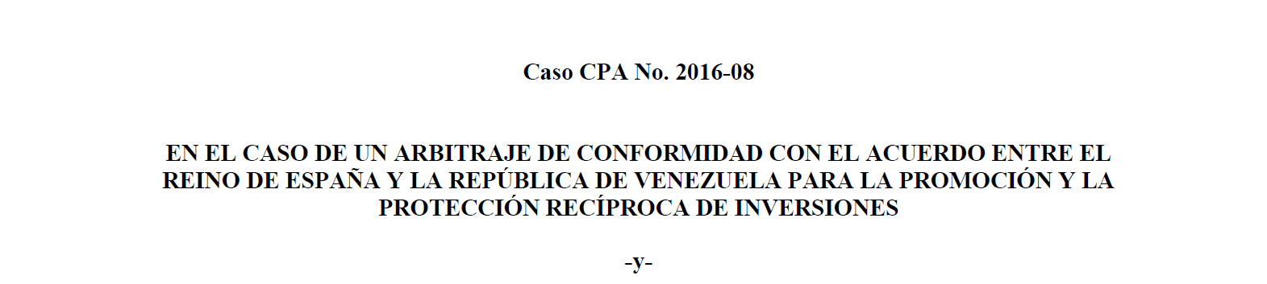
<!DOCTYPE HTML PUBLIC '-//W3C//DTD HTML 4.0 Transitional//EN'>
<html>
<head>
<link rel='stylesheet' type='text/css' href='style.css' />
</head>
<body>
<div class='html-container Art'>
<div class='middletext' style='padding-top:16.8713595512354px;padding- bottom:16.8713595512354px;'><b>Caso CPA No. 2016-08</b>
</div>

<div class='middletext'><b>EN EL CASO DE UN ARBITRAJE DE CONFORMIDAD CON EL ACUERDOENTRE EL</b> </div>
<div class='middletext'><b>REINO DE ESPAÑA Y LA REPÚBLICA DE VENEZUELA PARA LA PROMOCIÓN Y LA</b></div>
<div class='middletext'><b>PROTECCIÓN RECÍPROCA DE INVERSIONES</b></div>
<div class='middletext' style='padding-top:0px;padding-bottom:4.27472186893104px;'>-<b>y-</b> </div>

</div>
</body>
</html>

Middle text html code

- Table of Contents: 'tocdiv' class is used to maintain toc format throughout all files.

Class toc1lvl is for first level of indentation. Similarly toc1lv2 is for sub level indentation. So for sub indentation use toc1lvl, toc1lv2, toc1lv3... Infinite for sub level toc.
Further, class='toc1lvl toc tocdots' : Is used to maintain first level and dots,
class='tocbullet': is for roman, alphabetical, etc ordering.
class='tocstring ': is used for text,
class=’tocpageno’ : is for page number,
class='tocpadding': is used before every sublevel.
eg. Tocpadding is used between toc1lv1 and toc1lv2.

<div class='toc1lvl toc tocdots'>
<span class='tocbullet'>IV. </span>
<span class='tocstring'>The Principal Claims and Submissions of the Parties</span>
<span class='tocpageno'> 24</span>
<div class='tocpadding'>
<div class='toc2lvl toc tocdots'>
<span class='tocbullet'>1. </span>
<span class='tocstring'>The Investor‟s Principal Claims and Submissions</span>
<span class='tocpageno'> 25</span>
</ div >
</ div >
</ div >

Below is the example of toc with html code.
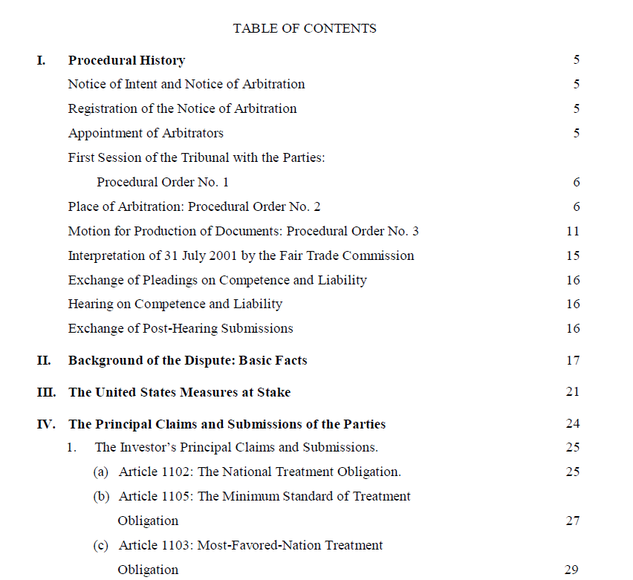

<div class='tocdiv'>

<div class='middletext'> TABLE OF CONTENTS </div>
<div class='toc1lvl toc tocdots'>
<span class='tocbullet'>I. </span>
<span class='tocstring'>Procedural History</span>
<span class='tocpageno'> 5</span>
</div>

<div class='toc1lvl toc tocdots'>
<span class='tocbullet'>IV. </span>
<span class='tocstring'>The Principal Claims and Submissions of the Parties</span>
<span class='tocpageno'> 24</span>
<div class='tocpadding'>
<div class='toc2lvl toc tocdots'>
<span class='tocbullet'>1. </span>
<span class='tocstring'>The Investor‟s Principal Claims and Submissions</span>
<span class='tocpageno'> 25</span>
<div class='tocpadding'>
<div class='toc3lvl toc tocdots'>
<span class='tocbullet'>(a) </span>
<span class='tocstring'>Article 1102: The National Treatment Obligation</span>
<span class='tocpageno'> 25</span>
</div>
<div class='toc3lvl toc '>
<span class='tocbullet'>(b) </span>
<span class='tocstring'>Article 1105: The Minimum Standard of Treatment</span>
<span class='tocpageno'></span>
</div>
</div>
</div>
</div>
</div>
</div>
</div>
</div>
Table of Contents html code

- PARAGRAPH TEXT: Below standard is used for paragraphs in pdf.

General format requires to use in all the paragraph. Class Para is general and paralvl1 is for first element of indentation. Similarly, paralvl2 is for sub level indentation. So, for sub indentation use paralvl1, paralvl2, paralvl3... Infinite for sub level paras.
<div class='para paralvl1'>
</div>

Further, class='paraBullet': Is used to maintain bullets,
class='ParaText': is used for para-text,
class='Parapadding': is used before every sublevel.
Eg. Parapadding is used between paralvl1 and paralvl2.

<div class='para paralvl1'>
<div class='paraBullet'>I. </div><div class='ParaText'>
<b>INTRODUCTION</b>
<div class='Parapadding'>
<div class='para paralvl2'>
<div class='paraBullet'>1. </div>
<div class='ParaText'>
The game is over for Italba.
</div>
</div>
</div>
</div>
</div>

Example with html code is shown below.

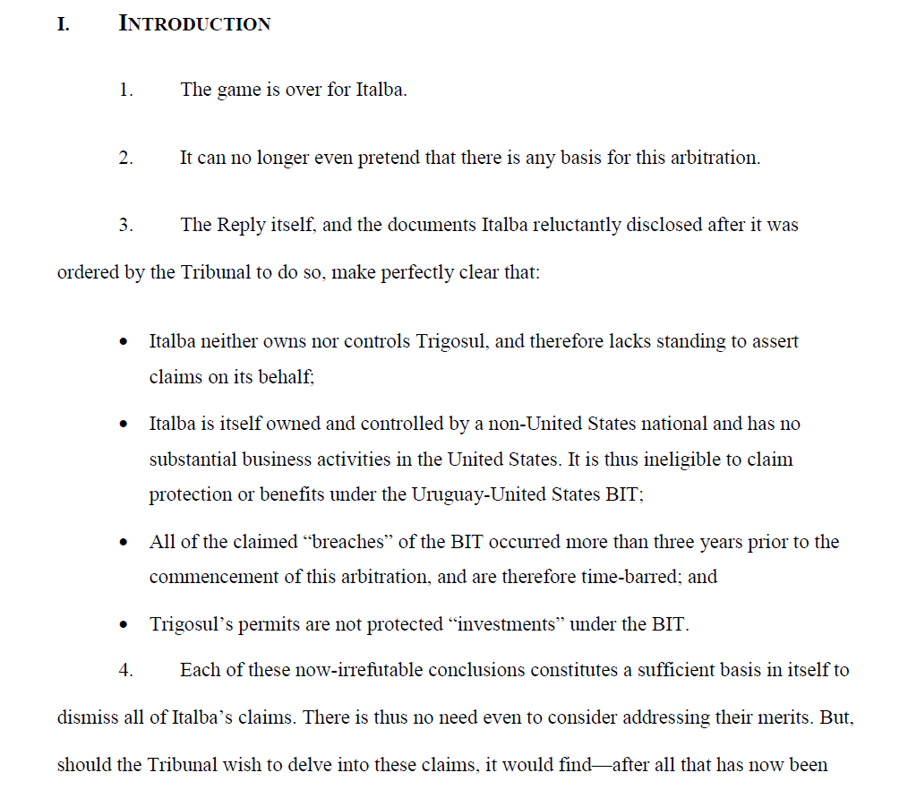
<div class='para paralvl1'>
<div class='paraBullet'>I. </div><div class='ParaText'>
<b>INTRODUCTION</b>
<div class='Parapadding'>
<div class='para paralvl2'>
<div class='paraBullet'>1. </div><div class='ParaText'>
The game is over for Italba.
</div>
</div>
<div class='para paralvl2'>
<div class='paraBullet'>2. </div><div class='ParaText'>
It can no longer even pretend that there is any basis for this arbitration.
</div>
</div>
<div class='para paralvl2'>
<div class='paraBullet'>3. </div><div class='ParaText'>
The Reply itself, and the documents Italba reluctantly disclosed after it was ordered by the Tribunal to do so, make perfectly clear that:
</div>
</div>
<div class='para paralvl2'>
<div class='paraBullet'>• </div>
<div class='ParaText'>
Italba neither owns nor controls Trigosul, and therefore lacks standing to assert claims on its behalf;
</div>
</div>
<div class='para paralvl2'>
<div class='paraBullet'>• </div><div class='ParaText'>
Italba is itself owned and controlled by a non-United States national and has no substantial business activities in the United States. It is thus ineligible to claim protection or benefits under the Uruguay-United States BIT;
</div>
</div>
<div class='para paralvl2'>
<div class='paraBullet'>7. </div><div class='ParaText'>
Italba’s Reply leaves no room for doubt: this Tribunal has no jurisdiction. Claimant has failed to override any of the four jurisdictional objections Uruguay has asserted,
each of which is sufficient to require the dismissal of all claims.
<div class='Parapadding'>
<div class='para paralvl3'>
<div class='paraBullet'>1. </div>
<div class='ParaText'>
<b>Italba’s Claimed Ownership of Trigosul</b>
</div>
</div>
</div>
</div>
</div>
</div>
</div>
</div>
Paragraph html code

- Paragraph without Bullets:
class='paraPaddingText lineheight' is used when paragraphs are not having bullets.

Below is the example of paragraph without bullets.

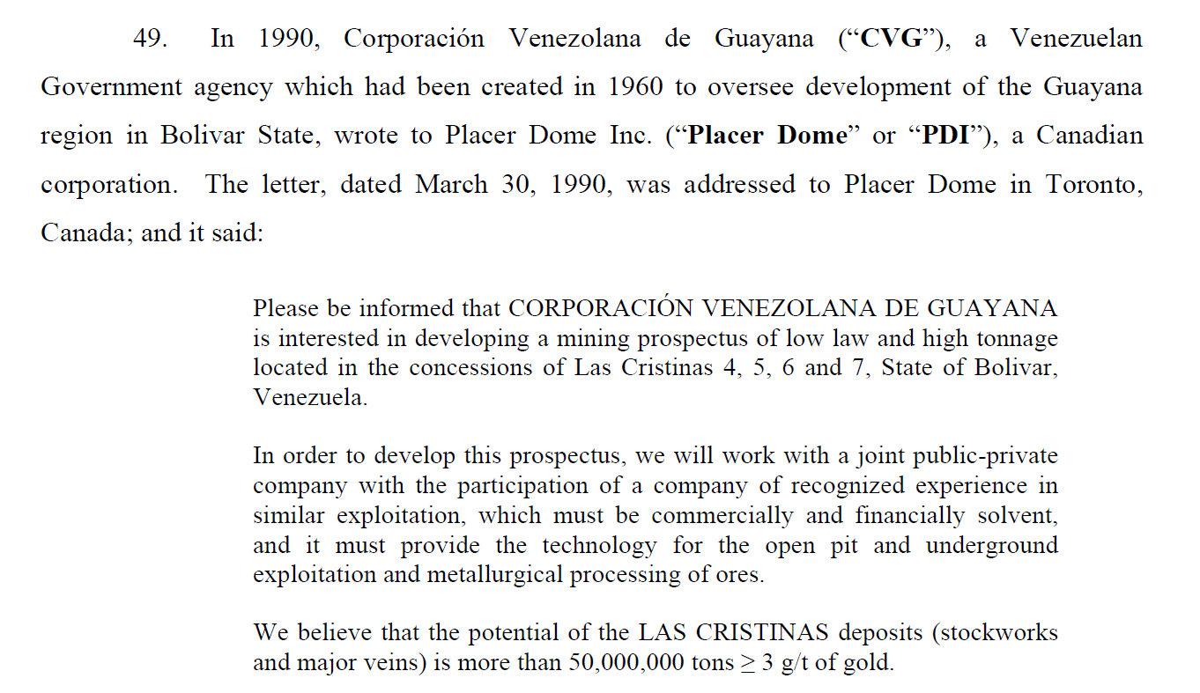

<div class='paraPadding'>
<div class='paraPaddingText lineheight'>
Please be informed that CORPORACIÓN VENEZOLANA DE GUAYANA
is interested in developing a mining prospectus of low law and high tonnage
located in the concessions of Las Cristinas 4, 5, 6 and 7, State of Bolivar,Venezuela.
</div>
</div>

Paragraph without Bullets

- Citation/footnote: ‘pdfcitation’ class is used for any citations in pdf files.
<sup> tag for citation numbers.

class='citationheight' is used to maintain number height.

Below is the example of Citation/footnote:
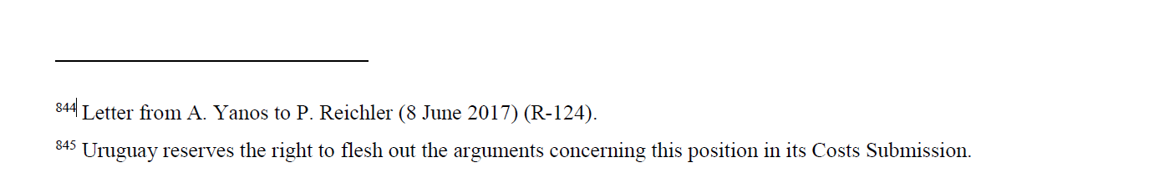

<div class='pdfcitation'>
<br /><br />
<sup>844</sup>
Letter from A. Yanos to P. Reichler (8 June 2017) (R-124).
<span class='citationheight'>&nbsp;</span>
<sup>845</sup>
Uruguay reserves the right to flesh out the arguments concerning this position in its Costs Submission.
</div>
Citation html code

- Right-Align Text: General class for right align text is class='righttext'.

Below is the example of Right-Align text:
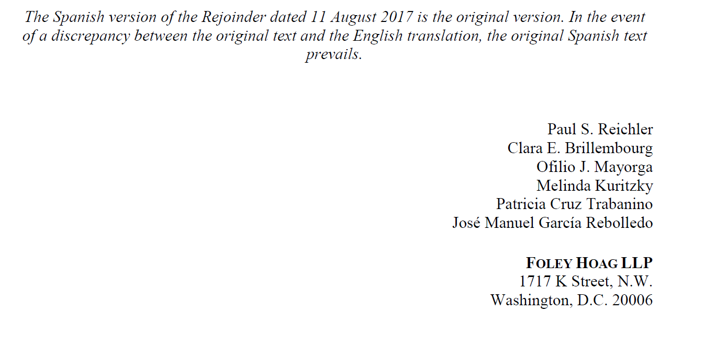

<div class='righttext'>Paul S. Reichler</div>
<div class='righttext'>Clara E. Brillembourg</div>
<div class='righttext'>Ofilio J. Mayorga</div>
<div class='righttext'>Melinda Kuritzky</div>
<div class='righttext'>Patricia Cruz Trabanino</div>
<div class='righttext'>José Manuel García Rebolledo</div>
Right-Align Text html code

- 2-column structure: To maintain two column structure, div container with id 'columnstruct' is used.

class='maindiv' is main div which is further divided in two parts having specific style to maintain.

Div for column one:

div style='width:50%;display:inline-block'>
<p style='padding-left: 20%;margin-bottom: 0px !important;margin-top: 2px !important;'>
Representing Claimant
</p>

Div for column two:

</div><div style='width:50%;display:inline-block'>
Representing Respondent
</div>
Note: all styles must be maintain.
<div class='maindiv'>
<div>
<div style='width:50%;display:inline-block'>
<p style='padding-left: 20%;margin-bottom: 0px !important;margin-top: 2px !important;'>
Representing Claimant
</p>
</div><div style='width:50%;display:inline-block'>
Representing Respondent
</div>
</div>
</div>

Below is the complete html code of 2- column structure.

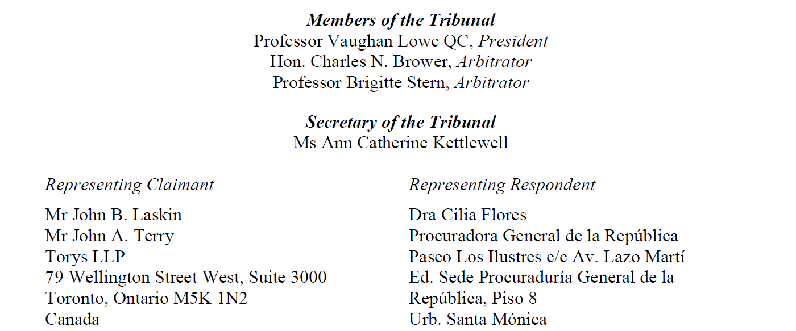

<div id='columnstruct'>
<div class='maindiv'>
<div>
<div style='width:50%;display:inline-block'>
<p style='padding-left: 20%;margin-bottom: 0px !important;margin-top: 2px !important;'>
Representing Claimant
</p>
</div><div style='width:50%;display:inline-block'>
Representing Respondent
</div>
</div>
</div>
<div class='maindiv'>
<div>
<div style='width:50%;display:inline-block'>
<p style='padding-left: 20%;margin-bottom: 0px !important;margin-top: 2px !important;'>
Mr John B. Laskin
</p>
</div><div style='width:50%;display:inline-block'>
Dra Cilia Flores
</div>
</div>
</div>

2-column structure html code

- Table structure: general class=’table’ is used for table format.

Below is the example of it.

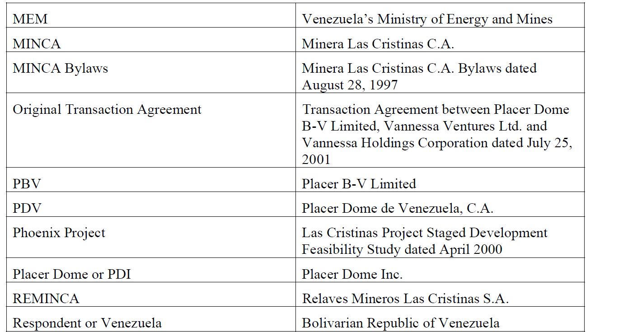

<table class='table'>
<tr>
<td> MEM </td>
<td> Venezuela’s Ministry of Energy and Mines</td>
</tr>
<tr>
<td> MINCA</td>
<td> Minera Las Cristinas C. A.</td>
</tr>
</table>

Table html code

Note: Please refer document Style.css (attached here) for all the definition of classes.

