P3 Project Flow

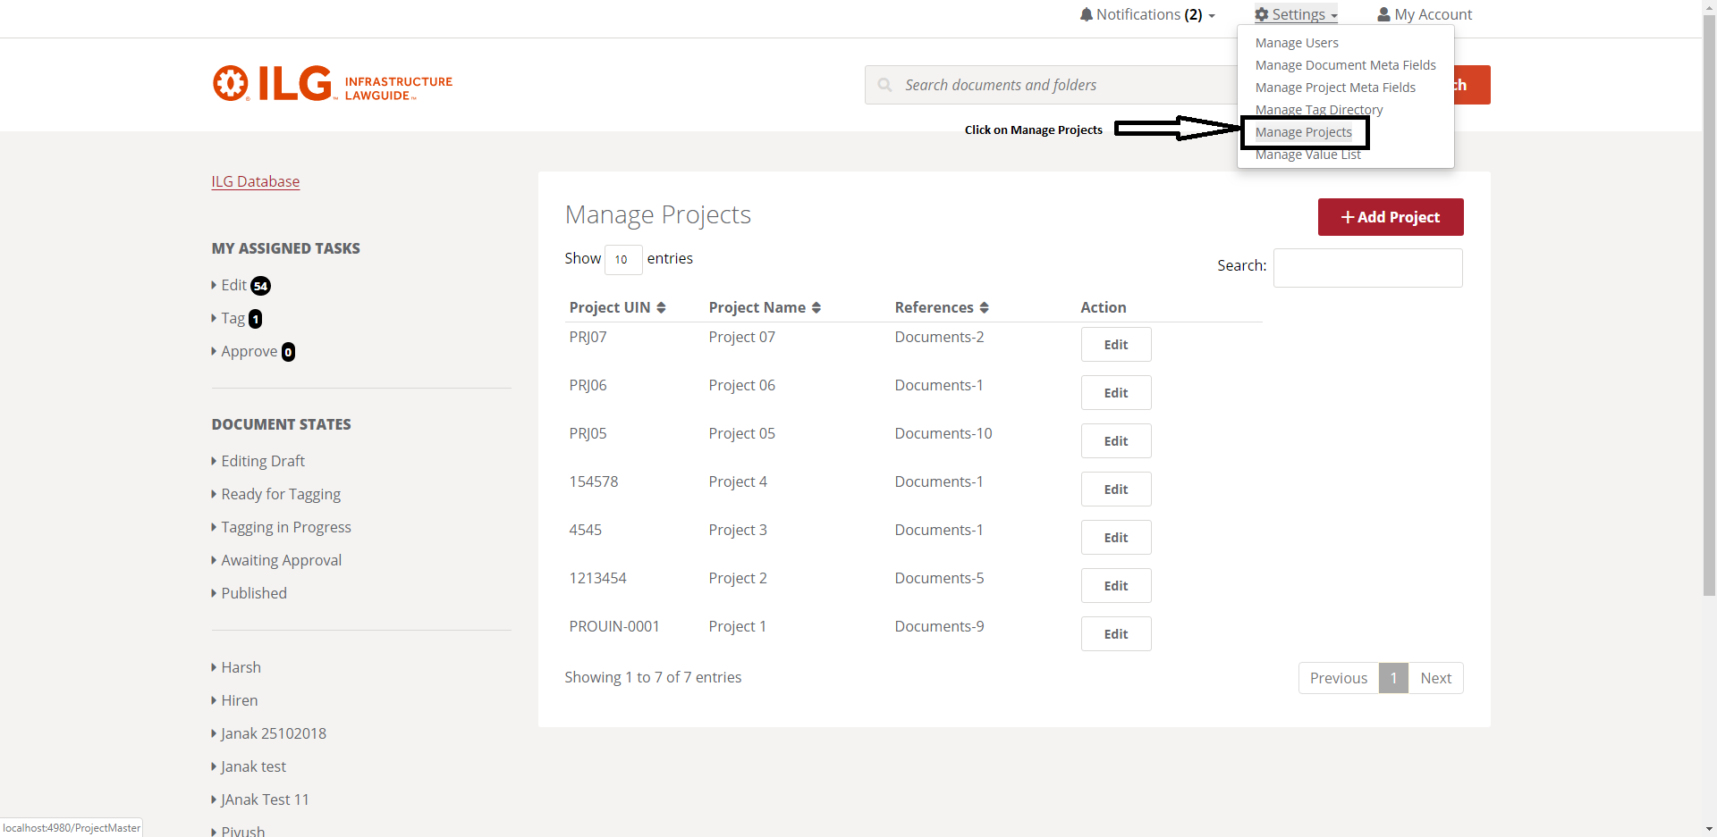

- Click on top right side Menu Setting ->Manage Project
- Below screen will display

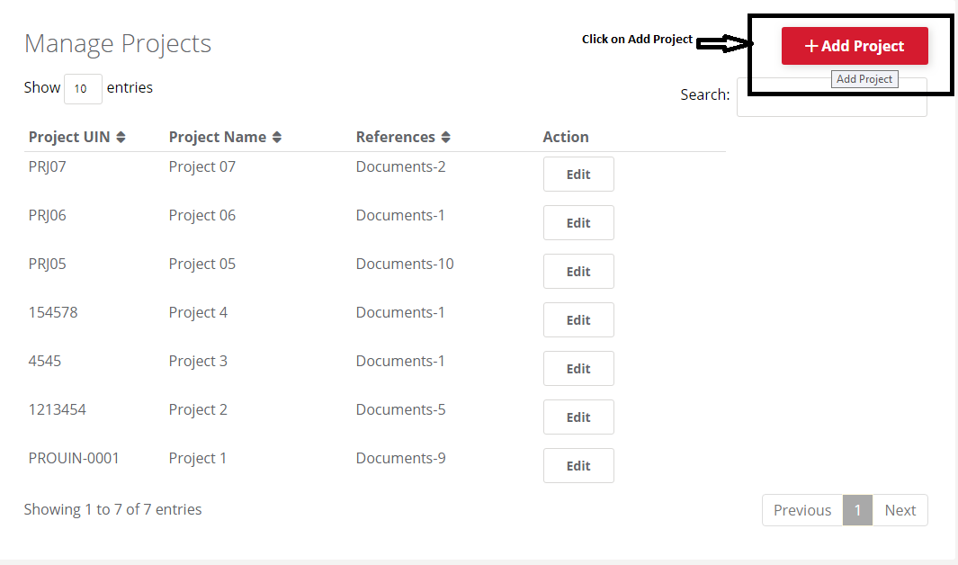

- Click on Add Project
- Below screen will display

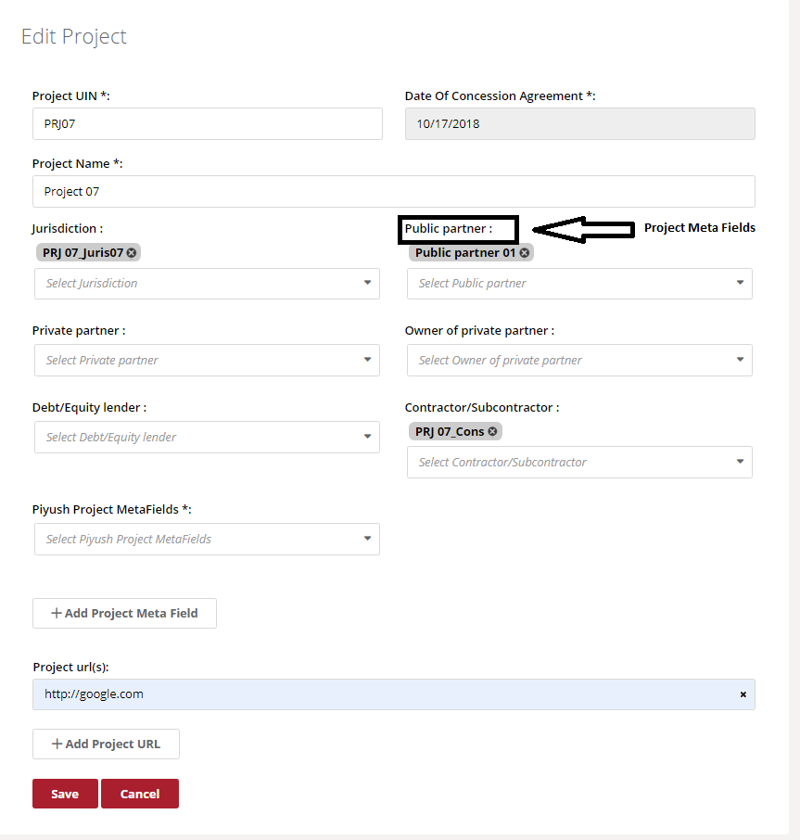
- In above screen project related fields will display
- Project Related Meta Fields also Map with Project

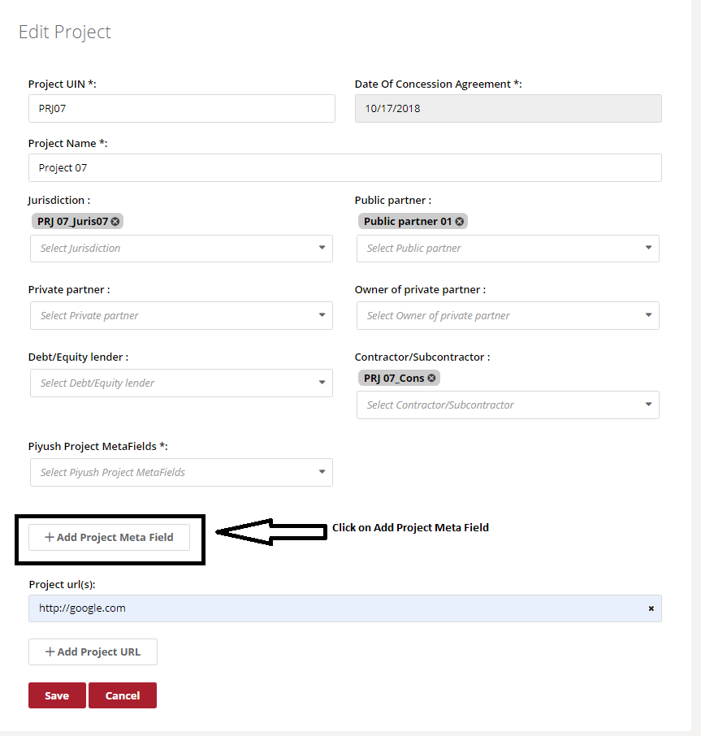

- Click on Add Project Meta Field
- Below screen will display

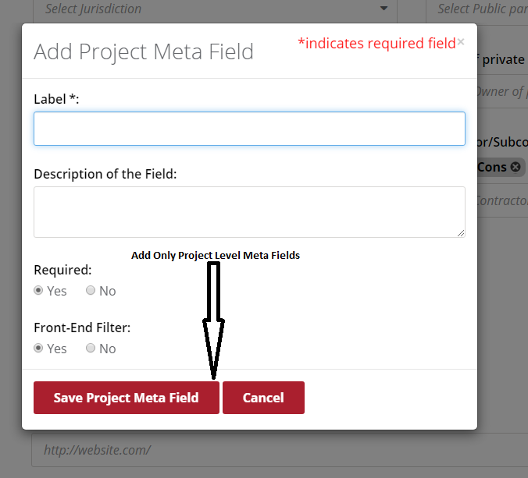

- We have create project level Meta Field which display only in particular Project

Document Flow

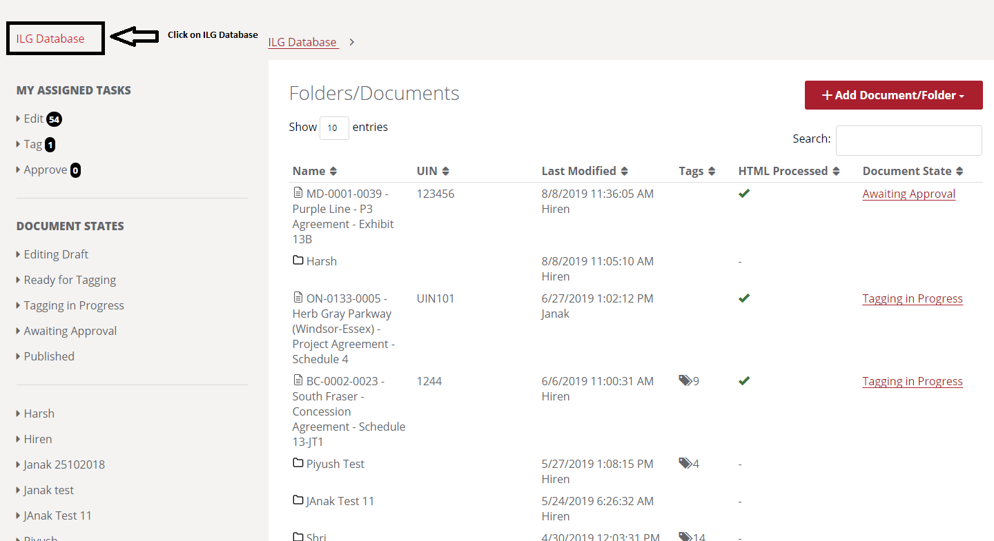

- Click on ILG Database
- Above screen will Display

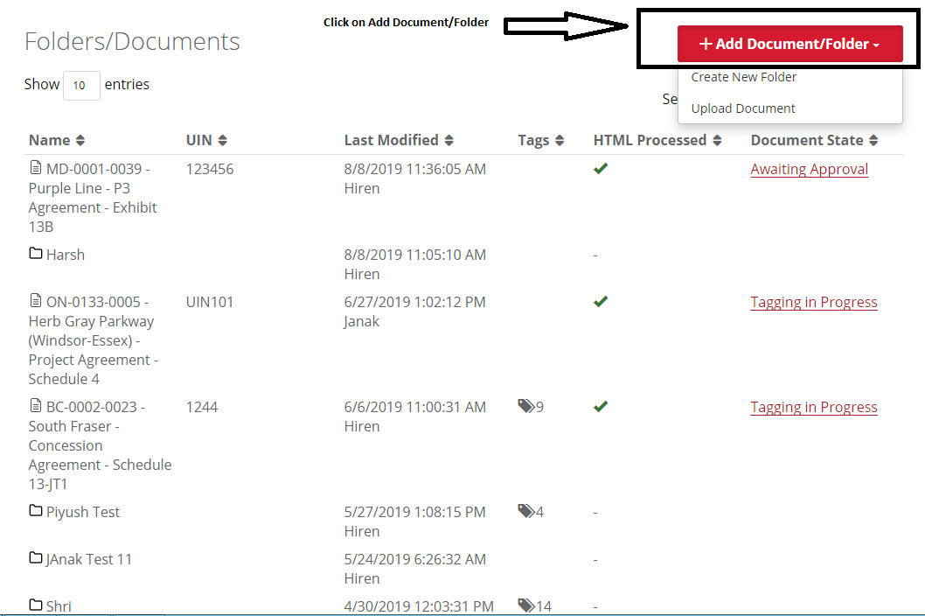

- Click on Add Document/Folder
- There are 2 option is there.

- Create New Folder
- Upload Document

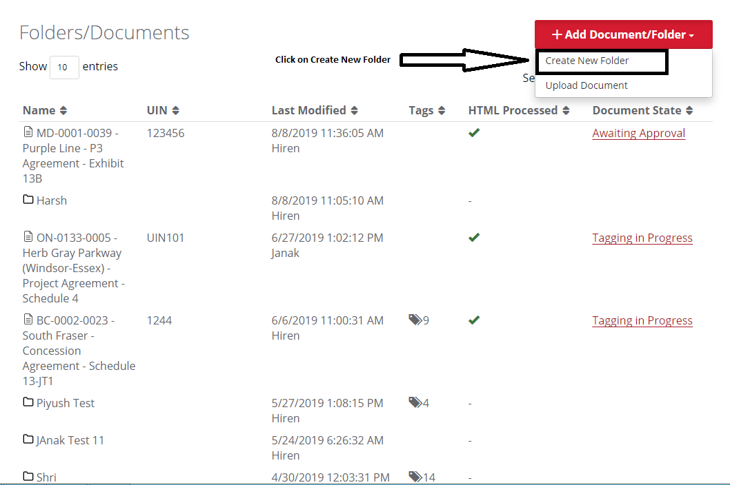

- Click on New Folder.
- We have to create nth level folder and upload document in the folder.

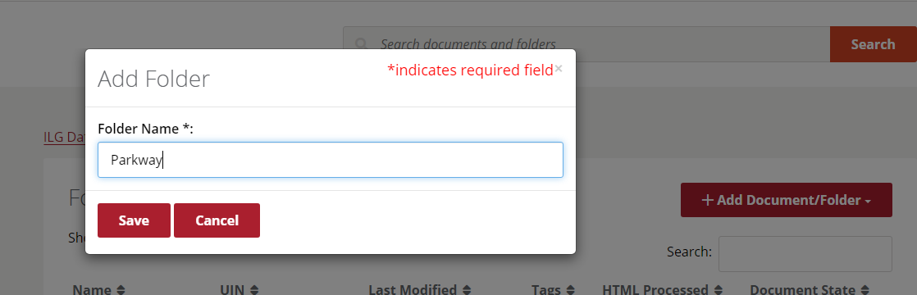

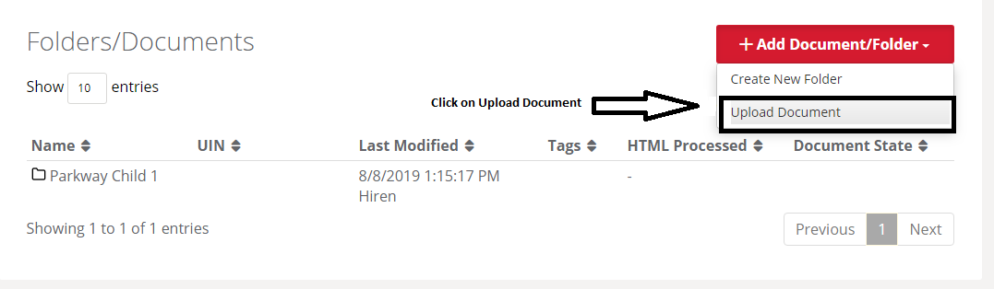

- We have Create nth level of folder structure and upload document in nth level of the folder structure.
- Find below screen shots.

We will consider document upload flow as per ISLG-Rebuild wireframe.

Step-1 : Choose or Drop files

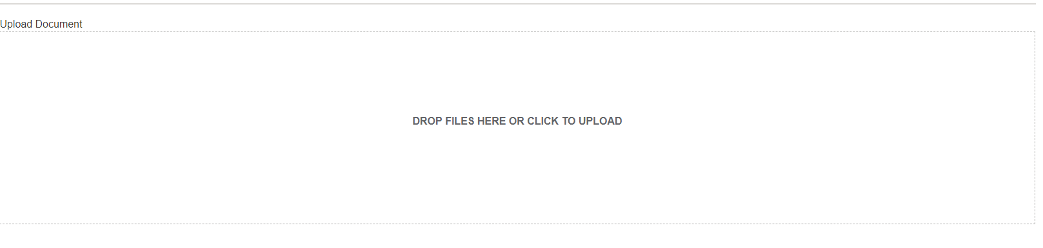

Step-2 : Enter UIN number for HTML cross references After that Admin can “Start Conversation”
It will convert PDF to HTML.

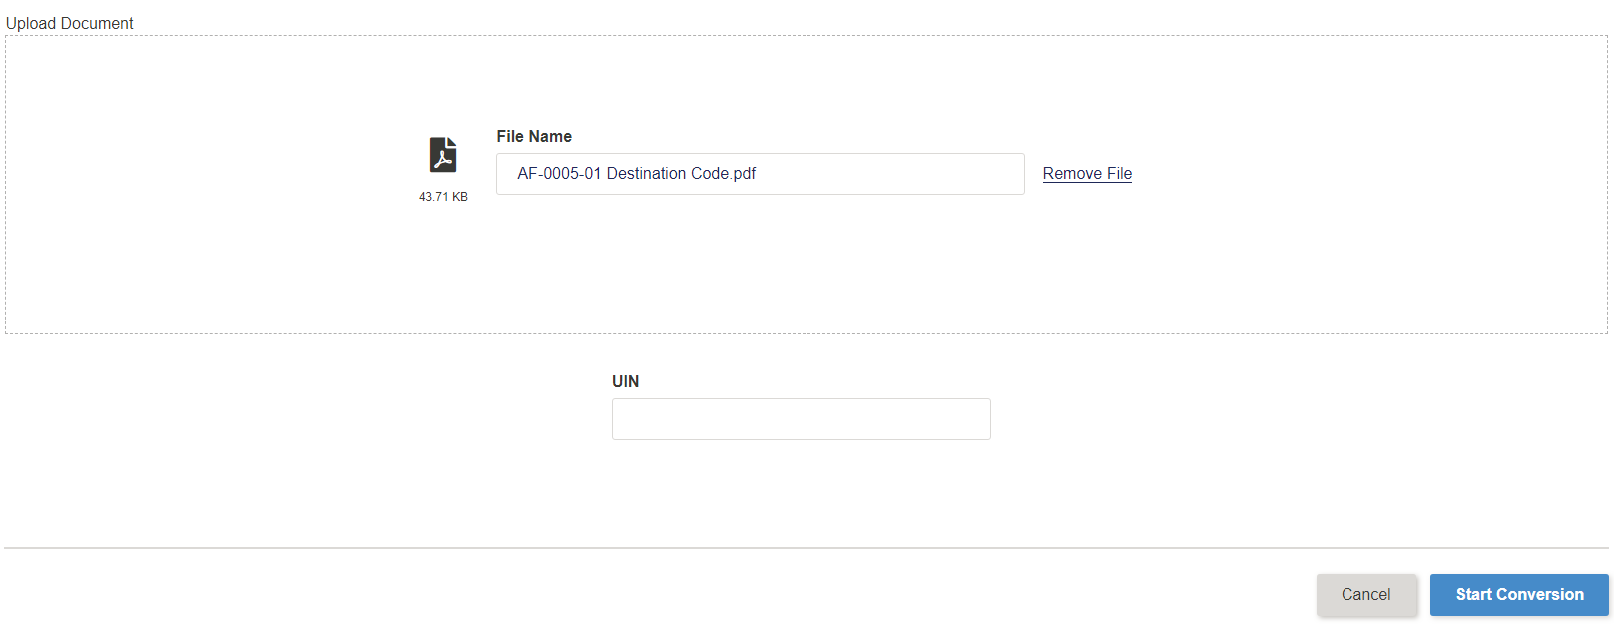

After Click on “Start Conversion” button following page will be display.
Currently, We are not showing Document Upload process here, as P3 prototype has not such activity if you want to display Document Upload Process as per ISLG-Rebuild, please provide wireframe for same.

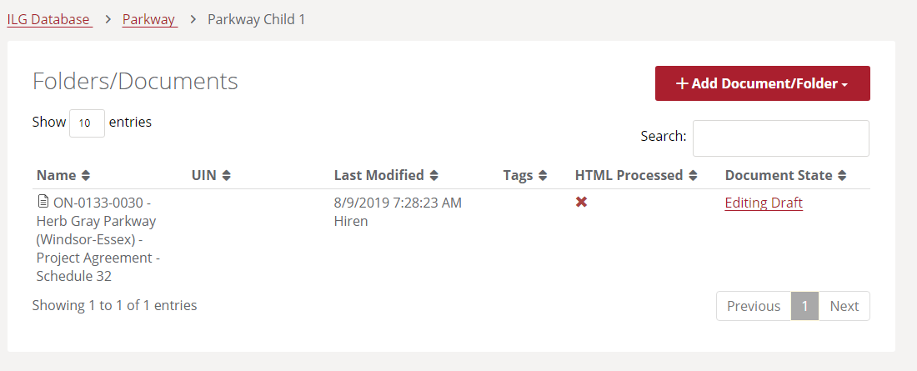

- We have to also direct upload document without created any folder structure.
- Find below screen shorts.

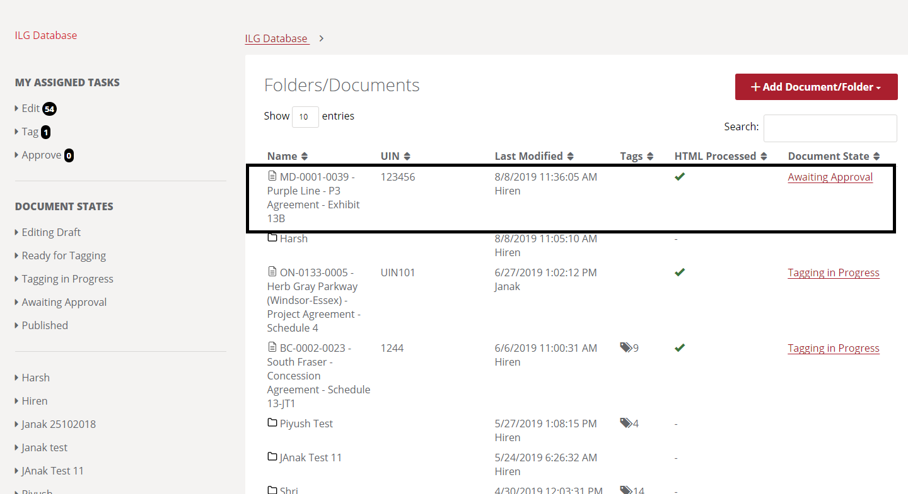

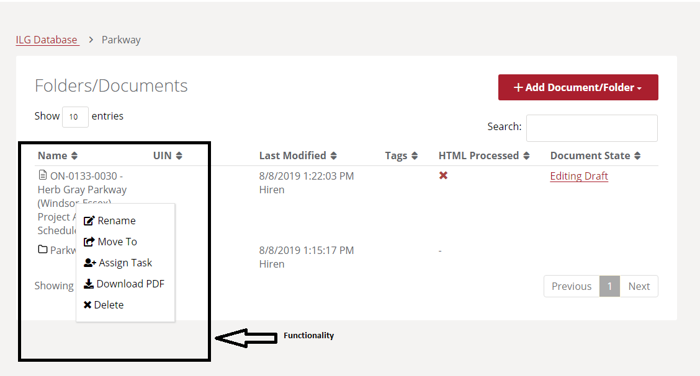

- After document upload we have to flow Rename, Move To, Assign Task, Download PDF and Delete Functionality.

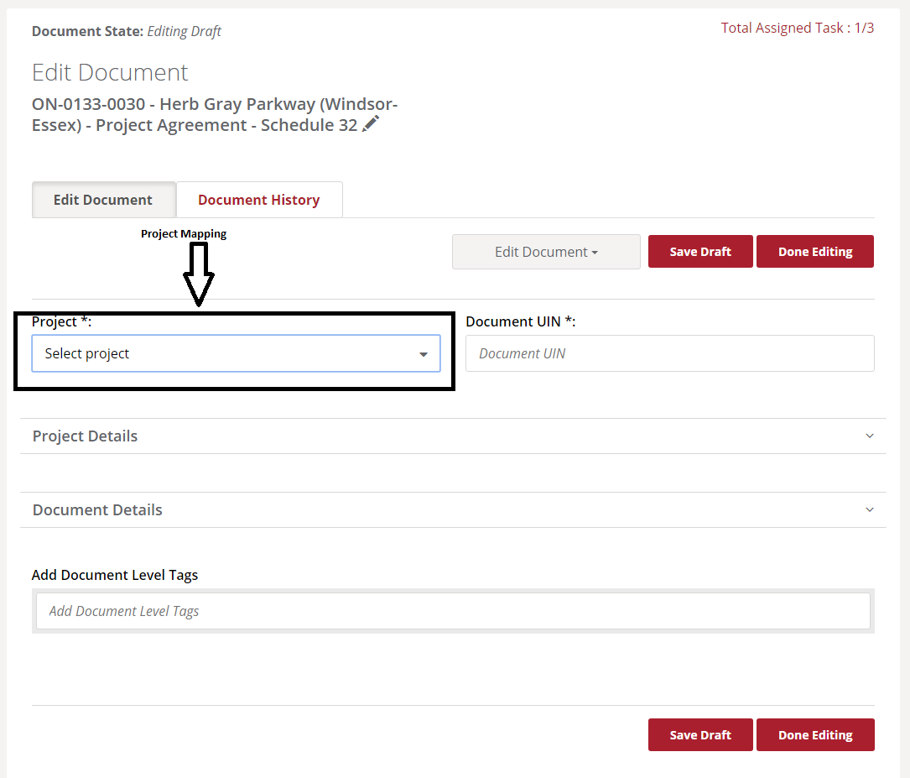
- After document upload we have to map project with document as shown in above screen shots.
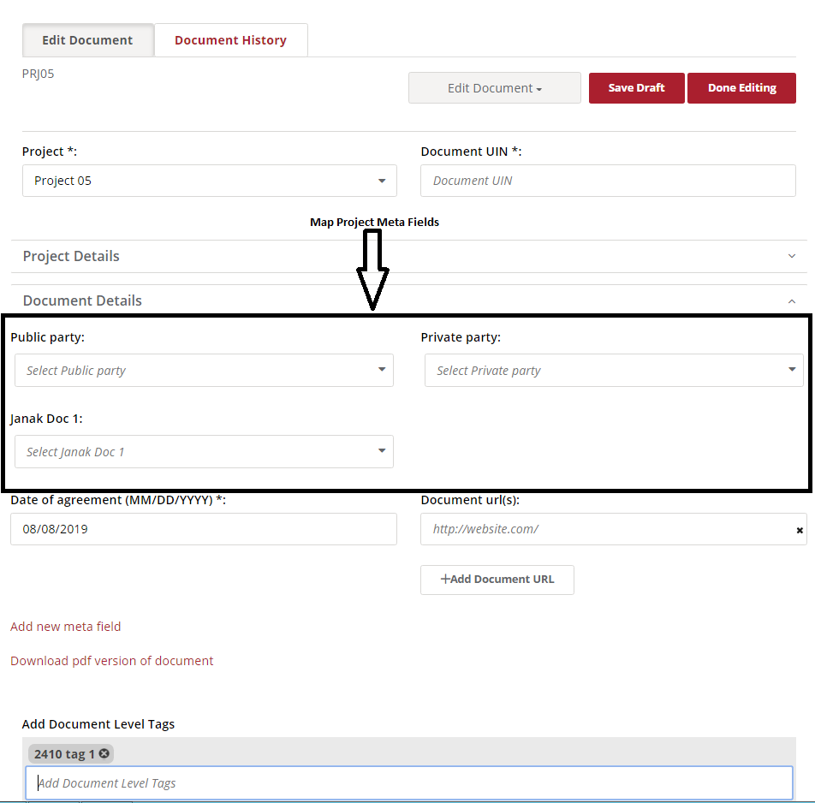

- Map Document meta fields with document.
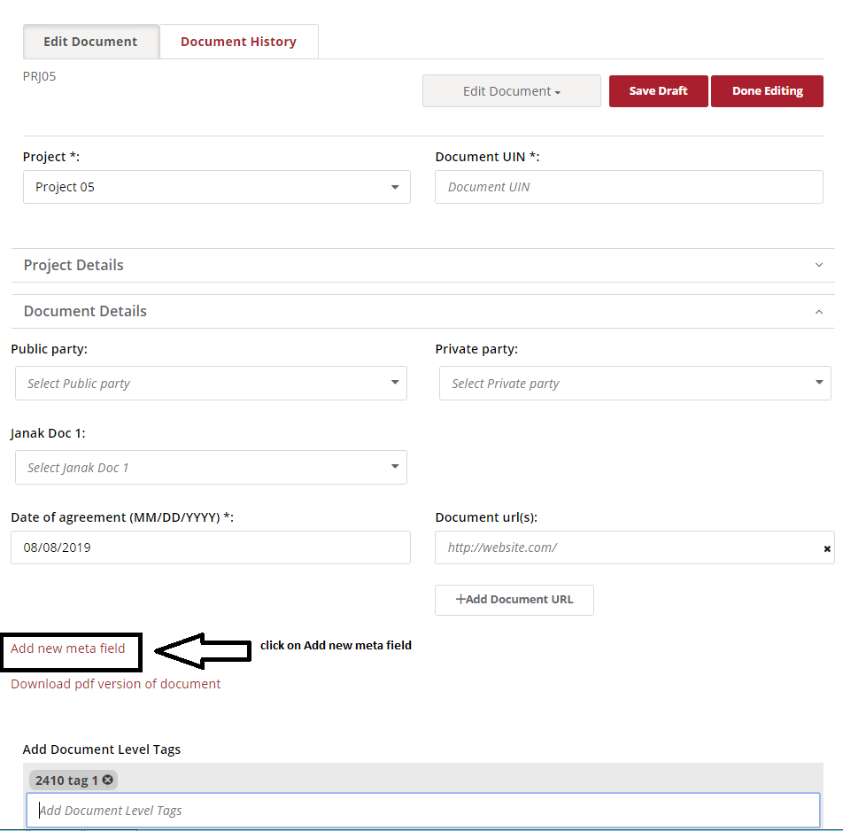

- We have also add new document meta field which is map with particular document only.
- For reference find below screen shots.

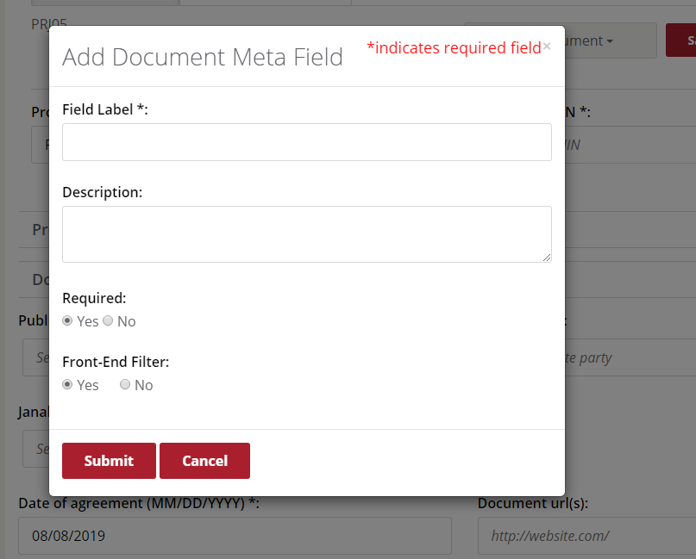

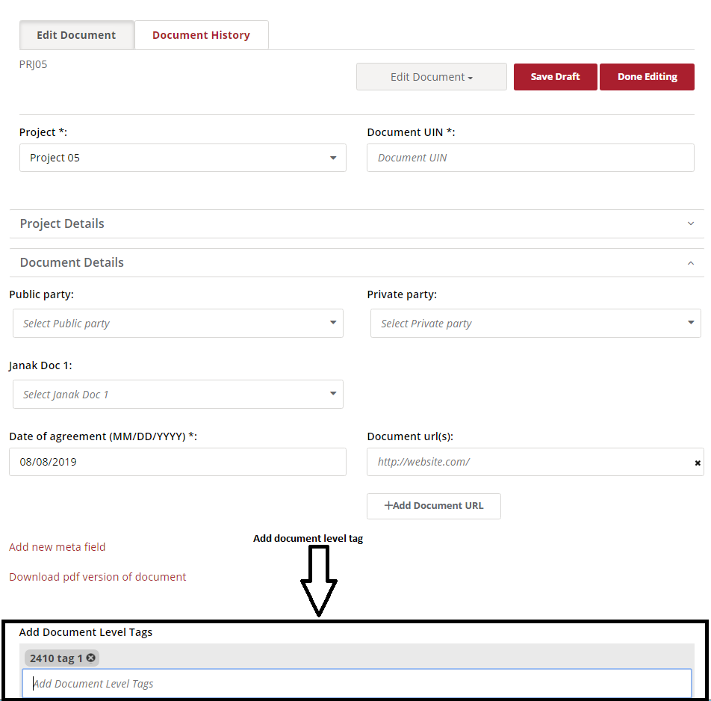

- We have add tag also document level.
- Please find above screen shots

Note:- we have to follow above project and document flow in New ILG which is implemented in P3 prototype.

