Contegra Implementation

Below step of implementation

Step: 1 DevIT will provide database View for result and Location of document directory.
Step: 2 Contegra team will take requirement and understanding of story to be implement.
Step: 3 dbIndexer will provide by Contegra team.
Step: 4 Contegra team will provide API project for dtsearch result pre-defined request and response
Step: 5 DevIT will integrate API project and display result.

Please consider below requirement of ILG project to display dtsearch result

Acceptance Criteria
- For each document appearing as a result of a keyword search, I can see the total number of matches that have been found for my keyword
  - The number of matches should be displayed
  - The keyword should be repeated
  - The above should result in the following string: [# of matches] matches for keyword(s): "[Keyword]"
- ​I can see the number of matches that have been found for my keyword inside document text
  - If there is at least one (1) keyword match inside the document's text, a link to view keyword excerpt(s) should be displayed
  - The number of such matches should also be displayed
  - The above should result in the following string: View keyword excerpt(s) [# of matches]
  - The behaviour of this link should not change from the current application
- I can see the number of matches that have been found for my keyword outside document text
  - If there is at least one (1) keyword match outside the document's text, a link to view keyword occurrence(s) should be displayed
  - The number of such matches should also be displayed
  - The above should result in the following string: View other keyword occurrences(s) [# of matches]
  - The behaviour of this link is detailed on #11637 Search by Keyword > Results > Keyword Matches > Other Keyword Occurrences

Below of screen shot for display dtsearch result.

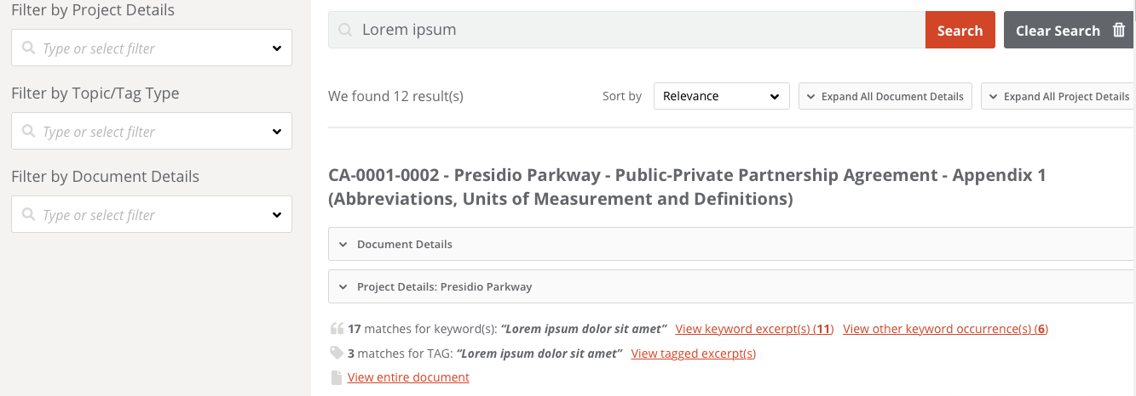

Wireframe: https://invis.io/4JTAJLMZ3HR#/376920027_SearchDocs_SCREEN_Keyword_Results (refer to the first result as it shows different links for keywords inside text and other occurrences)

Reference link as per TargetProcess:

https://industrialagency.tpondemand.com/RestUI/Board.aspx#page=board/5757498339396675872&appConfig=eyJhY2lkIjoiMUVBNzRGNTE4NTIwNjE3REEzNjU1QjNFREE2NjAzQ0IifQ==&boardPopup=userstory/11277/silent

https://industrialagency.tpondemand.com/RestUI/Board.aspx#page=board/5757498339396675872&appConfig=eyJhY2lkIjoiMUVBNzRGNTE4NTIwNjE3REEzNjU1QjNFREE2NjAzQ0IifQ==&boardPopup=userstory/19248/silent

https://industrialagency.tpondemand.com/RestUI/Board.aspx#page=board/5757498339396675872&appConfig=eyJhY2lkIjoiMUVBNzRGNTE4NTIwNjE3REEzNjU1QjNFREE2NjAzQ0IifQ==&boardPopup=userstory/11638/silent

