P3 – Prototype: Demo Manual
Contents
Background 2
1. PDF 3
2. Files 4
2.1. Tagging 4
3. TAG 9
3.1. Search Now 9
3.2. TAG 11

Background
P3 – Prototype is an application which provide following facility to user
- Upload PDF file and automatically converted into HTML file
- View and delete uploaded pdf files
- Add dynamic master tag
- Add, edit or delete tags on converted html files
- Perform search based on tag key words
- View searched tag content
User have to open below link in browser.
http://p3.demo.wwhnetwork.net
It will give 3 menu options at left side as below:

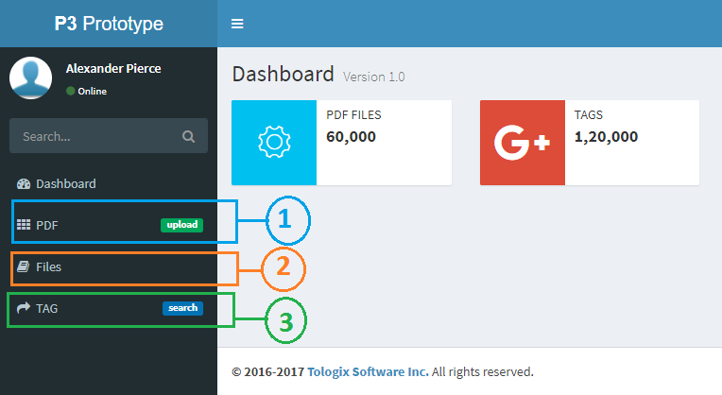
Figure: Home

Here, there are three options:
- PDF
- Files
- TAG

PDF
Using this option user can upload a pdf file and it will be converted into a HTML file.
Follow below step to achieve this functionality.
- Click on PDF menu on left side and below screen will display.

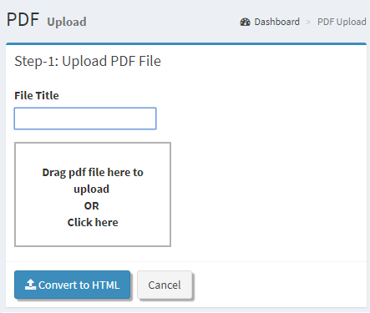
Figure: Upload PDF
- Write file title and brose or drag and drop pdf file.
- Click on convert to html

Files
Here, all uploaded PDF files will be listed and from here user can:
- View: Uploaded pdf file is separate tag
- Tagging: allows to add, edit or remove tags into HTML file
- Delete: Using it one can delete a file

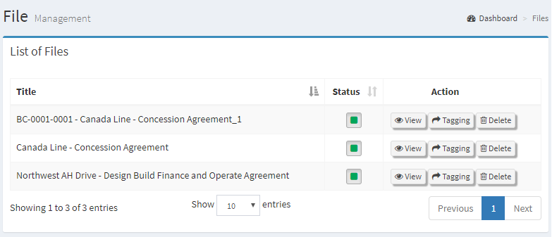
Figure: Uploaded files
Follow below step to achieve this functionality.
- Click on files on left menu.
- Above screen will display.

Tagging
Click on tagging button for tag on html file
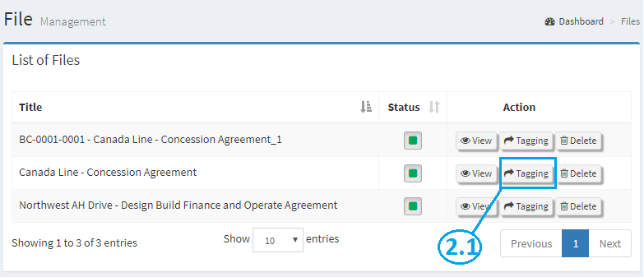

- After click on tagging html file display in html editor.
- User can insert new tag using insert tag button on html editor.

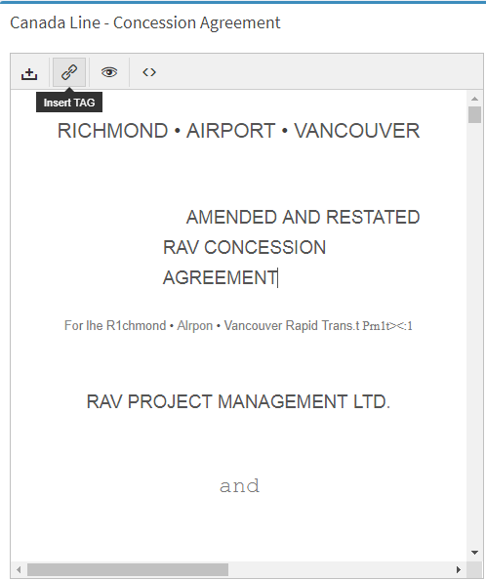

- After click on insert tag button popup will open and write master tag name.
- Then after click on ok button to save tag.

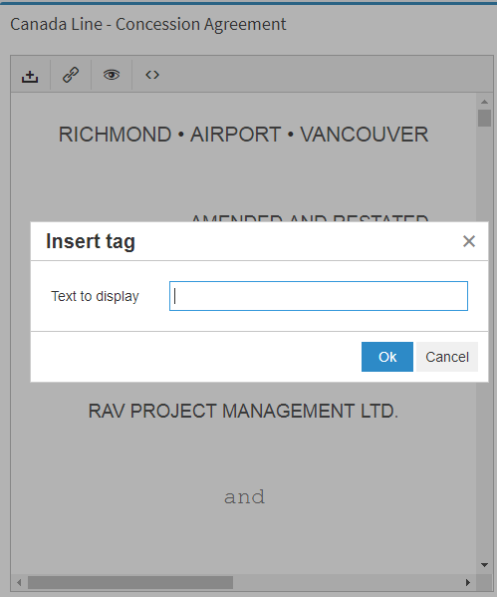

- To make tagging in html page, select content which you want to tag.
- Then after click on Add tag button on html editor and click on tag button for tagging.
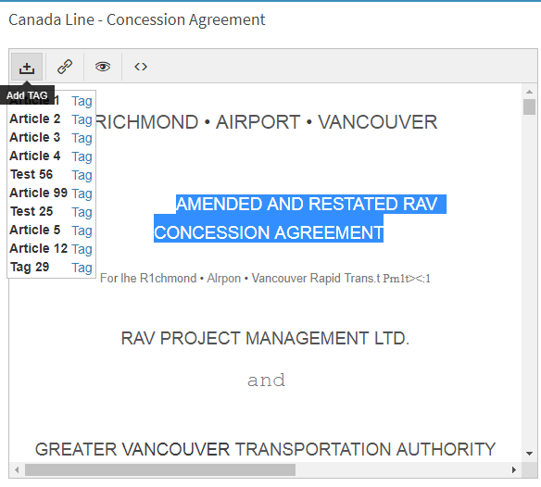

- After tag content display like as below.
- From here, actual tags can be add, edit or removed into HTML file

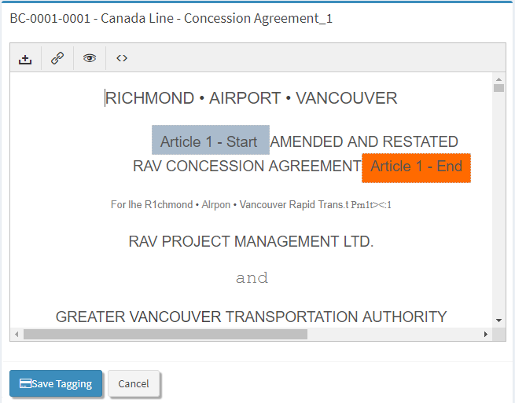
Figure: Save Tagging
After tagging, click on save button for save all tags.

TAG
It allows to perform searching based on search key words
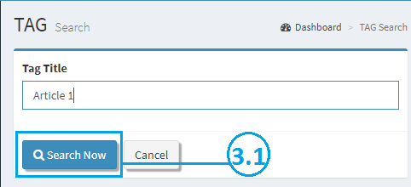
Figure: Search Tag

Search Now
From here user can:
File: allows to view PDF file in separate browser
TAG: allows to view particulate tag content

- To find particular Tag in all html files write Tag title and then after click on search now button.
- It will display all files which have tagging by tag title.

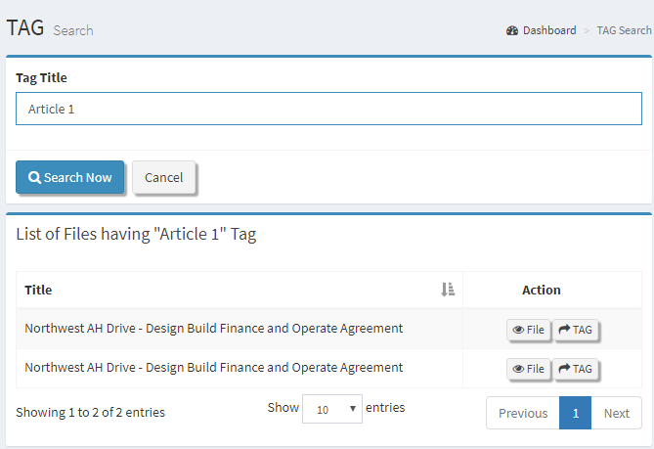
Figure: Tag Search

TAG

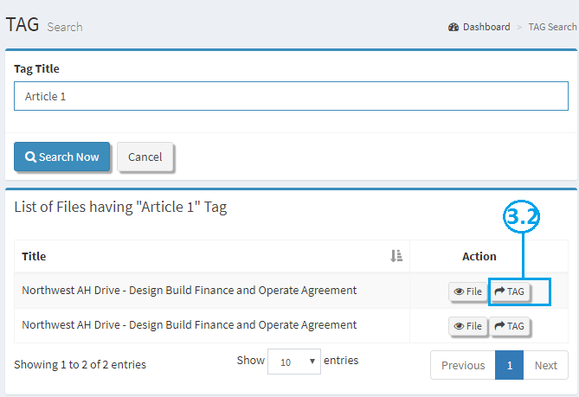
Figure: TAG View

To view Tag content, click on tag button which display details content of Tag.


Figure: TAG View

