To: Dhrumil Shah and DevIT Machine Learning Team
From: Morgan Maguire, Paul Moon and Nafiseh Arghandehpour
Date: 11 July 2019
Re: AuzureML based Auto-Suggest Prototype
This report purports to provide feedback on the new AzureML based auto-suggest search engine prototype available here: http://tologix.demo.wwhnetwork.net/ with a focus on the relevancy of suggested keywords, taking into consideration the scope of sample documents provided by Dhrumil (30 PDFs: https://islg.egnyte.com/fl/3TQtfWEsfo). In this report, the focus will be placed on whether the auto-suggest is providing suggestions that can be considered relevant or useful for front-end users. For this purpose, several terms and phrases that have a high frequency (appear at least three times in the sample PDF) and have a high importance to the area (based on subject-matter expertise) have been selected for testing.
- Review of the relevancy of suggested keywords
These are the selected terms and phrases used for testing:
- “Fair” in Fair and Equitable Treatment;
- “Treatment” in Most-Favored-Nation Treatment, National Treatment and Discriminatory Treatment;
- “Manifest” in Manifest Excess of Powers;
- “Due” in Due Process;
- “Denial” in Denial of Benefits;
- “Rule” in Additional Facility Rules; and
- “Provisional” in Provisional Measure.
The PDF Document UINs and the frequency of the above terms and phrases are as follows:
Terms/Phrase | UIN | Frequency
Fair and Equitable Treatment | IC/0160/02 | 25
Most-Favored-Nation Treatment | IC/0160/02 | 14
National Treatment | AF/0004/08 | 3
Discriminatory Treatment | AF/0004/08 | 5
Manifest Excess of Powers | IC/0135/03 | 8
Due Process | IC/0135/03 | 7
Denial of Benefits | IC/0051/11 | 11
Additional Facility Rules | AF/0009/09 | 5
Provisional Measure | AF/0009/09 | 4

Also, in order to provide a better understanding of what the expected results of the auto-suggest search should be, a comparison has been made between Contegra and the Azure ML search. It is duly note that the sample of documents for Contegra is much larger than the Azure ML, which have an affect on our ability to make comparisons of the tools.
Please note the list includes two examples of keywords with connector words (“Fair and Equitable Treatment” and “Denial of Benefits”) which appear frequently in the 30 PDF samples. They are expected to appear in the search results.
- Results:

“Fair” in Fair and Equitable Treatment:
AzureML:
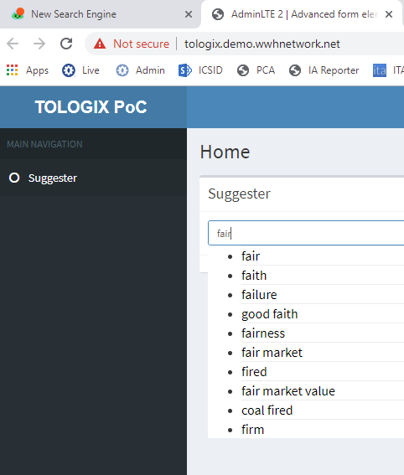
Contegra:
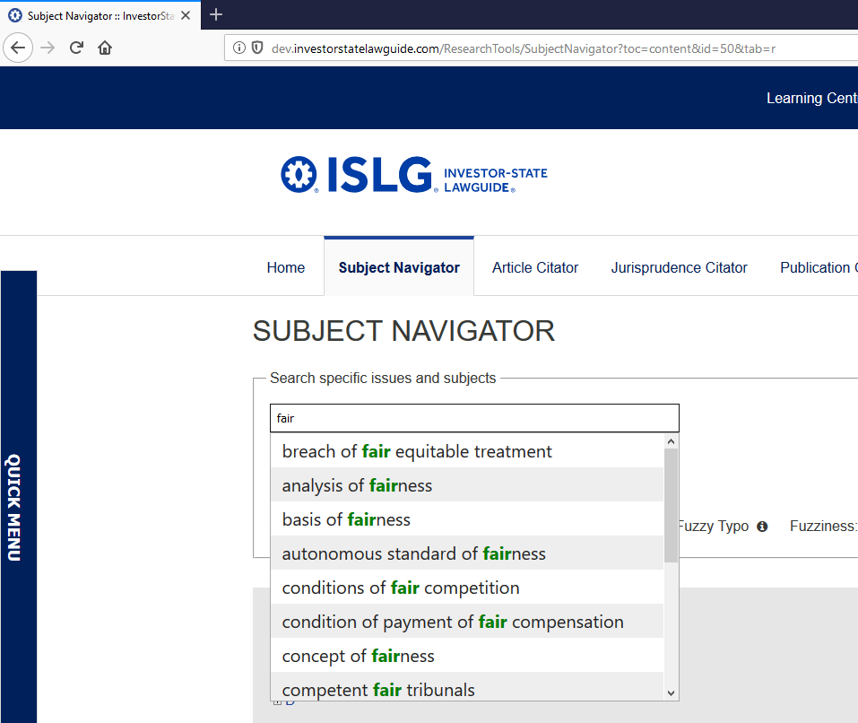
Summary: “fair and equitable treatment” is missing from results. Azure ML does not include any phrases with connector words (“and”, “of”, “or”, etc.). AzureML include terms with spelling variations of inputted term (e.g., “faith”, “fired”, etc.).

“Treatment” in “Most-Favored-Nation Treatment”, “National Treatment” and “Discriminatory Treatment”:
AzureML:
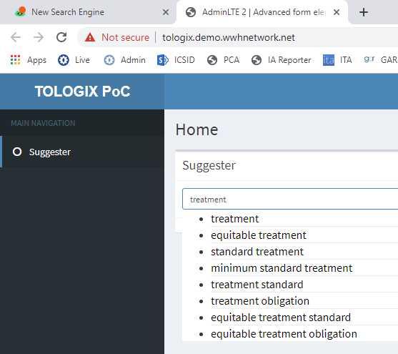
Contegra:
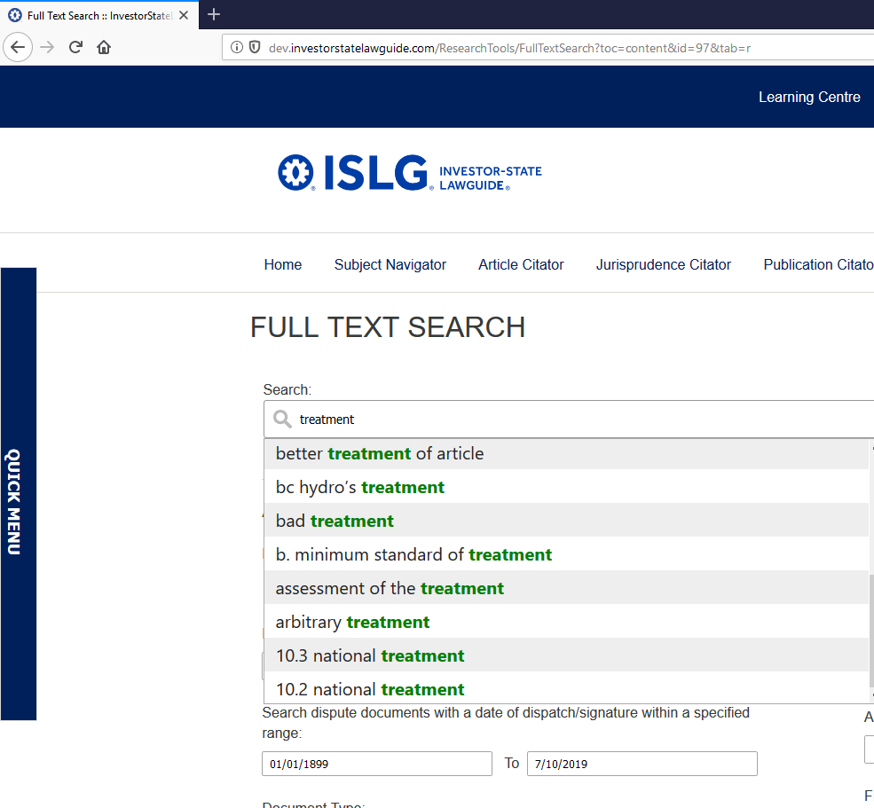
Summary: Notable phrases are missing: “most-favored-nation treatment”, “national treatment” and “discriminatory treatment”.

“Manifest” in Manifest Excess of Powers:
AzureML:
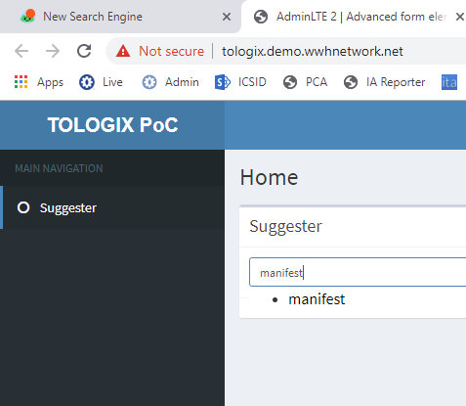
Contegra:
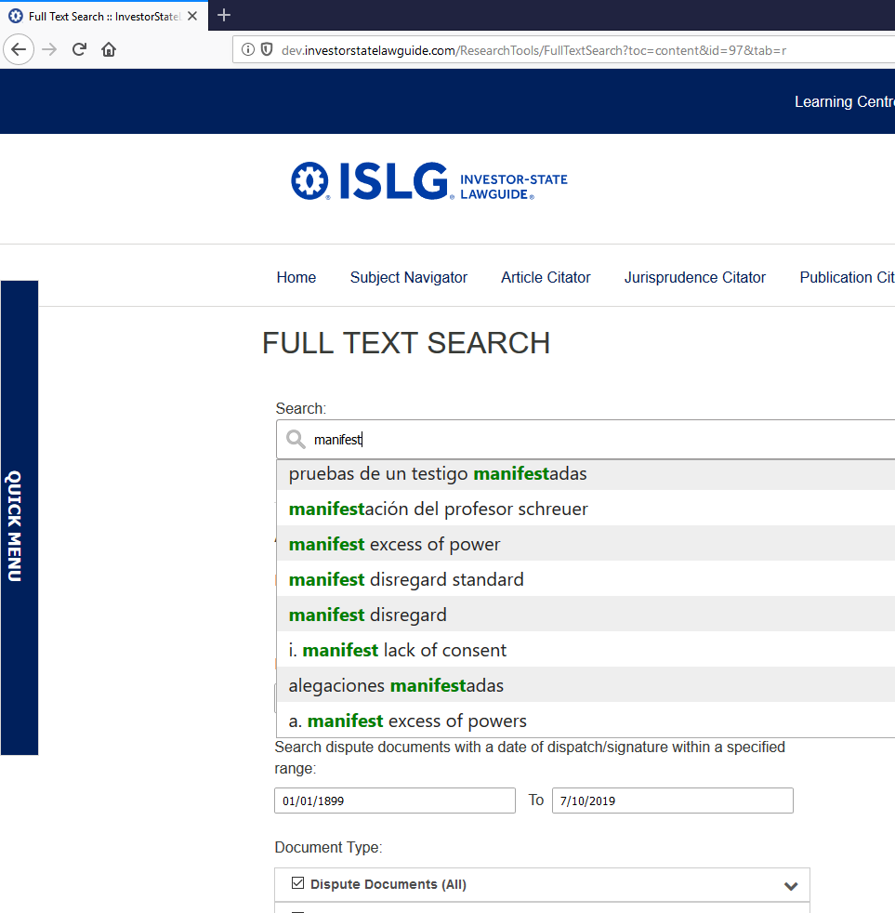
Summary: Anything beyond “manifest…” is missing from AzureML. Contegra include “manifest excess of power”.

“Due” in Due Process:
AzureML:
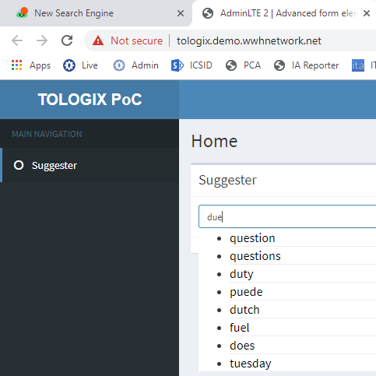
Contegra:
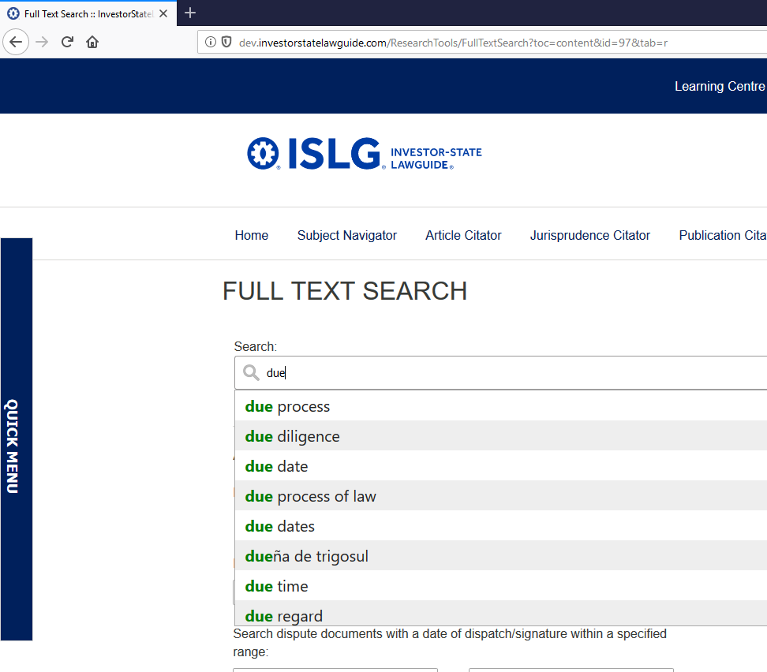
Summary: AzureML omitted to include any suggested terms or phrases that included “due”. Contegra include “due process”.

“Denial” in Denial of Benefits:
AzureML:
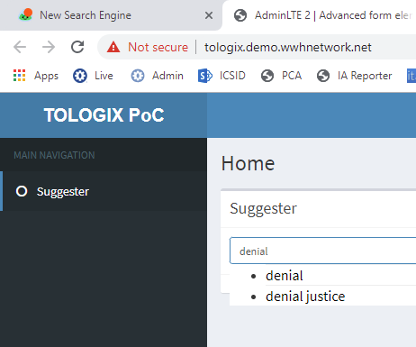
Contegra:
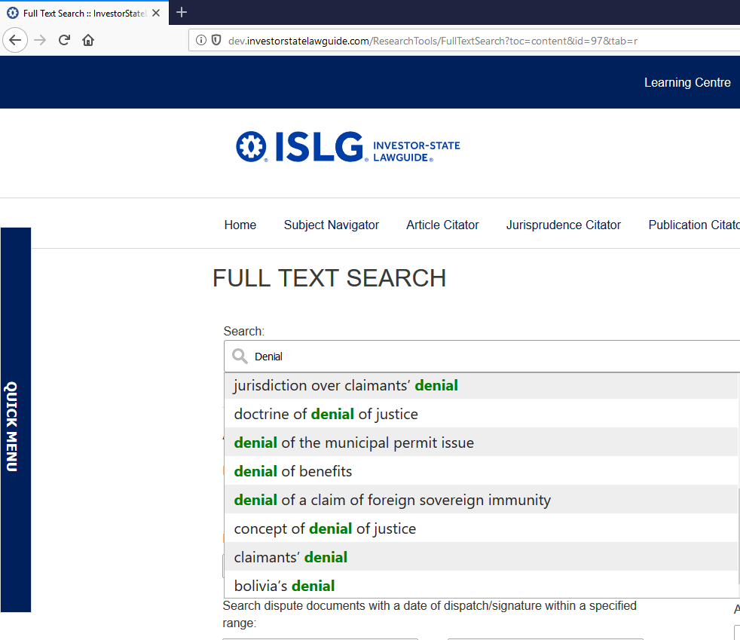
Summary: AzureML is missing connector word “of” for “denial of justice”.

“Rule” in Additional Facility Rules:
AzureML:
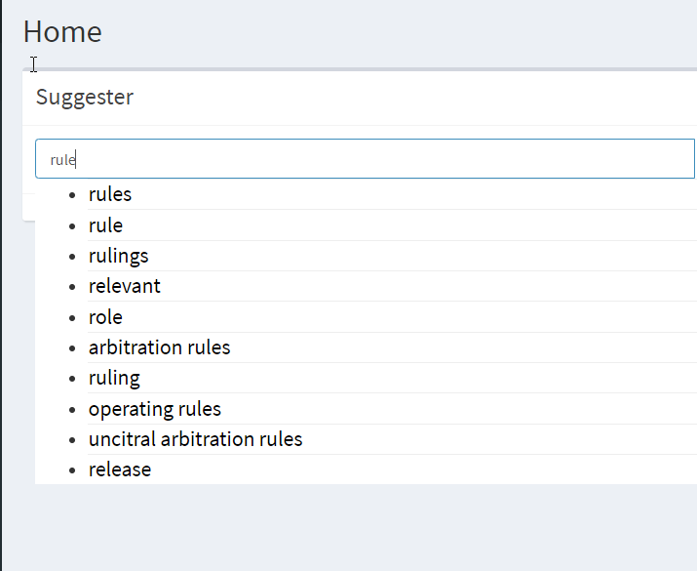
Contegra:
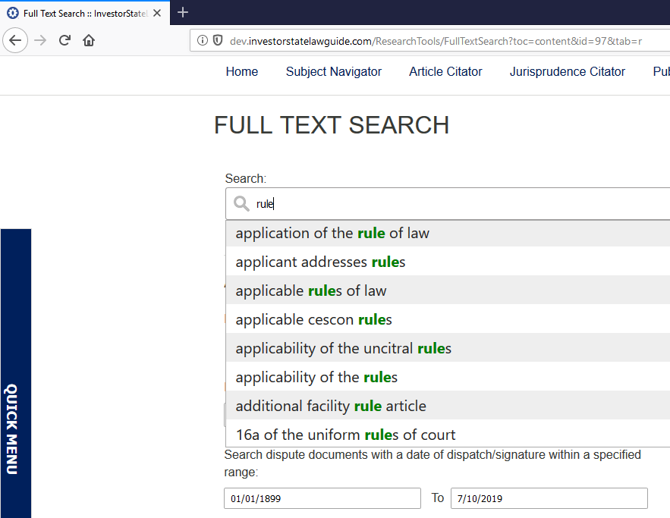
Summary: reasonable relevant results from both, but missing “Additional Facility Rules”.

“Provisional” in Provisional Measure:
AzureML:
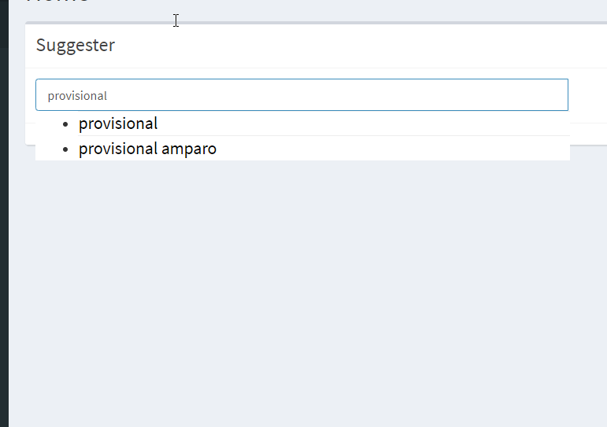
Contegra:
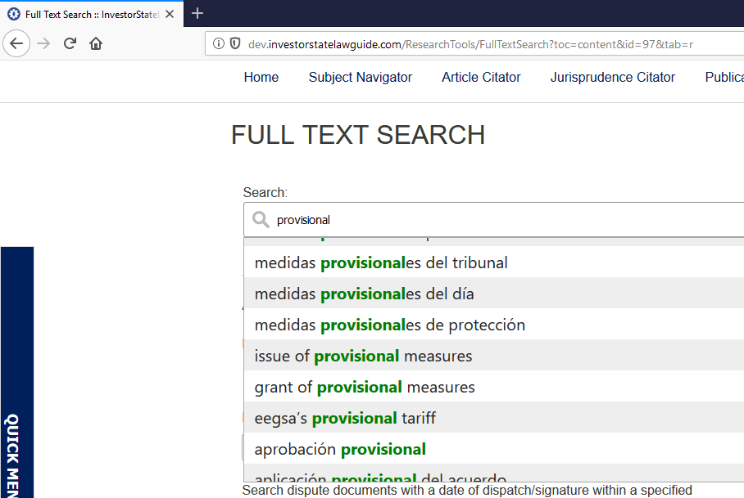
Summary: AzureML missing “provisions measure” but include random phrases of “provisional amparo”.
- Other Issues
In addition to the auto-suggest function and the search results that are expected to be found, there are some search results that seem irrelevant to the keywords as well as some typos as shown in examples below:

- “Rlge article”:
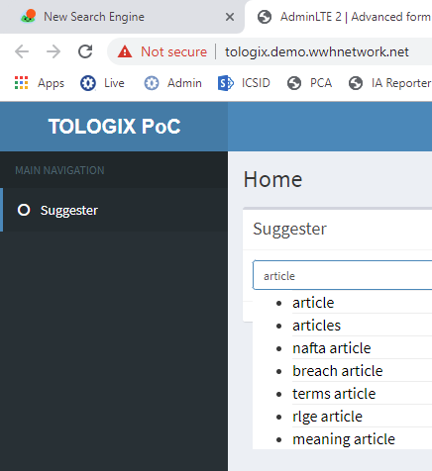

Services public version confidential February 26:

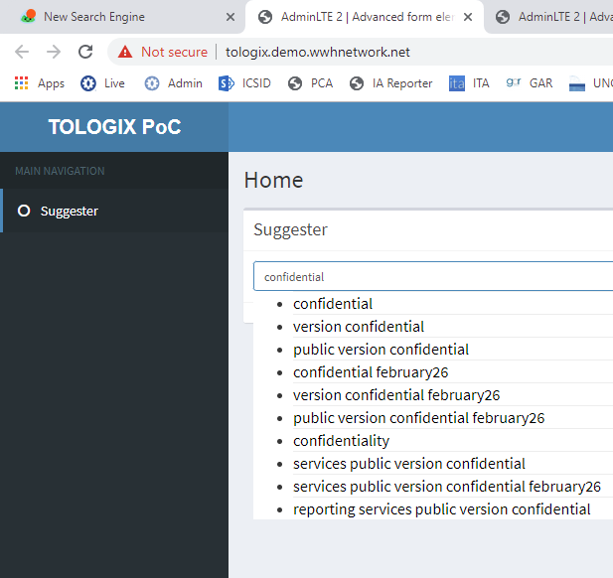

Lower, lack, largest, …:

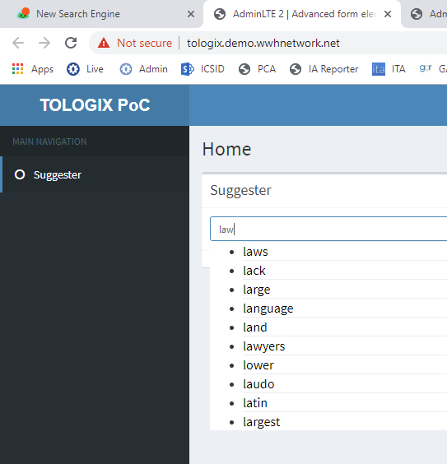

Climate change, climate leadership plan, ….:

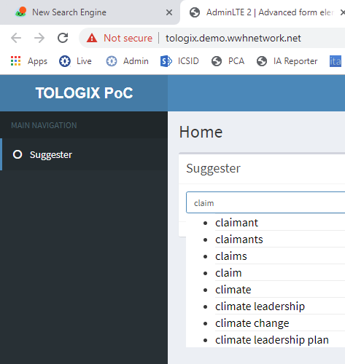

Contegra auto-suggest search has been integrated into the searches powered by dtSearch (Subject Navigator and Full Text Search) on the development environment for the current ISLG application (dev.investorstatelawguide.com).

