Analyze /Tagging Approach

Following approach, we will be used to achieved current ISLG tagged/cited data after migration in Analyzing/Tagging functionality of new ISLG application.

- Step 1: - The converted HTML will be rendered when any admin user select Analyze Data Capture task.

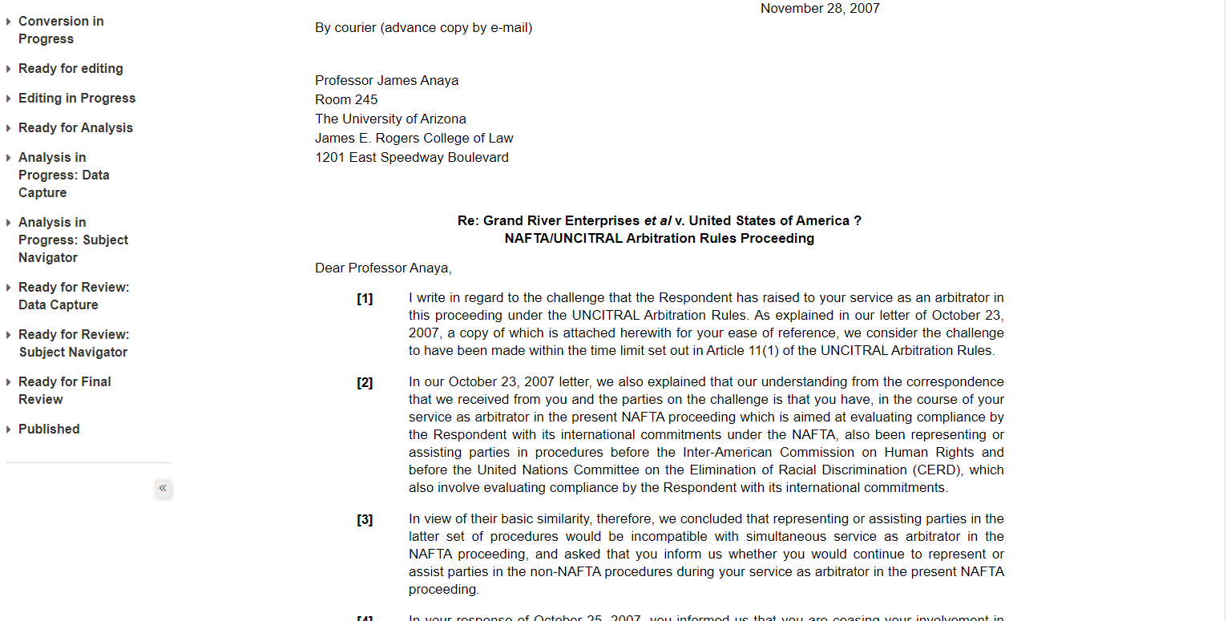

- Step 2: - When admin user will select any text or parapgh from HTML that time we will fetch all Paragraphs and Footnotes by Getselection () method Ranges.

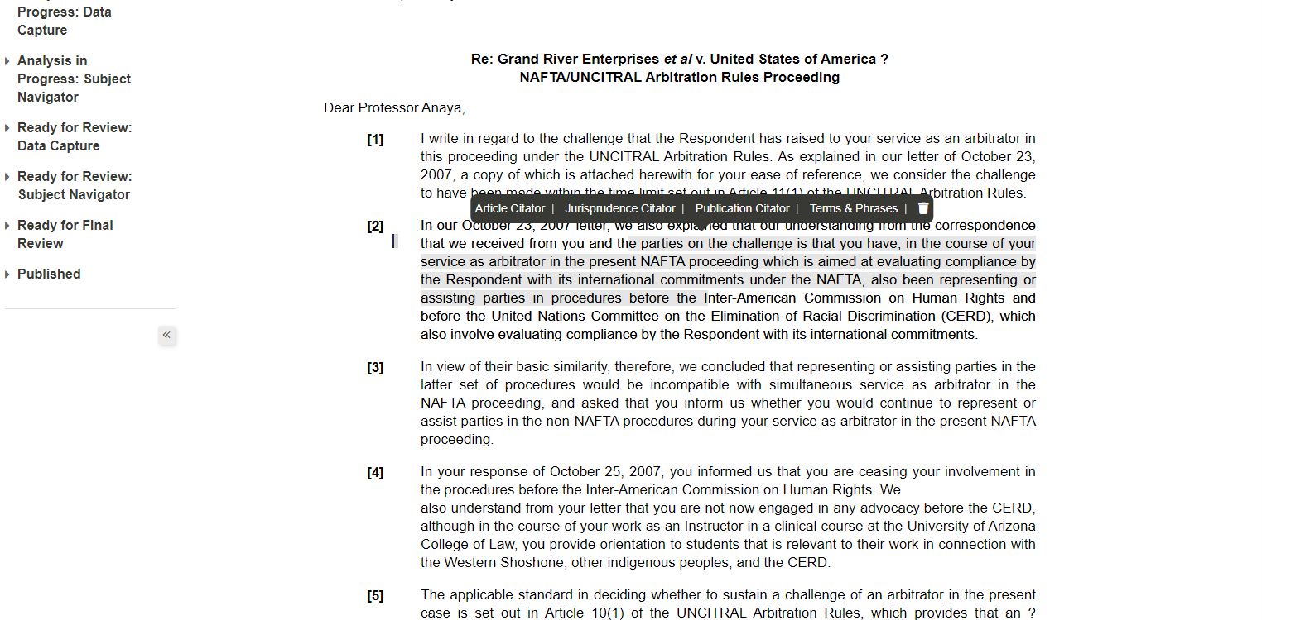

- Step 3: - If user select any text or paragraph that time we will create clone of whole paragraph.

- Following, the purpose of why we are creating the clone of selected paragraph.

- Run time highlighted the paragraph or text
- This clone will be useful while we migrate old ISLG data

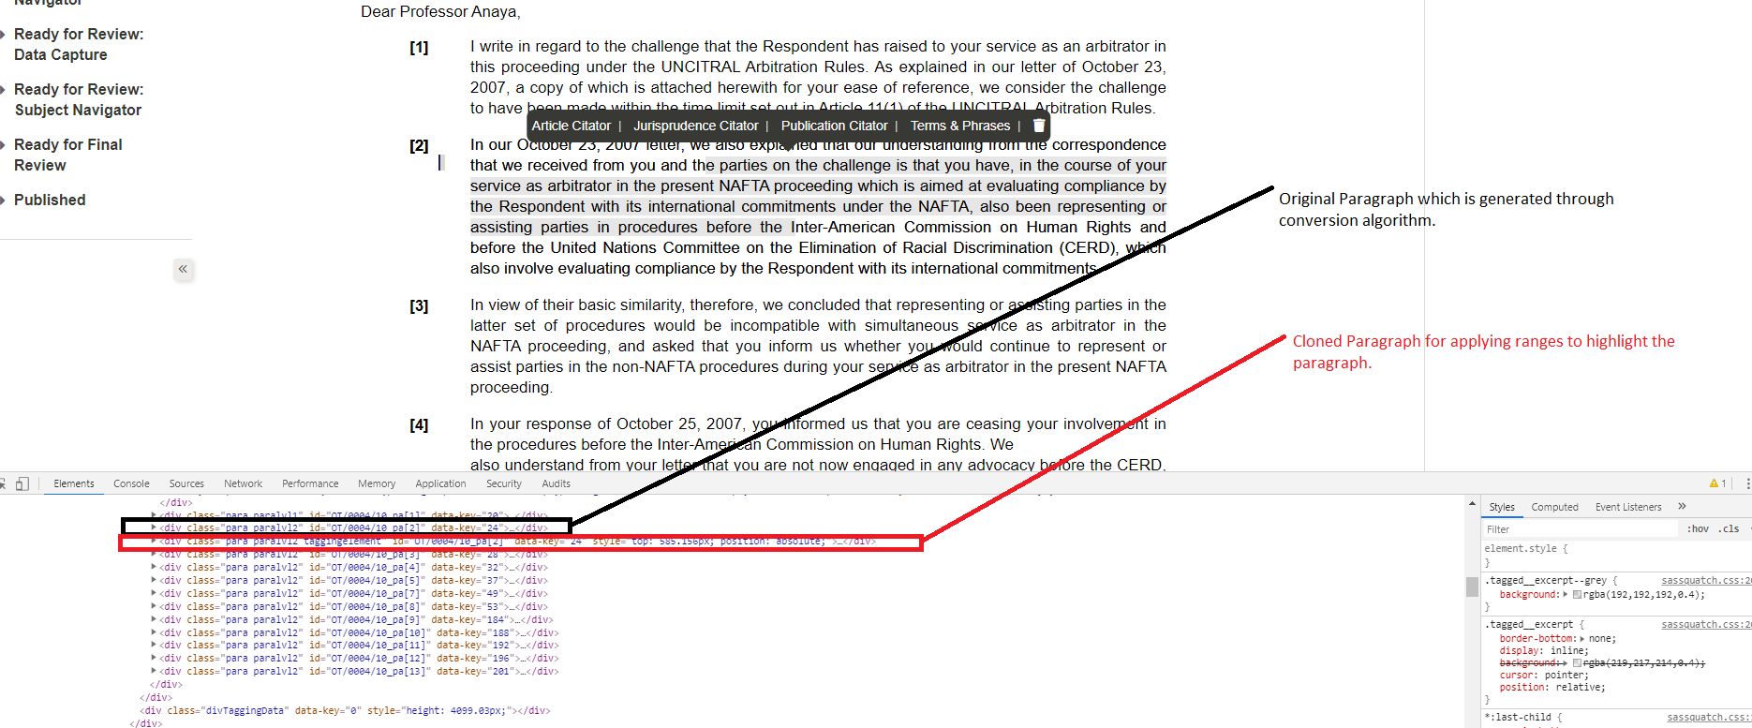

- Step 4: - We will apply ranges to particular selected cloned paragraph. By using those ranges, we will get Start Element and End Element of selected cloned Paragraph.

- Step 5: - We will insert those Start Element and End Element in to our database.

- Step 6: - By using those Start Element and End Element, Run time again we will be highlighted the selected paragraph or text.

Thanks

