To: Industrial
From: Morgan
Date: 6 July 2020
Re: Data Visualization
This document provides a description of the different data visualizations required for the new ISLG application. Generally, we want data visualizations to appear on the main legal analytics pages (Dispute Analytics, People Analytics, Organization Analytics and Country Analytics) and then as well on the individual profile pages (Individual People Profile and Individual Organization Profile).

Dispute Analytics
Wireframe: https://projects.invisionapp.com/share/JET7XMPSQFW#/screens/418984873
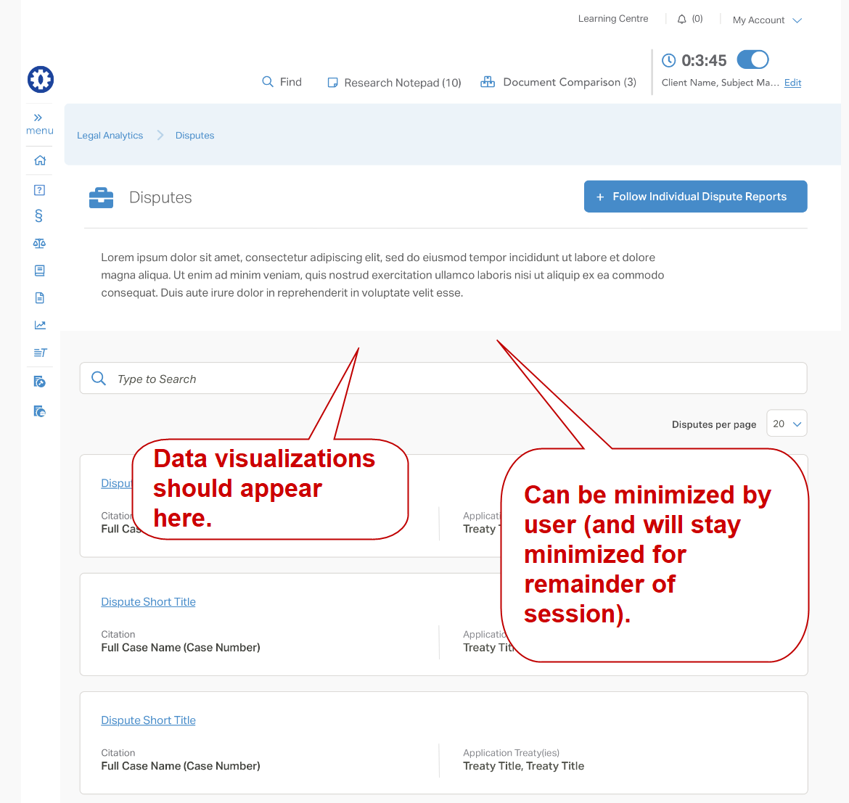
- Applicable Treaties (pie chart)
  - Pulls data from Disputes: Applicable Treaty and presents the number of disputes based on the Treaties: Treaty Type
    - International Treaties & Rules
    - Bilateral Investment Treaties (BITs)
    - Free Trade Agreement (FTAs)
    - NAFTA
    - Regional/Sectoral Agreements
    - National Investment Law
    - Other
- Applicable Rules (pie chart)
  - Pulls data from Disputes: Applicable Arbitration Rules and presents the number of disputes based on the Arbitration Rules: Issuing Organization (display acronym only)
    - Cairo Regional Centre for International Commercial Arbitration = CRCICA
    - International Chamber of Commerce = ICC
    - International Centre for Settlement of Investment Disputes = ICSID
    - London Court of International Arbitration = LCIA
    - Moscow Chamber of Commerce and Industry = MCCI
    - Permanent Court of Arbitration = PCA
    - Stockholm Chamber of Commerce = SCC
    - United Nations Commission on International Trade Law = UNCITRAL
- Respondent State (pie chart)
  - Pulls data from Disputes: Respondent State and presents the number of disputes based on the Country: Region
    - East Asia and Pacific
    - Europe and Central Asia
    - Latin America & the Caribbean
    - Middle East and North Africa
    - North America
    - South Asia
    - Sub-Saharan Africa
- Claimant Nationalities (pie chart)
  - Pulls data from Disputes: Claimant(s) > Nationality and presents the number of disputes based on the Country: Region
    - East Asia and Pacific
    - Europe and Central Asia
    - Latin America & the Caribbean
    - Middle East and North Africa
    - North America
    - South Asia
    - Sub-Saharan Africa

Individual People Profile
Wireframe: https://projects.invisionapp.com/share/JET7XMPSQFW#/screens/418796771
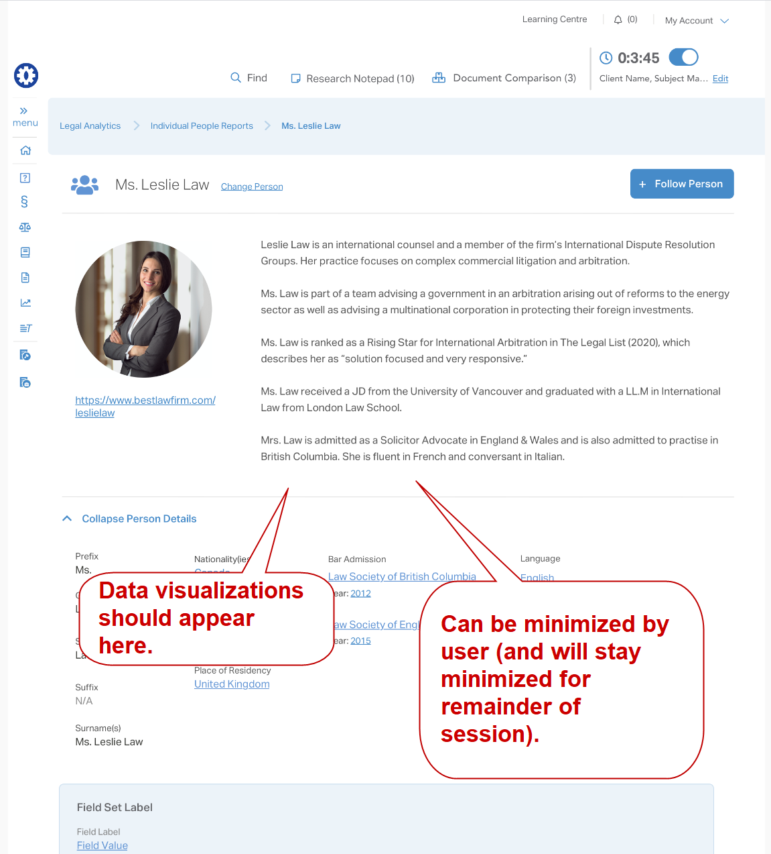

- Roles (pie chart)
  - Pulls data from Experience: Roles report (Roles (combined fields) and presents the number of disputes based on roles:
    - Counsel (Claimant)
    - Counsel (Respondent)
    - Tribunal Secretary
    - Arbitrator (President)
    - Arbitrator
    - Annulment Committee Member (President)
    - Annulment Committee Member
    - Expert
- Applicable Treaties (pie chart)
  - Pulls data from Disputes: Applicable Treaty and presents the number of disputes based on the Treaties: Treaty Type where that person is associated with the dispute
    - International Treaties & Rules
    - Bilateral Investment Treaties (BITs)
    - Free Trade Agreement (FTAs)
    - NAFTA
    - Regional/Sectoral Agreements
    - National Investment Law
    - Other
- Applicable Rules (pie chart)
  - Pulls data from Disputes: Applicable Arbitration Rules and presents the number of disputes based on the Arbitration Rules: Issuing Organization (display acronym only) where that person is associated with the dispute
    - Cairo Regional Centre for International Commercial Arbitration = CRCICA
    - International Chamber of Commerce = ICC
    - International Centre for Settlement of Investment Disputes = ICSID
    - London Court of International Arbitration = LCIA
    - Moscow Chamber of Commerce and Industry = MCCI
    - Permanent Court of Arbitration = PCA
    - Stockholm Chamber of Commerce = SCC
    - United Nations Commission on International Trade Law = UNCITRAL

