To: Industrial
From: Morgan
Date: 7 July 2020
Re: Data Visualization
This document provides a description of the different data visualizations required for the new ISLG application. We want data visualizations to appear on the main legal analytics pages (Dispute Analytics, People Analytics, Organization Analytics and Country Analytics) and then as well on the individual profile pages (Individual People Profile and Individual Organization Profile).
Note for that each data visualization should be clickable, which will lead the user to the applicable report within Legal Analytics.

Dispute Analytics
Wireframe: https://projects.invisionapp.com/share/JET7XMPSQFW#/screens/418984873
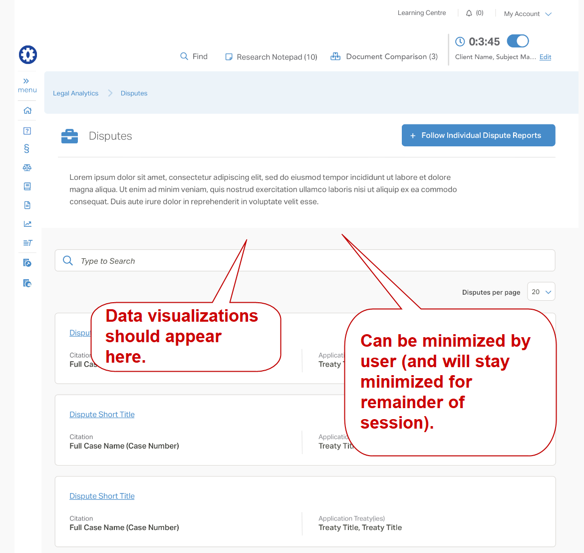
- Applicable Treaties (pie chart)
  - Pulls data from Disputes: Applicable Treaty and presents the number of disputes based on the Treaties: Treaty Type
    - International Treaties & Rules
    - Bilateral Investment Treaties (BITs)
    - Free Trade Agreement (FTAs)
    - NAFTA
    - National Investment Law
    - Regional/Sectoral Agreements
    - Other
- Applicable Rules (pie chart)
  - Pulls data from Disputes: Applicable Arbitration Rules and presents the number of disputes based on the Arbitration Rules: Issuing Organization (display acronym only)
    - Cairo Regional Centre for International Commercial Arbitration = CRCICA
    - International Chamber of Commerce = ICC
    - International Centre for Settlement of Investment Disputes = ICSID
    - London Court of International Arbitration = LCIA
    - Moscow Chamber of Commerce and Industry = MCCI
    - Permanent Court of Arbitration = PCA
    - Stockholm Chamber of Commerce = SCC
    - United Nations Commission on International Trade Law = UNCITRAL
- Respondent State (pie chart)
  - Pulls data from Disputes: Respondent State and presents the number of disputes based on the Country: Region
    - East Asia and Pacific
    - Europe and Central Asia
    - Latin America & the Caribbean
    - Middle East and North Africa
    - North America
    - South Asia
    - Sub-Saharan Africa
- Claimant Nationalities (pie chart)
  - Pulls data from Disputes: Claimant(s) > Nationality and presents the number of disputes based on the Country: Region
    - East Asia and Pacific
    - Europe and Central Asia
    - Latin America & the Caribbean
    - Middle East and North Africa
    - North America
    - South Asia
    - Sub-Saharan Africa

People Analytics
Wireframe: https://projects.invisionapp.com/share/JET7XMPSQFW#/screens/418987641
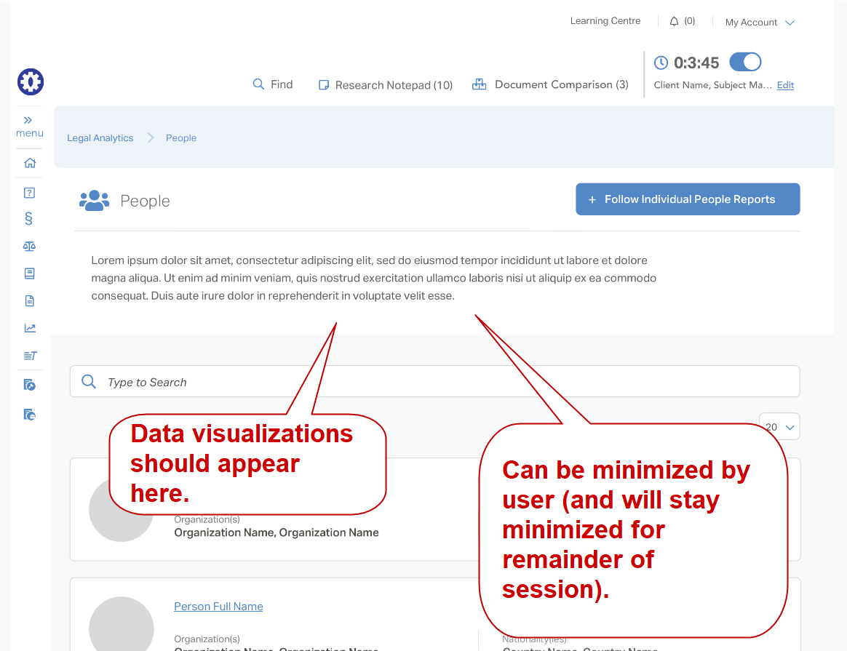
- Roles (pie chart)
  - Pulls data from Disputes and presents the number of People with the following roles:
    - Counsel (Claimant)
    - Counsel (Respondent)
    - Tribunal Secretary
    - Arbitrator (President)
    - Arbitrator
    - Annulment Committee Member (President)
    - Annulment Committee Member
    - Expert
- Nationalities (pie chart)
  - Pulls data from People: Nationality and presents the top 10 nationalities (based on the number of People with the country assigned as the nationality) and then aggregates the remaining countries as “Other”
  - For example
    - United States = 86
    - United Kingdom = 48
    - France = 40
    - Germany = 27
    - Switzerland = 23
    - Mexico = 22
    - Canada = 21
    - Sweden = 13
    - Argentina = 13
    - Australia = 13
    - Other = 284

Organization Analytics
Wireframe: https://projects.invisionapp.com/share/JET7XMPSQFW#/screens/418987642
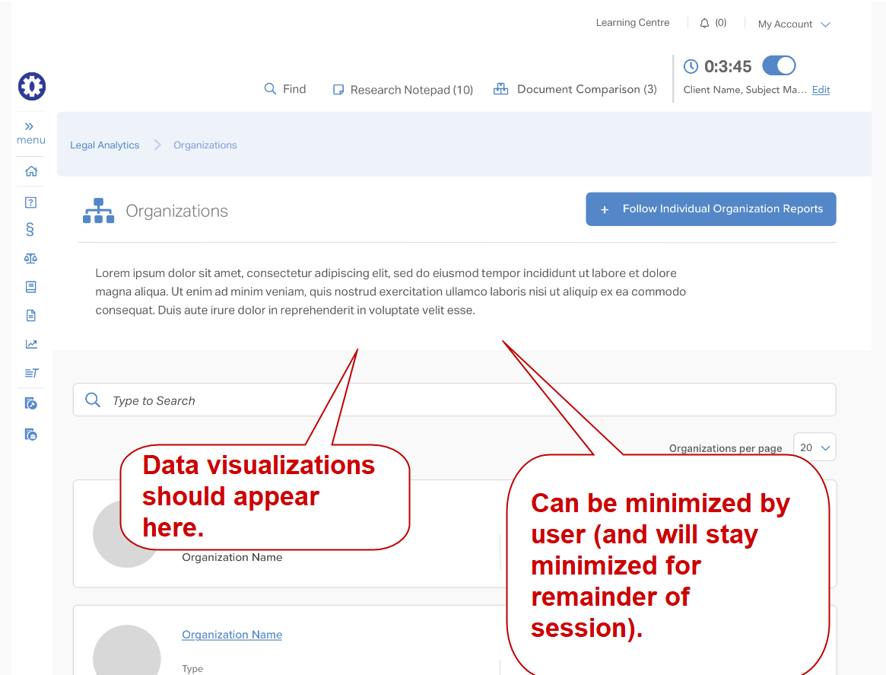
- Types (pie chart)
  - Pulls data from Organizations: Type and presents the number of Organizations for each type:
    - Law Firm
    - Private Enterprise
    - Third Party Fund
    - Government
    - Non-Profit
    - Other
- Most Disputes (Top 10) (pie chart)
  - Pulls data from Disputes and presents the top 10 organizations based on the number of disputes the organization is associated with.
  - For example:
    - Freshfields Bruckhaus Deringer LLP = 64
    - White & Case LLP = 54
    - King & Spalding LLP = 51
    - Foley Hoag LLP = 42
    - Procurador del Tesoro/Procuración del Tesoro (Argentina) = 40
    - Arnold & Porter LLP = 40
    - Essex Court Chambers = 32
    - Allen & Overy = 31
    - Curtis Mallet-Prevost, Colt & Mosle LLP = 30
    - Attorney General (Venezuela) = 29

Country Analytics
Wireframe: https://projects.invisionapp.com/share/JET7XMPSQFW#/screens/418991050
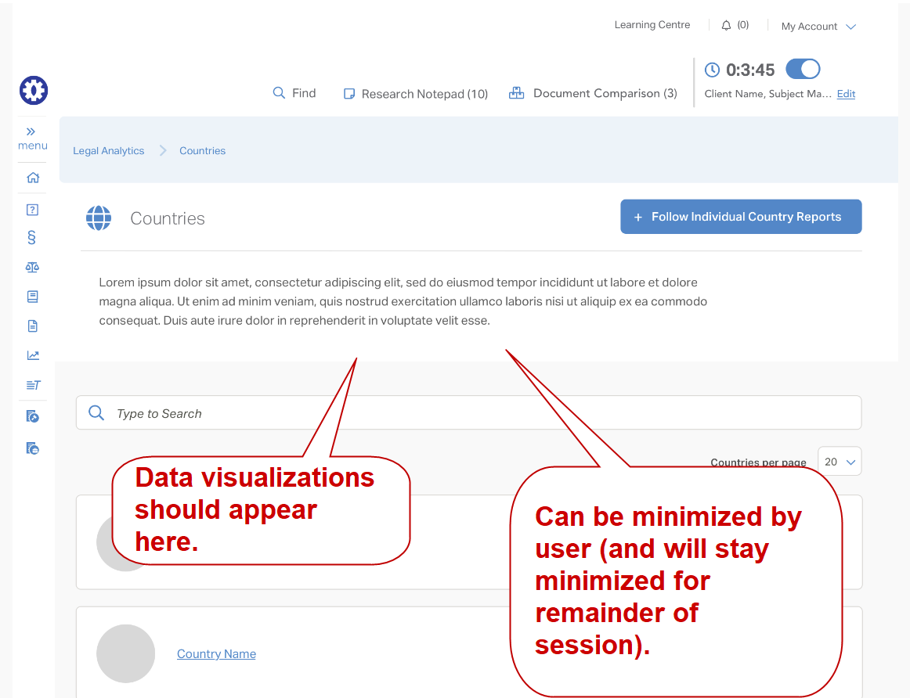

- Most Disputes (Top 10) (pie chart)
  - Pulls data from Disputes: Respondent State and presents the top 10 countries associated with disputes
  - For example
    - Argentina = 45
    - Venezuela = 43
    - Mexico = 37
    - Canada = 34
    - Czech Republic = 32
    - Spain = 31
    - United States = 24
    - Ecuador = 23
    - Russia = 20
    - Ukraine = 19
- Most Treaties (Top 10) (pie chard)
  - Pulls data from Treaties: Parties to the Treaty and presents the top 10 countries associated with treaties
  - For example
    - United Kingdom = 115
    - United States = 111
    - Belgium = 97
    - Luxembourg = 96
    - Spain = 92
    - Canada = 91
    - Germany = 82
    - Indonesia = 73
    - Netherlands = 63
    - France = 68

Individual People Profile
Wireframe: https://projects.invisionapp.com/share/JET7XMPSQFW#/screens/418796771
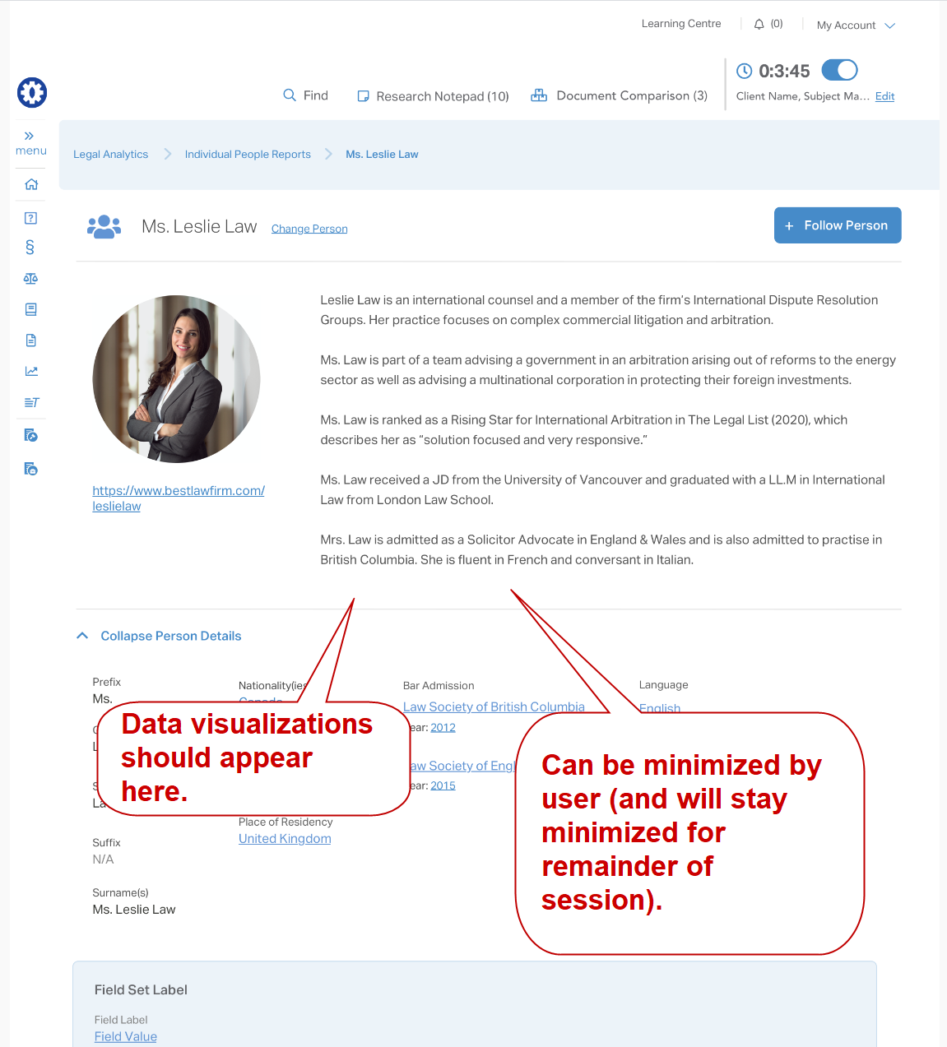

- Disputes (Dispute icon with number)
  - Pulls data from Disputes (combined fields) and displays the total number of disputes the person has been associated with.
- Roles (pie chart)
  - Pulls data from Experience: Roles report (Roles (combined fields) and presents the number of disputes based on roles:
    - Counsel (Claimant)
    - Counsel (Respondent)
    - Tribunal Secretary
    - Arbitrator (President)
    - Arbitrator
    - Annulment Committee Member (President)
    - Annulment Committee Member
    - Expert
- Applicable Treaties (pie chart)
  - Pulls data from Disputes: Applicable Treaty and presents the number of disputes based on the Treaties: Treaty Type where that person is associated with the dispute
    - International Treaties & Rules
    - Bilateral Investment Treaties (BITs)
    - Free Trade Agreement (FTAs)
    - NAFTA
    - Regional/Sectoral Agreements
    - National Investment Law
    - Other
- Applicable Rules (pie chart)
  - Pulls data from Disputes: Applicable Arbitration Rules and presents the number of disputes based on the Arbitration Rules: Issuing Organization (display acronym only) where that person is associated with the dispute
    - Cairo Regional Centre for International Commercial Arbitration = CRCICA
    - International Chamber of Commerce = ICC
    - International Centre for Settlement of Investment Disputes = ICSID
    - London Court of International Arbitration = LCIA
    - Moscow Chamber of Commerce and Industry = MCCI
    - Permanent Court of Arbitration = PCA
    - Stockholm Chamber of Commerce = SCC
    - United Nations Commission on International Trade Law = UNCITRAL

Individual Organization Profile
Wireframe: https://projects.invisionapp.com/share/JET7XMPSQFW#/screens/418796773
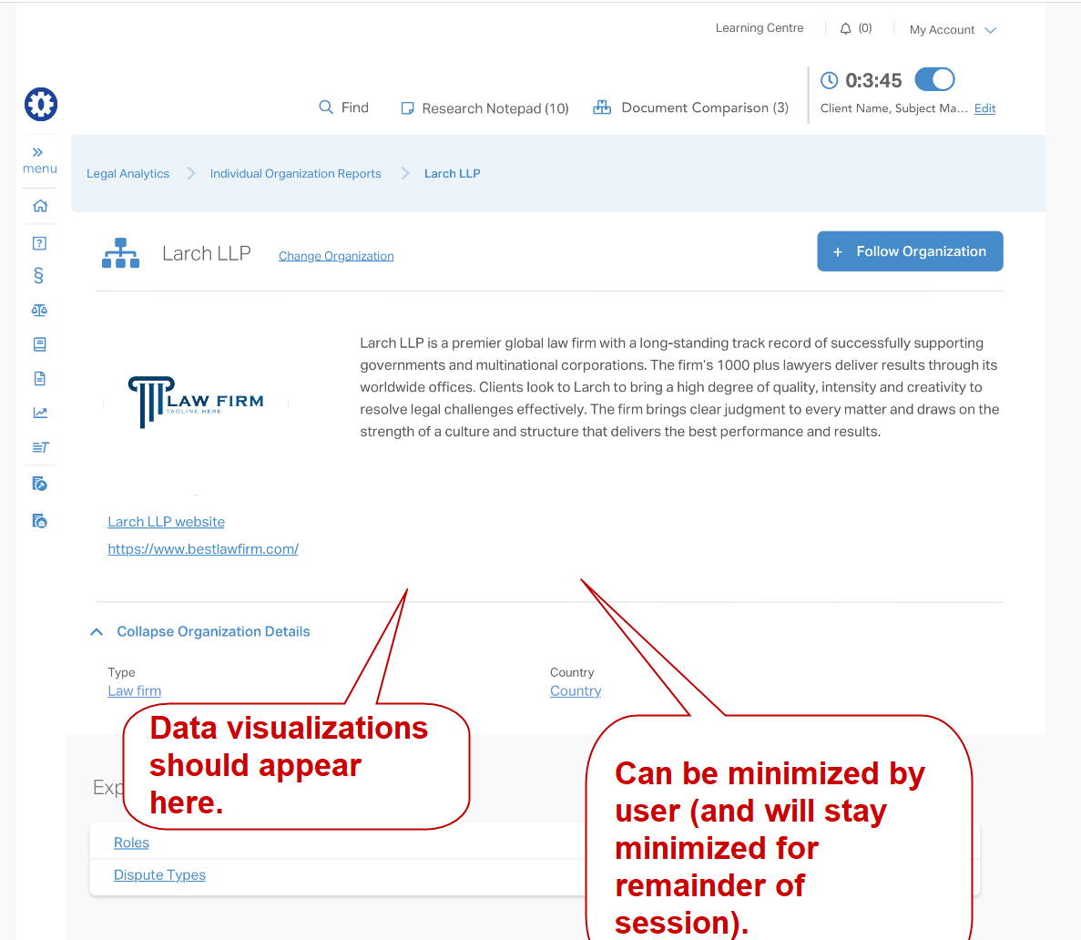
- Disputes (Dispute icon with number)
  - Pulls data from Disputes (combined fields) and displays the total number of disputes the organization has been associated with.
- Roles (pie chart)
  - Pulls data from Experience: Roles report (Roles (combined fields) and presents the number of disputes based on roles:
    - Counsel (Claimant)
    - Counsel (Respondent)
    - Expert
- People (People icon with number)
  - Pulls data from People: Organization(s) and displays to total number of people associated with the organization.

