ARB/0056
Master Lists, Dispute Documents, UN/0015/03, Analysis List, Article Citator

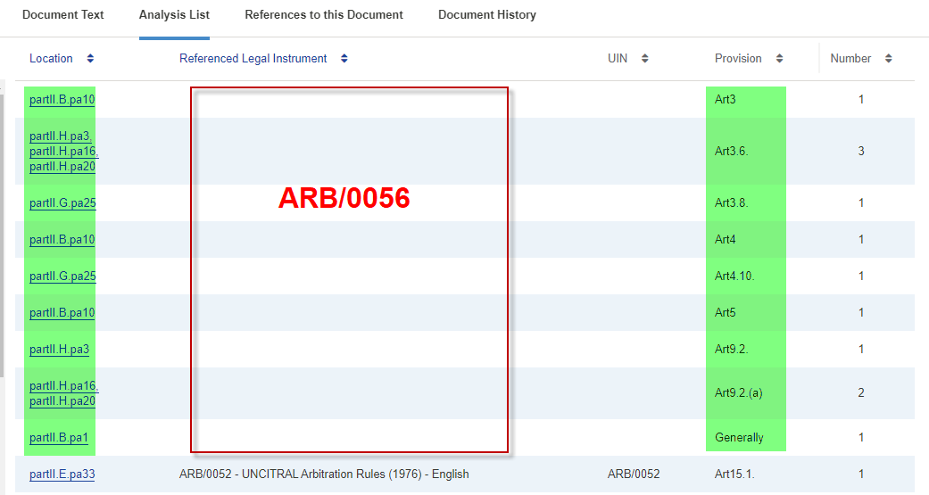
Master Lists, Dispute Documents, IC/0079/01, Analysis List, Article Citator

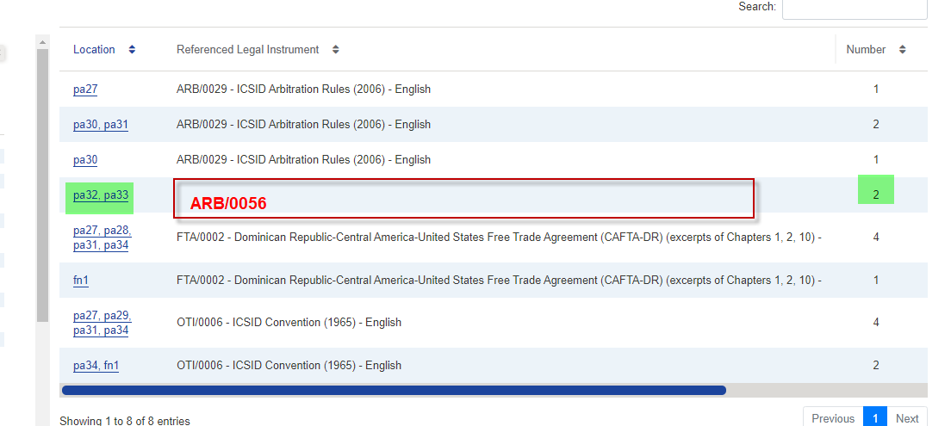

Master Lists, Dispute Documents, UN/0005/01, Analysis List, Article Citator

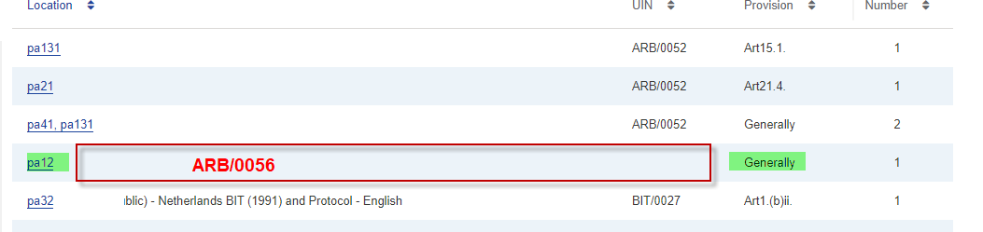

Master Lists, Dispute Documents, AF/0017/01, Analysis List, Article Citator
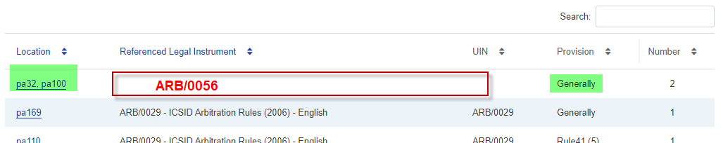

Master Lists, Dispute Documents, UN/0035/01, Analysis List, Article Citator

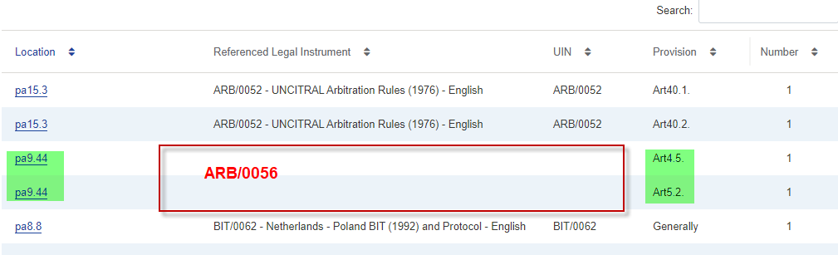

Master Lists, Dispute Documents, IC/0131/01, Analysis List, Article Citator

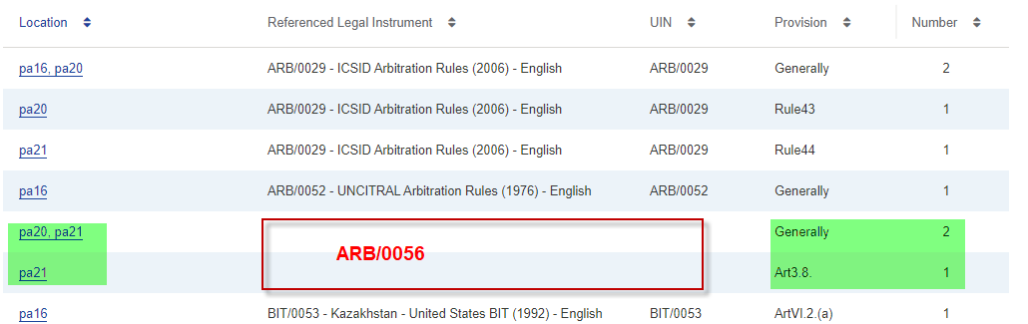

Master Lists, Dispute Documents, UN/0029/22, Analysis List, Article Citator
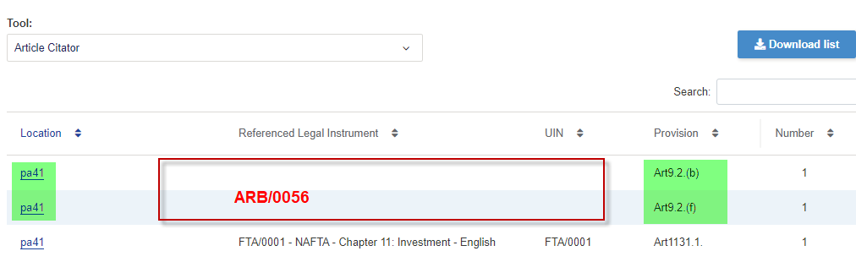

Master Lists, Dispute Documents, UN/0031/21, Analysis List, Article Citator
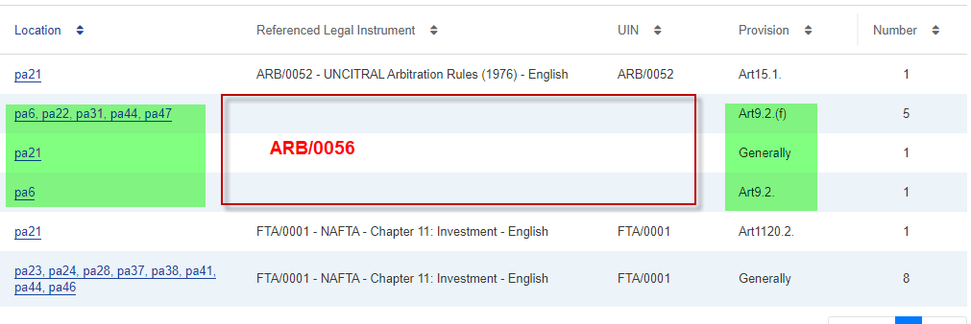
ARB/0059
Master Lists, Dispute Documents, IC/0086/03, Analysis List, Article Citator
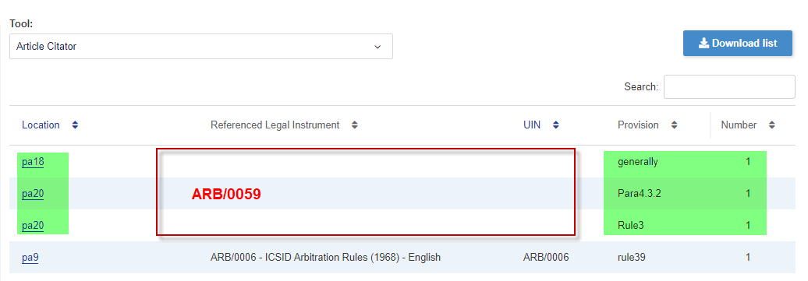
Master Lists, Dispute Documents, UN/0137/54, Analysis List, Article Citator
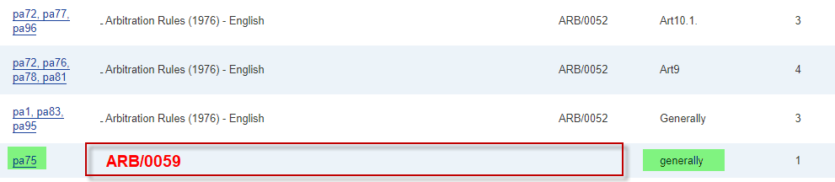

ARB/0060
Master Lists, Dispute Documents, IC/0039/10, Analysis List, Article Citator
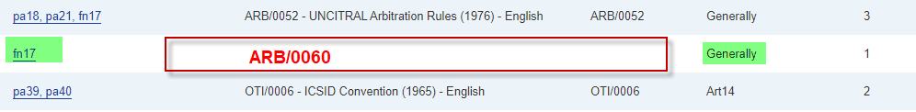
Master Lists, Dispute Documents, UN/0028/06, Analysis List, Article Citator
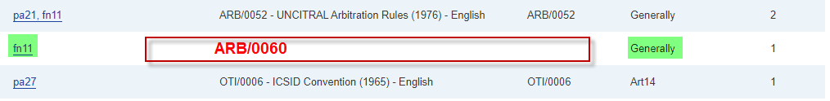

Master Lists, Dispute Documents, UN/0028/05, Analysis List, Article Citator


Master Lists, Dispute Documents, IC/0038/09, Analysis List, Article Citator
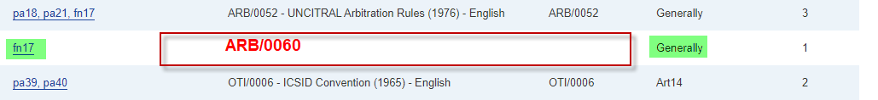
Master Lists, Dispute Documents, IC/0039/11, Analysis List, Article Citator
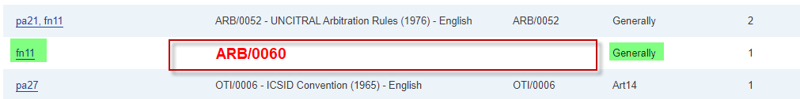

Master Lists, Dispute Documents, IC/0038/10, Analysis List, Article Citator
