BIT/0314 Argentina - Austria BIT (1992) [Spanish] issue with XML
Link to Dev site: http://dev.investorstatelawguide.com/Treaties/AnnotDocument?toc=annotSection&agreementID=548&tabcontent=&cat=bit
Dev.islg Live site [issue]
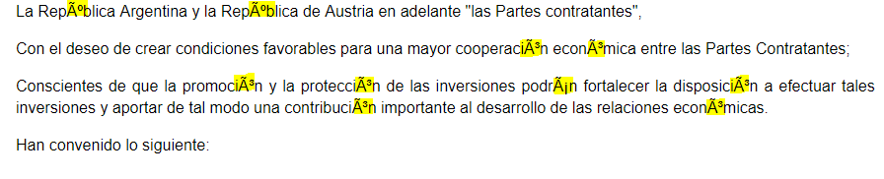

BIT/0021 Chile - Malaysia BIT (1992) [Spanish]
Islg Live Site [no issue]
Link to Islg Live Site
https://www.investorstatelawguide.com/Treaties/AnnotDocument?toc=annotSection&agreementID=548&tabcontent=&cat=bit
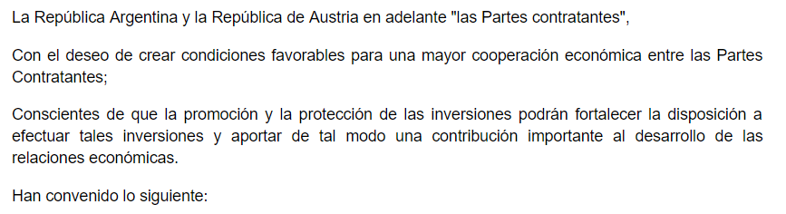

http://dev.investorstatelawguide.com/Treaties/AnnotDocument?toc=annotSection&agreementID=226&tabcontent=&cat=bit

BIT/0811 Belgium - Luxembourg - Poland BIT (1987) [French] issue with XML
Dev.islg Live site [issue]
Link to Dev Live Site: http://dev.investorstatelawguide.com/Treaties/AnnotDocument?toc=annotSection&agreementID=1475&tabcontent=&cat=bit
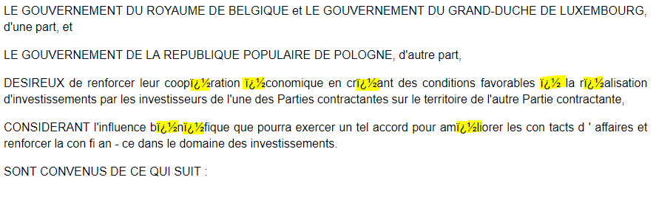

Dev site:

Islg Live site [no issue]
Link to Islg Live Site: https://www.investorstatelawguide.com/Treaties/AnnotDocument?toc=annotSection&agreementID=1475&tabcontent=&cat=bit

