This document provides a description of how the bookmark icons for the Notepad Feature need to be changed and updated. Currently, there are two different bookmark icons being used on the system:
https://www.investorstatelawguide.com/ResearchTools/SubjectNavigator?toc=content&id=50&kwList=25889,&exList=&search=&ci=25889&searchBranchLevel=#25889 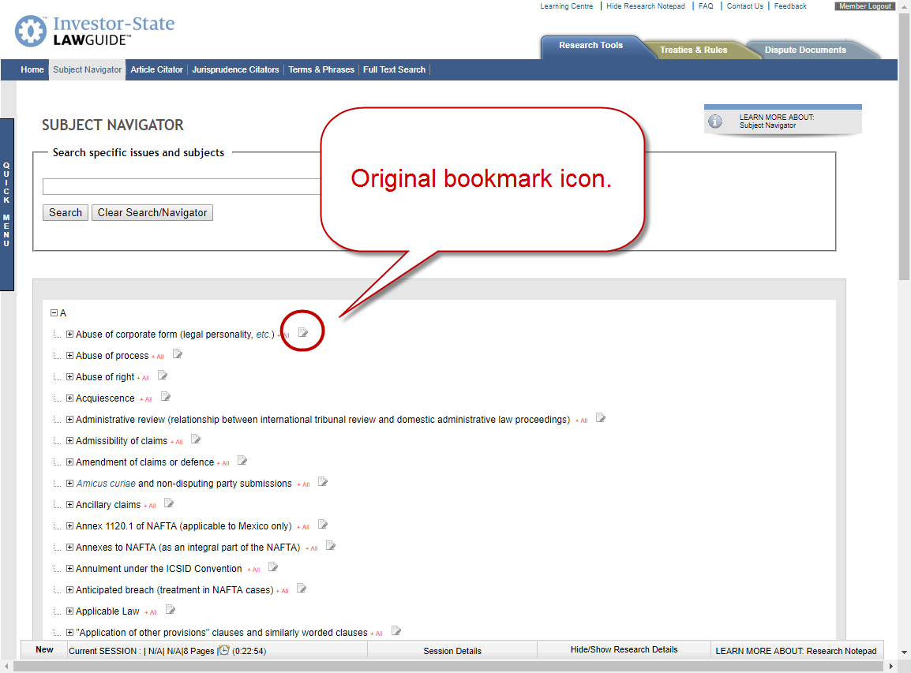
https://www.investorstatelawguide.com/disputedirectory/disputedocument?toc=disputedirectory&id=10 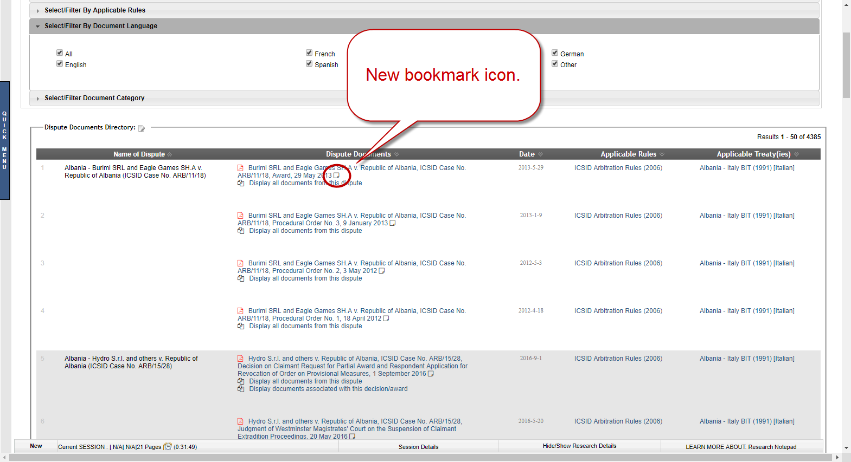
The old bookmark icon has created problems with the loading times of certain pages, and the new bookmark icon looks too similar to the “Display all documents…” icon under the Dispute Document tab. The proposed new icon uses an image more commonly seen in other product, and will look different before and after the bookmark is selected and added to the current Research Details list.
- Before the bookmark is added to the current Research Details:

- After the bookmark is added to the current Research Details:

This will function as follows:
