This document provides a description of the changes for the bookmark location descriptions created through the Full Text Search. Below will provide an overview of how the location descriptions should be formatted overall, and a separate document will address issues with specific search filters. An example is used to show the present state of location descriptions, and then modifications are made in track changes to indicate what changes need to be made to the formatting the location descriptions.
All the descriptions below are based on the example of searching for the term: nationality. Changes to the system should incorporate other search scenarios using different search filters.
http://dev.investorstatelawguide.com/ResearchTools/FullTextSearch?&newchkvalue=&toc=content&id=97&cuncheck=1&c1_param=&c2_param=&c3_param=&c4_param=&c5_param=&c6_param=&c7_param=&c8_param=&c9_param=&c10=1&c10_param=&c11_param=&c12_param=&c13_param=&c14=1&c14_param=&c15_param=&c16_param=&c17_param=&c18=1&c18_param=&c19_param=&c20_param=&c21_param=&c22_param=&c23=1&c23_param=&c24_param=&c25_param=&c26_param=&c27_param=&c28_param=&c29_param=&c30=1&c30_param=&c31_param=&c32_param=&c33_param=&c34_param=&checkboxesCheckedValuePass=cat%3D3%5Etype%3D4%5E%5Ecat%3D3%5Etype%3D7%5E%5Ecat%3D3%5Etype%3D6%5E%5Ecat%3D1%5E%5ERulesArbitHidden%3DICSID+%28ICS%29%5E%5Ecat%3D2%5E%5EInvestTreatyHidden%3DFree+Trade+Agreement&q=nationality&testfeild=test&c1t=test&agreementID=809&provisionSourceID=&languageId=test&addselection=%2C809&countryid=&country_id=513254&treaty_id=66%2C67&rules_id=1560%2C819%2C855%2C828&fuzziness_id=2&c1tid=+&language_id=E&disputid=&provision_idsource=51763%2C51764%2C51765%2C51766%2C51767&TreatiesandOtherInstrumentsid=&RulesofArbitrationid=&DispId=c10%2Cc14%2Cc18%2Cc23%2Cc30&drpdwnId=%2CICSID+Convention+%281965%29&listId=Article+25%282%29%28b%29&country_name=Argentina&treaty_name=Argentina+-+United+Kingdom+BIT+%281991%29%2CArgentina+-+United+States+BIT+%281991%29+and+Protocol&rules_name=ICSID+Arbitration+Rules+%281968%29%2CICSID+Arbitration+Rules+%281984%29%2CICSID+Arbitration+Rules+%282003%29%2CICSID+Arbitration+Rules+%282006%29&c1t_name=&traty_instrument_id=809-51763%2C809-51764%2C809-51765%2C809-51766%2C809-51767&searchType=boolean&stem=1&sortMethod=circ_newest&thes=1&ftypo=1&fuzziness=2&language=E&All_circDate1=01%2F01%2F2000&All_circDate2=9%2F8%2F2016&RulesArbitHidden=&All_filter_country_id=&All_agreement_id=&All_Arbitrator=&All_ArbitratorRules=&Dispute_circDate1=&Dispute_circDate2=&WTOJurAny_circDate1=&WTOJurAny_circDate2=&WTOJurAny_filter_country_id=&WTOJurAny_agreement_id=&WTOJurAny_NSCheckboxes=&InvestmentTreaty_CountryId=&InvestmentTreaty_TreatyId=&RD=Y
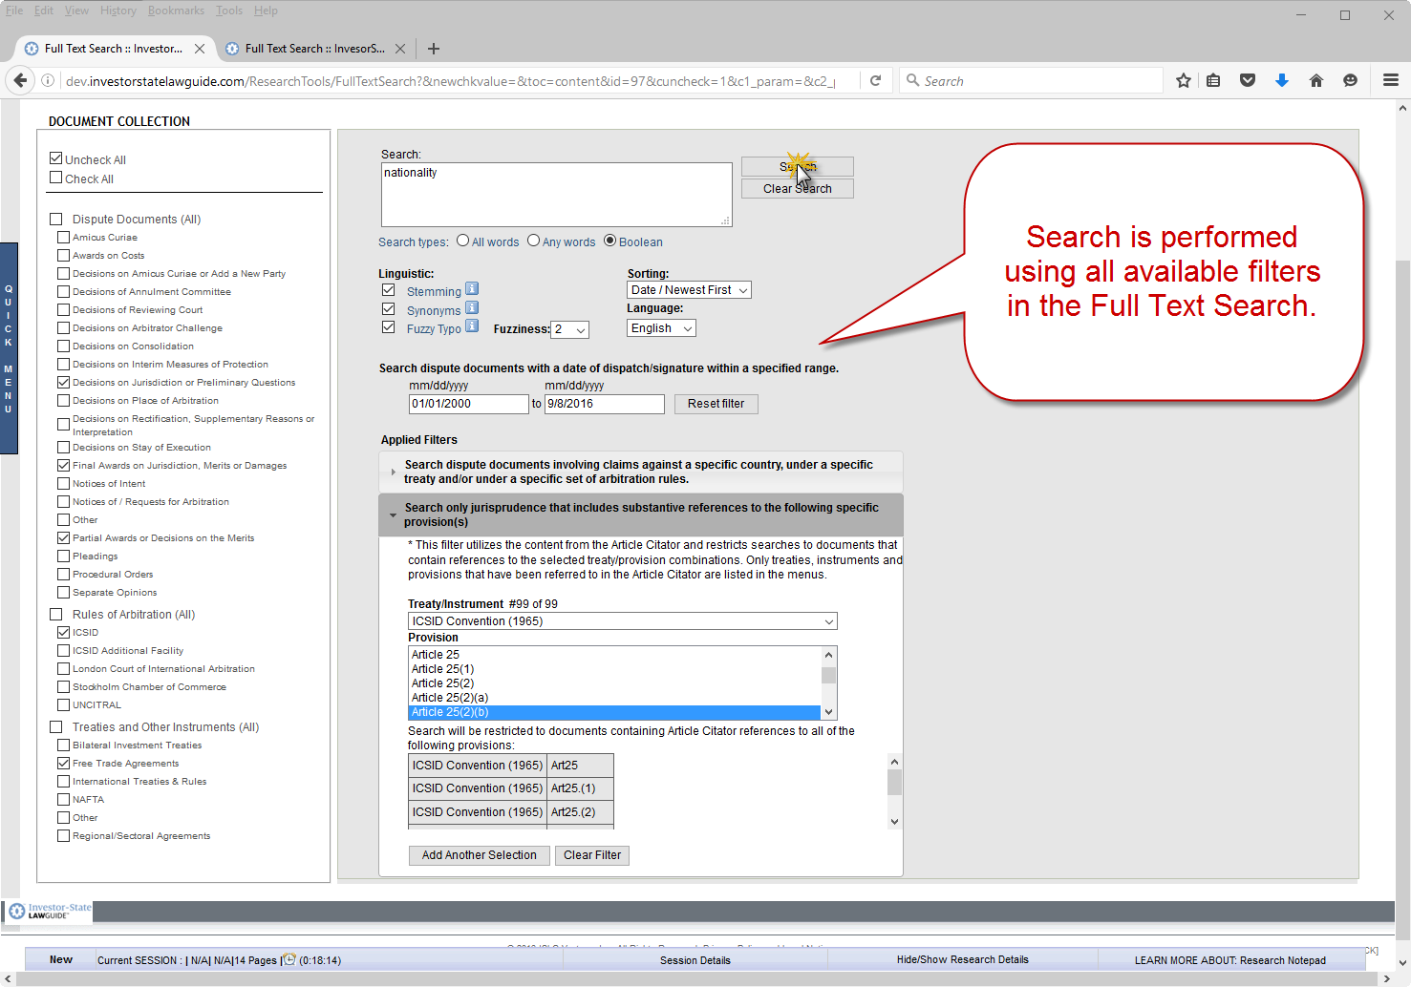
http://dev.investorstatelawguide.com/ResearchTools/DTSearchFTS?action=search&newchkvalue=&toc=content&id=97&cuncheck=1&c1_param=&c2_param=&c3_param=&c4_param=&c5_param=&c6_param=&c7_param=&c8_param=&c9_param=&c10=1&c10_param=&c11_param=&c12_param=&c13_param=&c14=1&c14_param=&c15_param=&c16_param=&c17_param=&c18=1&c18_param=&c19_param=&c20_param=&c21_param=&c22_param=&c23=1&c23_param=&c24_param=&c25_param=&c26_param=&c27_param=&c28_param=&c29_param=&c30=1&c30_param=&c31_param=&c32_param=&c33_param=&c34_param=&checkboxesCheckedValuePass=cat%3D3%5Etype%3D4%5E%5Ecat%3D3%5Etype%3D7%5E%5Ecat%3D3%5Etype%3D6%5E%5Ecat%3D1%5E%5ERulesArbitHidden%3DICSID+%28ICS%29%5E%5Ecat%3D2%5E%5EInvestTreatyHidden%3DFree+Trade+Agreement&q=nationality&testfeild=test&c1t=test&agreementID=809&provisionSourceID=&languageId=test&addselection=%2C809&countryid=&country_id=513254&treaty_id=66%2C67&rules_id=1560%2C819%2C855%2C828&fuzziness_id=2&c1tid=+&language_id=E&disputid=&provision_idsource=51763%2C51764%2C51765%2C51766%2C51767&TreatiesandOtherInstrumentsid=&RulesofArbitrationid=&DispId=c10%2Cc14%2Cc18%2Cc23%2Cc30&drpdwnId=%2CICSID+Convention+%281965%29&listId=Article+25%282%29%28b%29&country_name=Argentina&treaty_name=Argentina+-+United+Kingdom+BIT+%281991%29%2CArgentina+-+United+States+BIT+%281991%29+and+Protocol&rules_name=ICSID+Arbitration+Rules+%281968%29%2CICSID+Arbitration+Rules+%281984%29%2CICSID+Arbitration+Rules+%282003%29%2CICSID+Arbitration+Rules+%282006%29&c1t_name=&traty_instrument_id=809-51763%2C809-51764%2C809-51765%2C809-51766%2C809-51767&searchType=boolean&stem=1&sortMethod=circ_newest&thes=1&ftypo=1&fuzziness=2&language=E&All_circDate1=01%2F01%2F2000&All_circDate2=9%2F8%2F2016&RulesArbitHidden=&All_filter_country_id=&All_agreement_id=&All_Arbitrator=&All_ArbitratorRules=&Dispute_circDate1=&Dispute_circDate2=&WTOJurAny_circDate1=&WTOJurAny_circDate2=&WTOJurAny_filter_country_id=&WTOJurAny_agreement_id=&WTOJurAny_NSCheckboxes=&InvestmentTreaty_CountryId=&InvestmentTreaty_TreatyId=#anchorsel
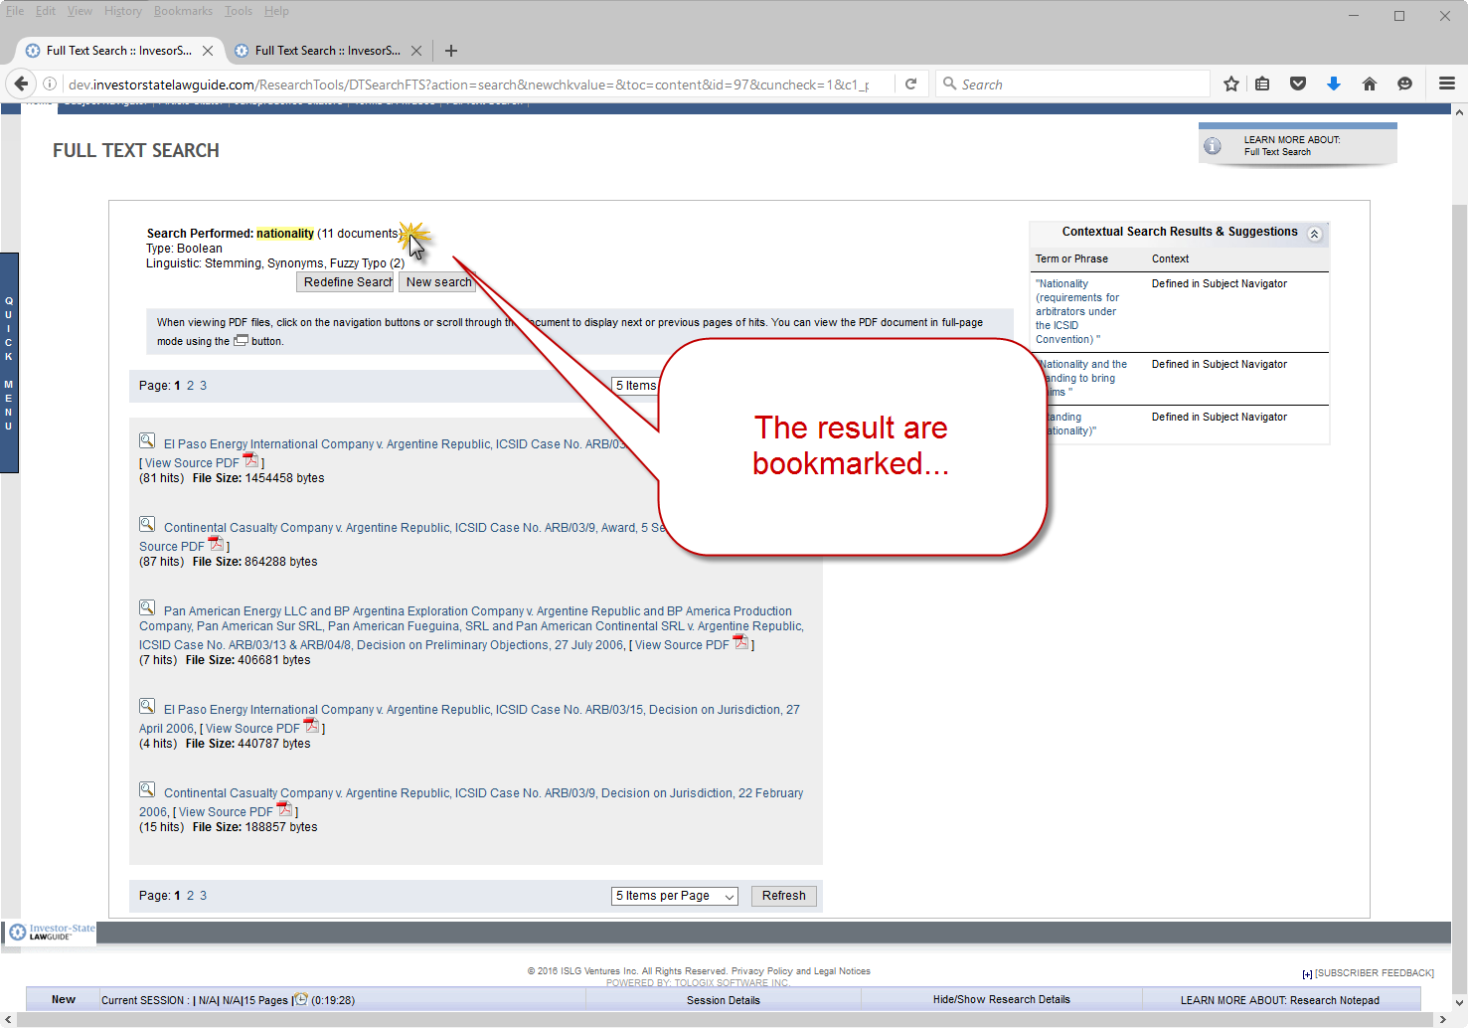
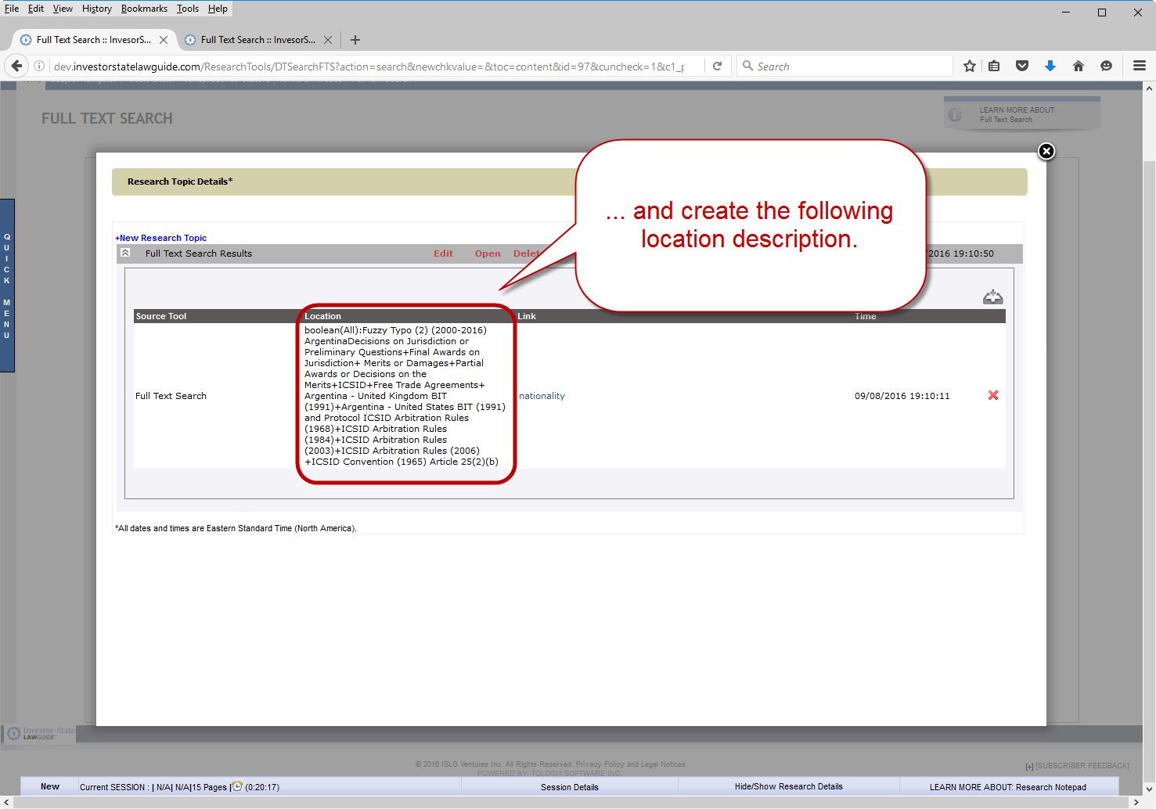
The location description for the bookmark is as follows:
boolean(All):Fuzzy Typo (2) (2000-2016) ArgentinaDecisions on Jurisdiction or Preliminary Questions+Final Awards on Jurisdiction+ Merits or Damages+Partial Awards or Decisions on the Merits+ICSID+Free Trade Agreements+ Argentina - United Kingdom BIT (1991)+Argentina - United States BIT (1991) and Protocol ICSID Arbitration Rules (1968)+ICSID Arbitration Rules (1984)+ICSID Arbitration Rules (2003)+ICSID Arbitration Rules (2006) +ICSID Convention (1965) Article 25(2)(b)
The following changes need to be made to the above location description:
- Search Types:
http://dev.investorstatelawguide.com/ResearchTools/FullTextSearch?toc=content&id=97&tab=r 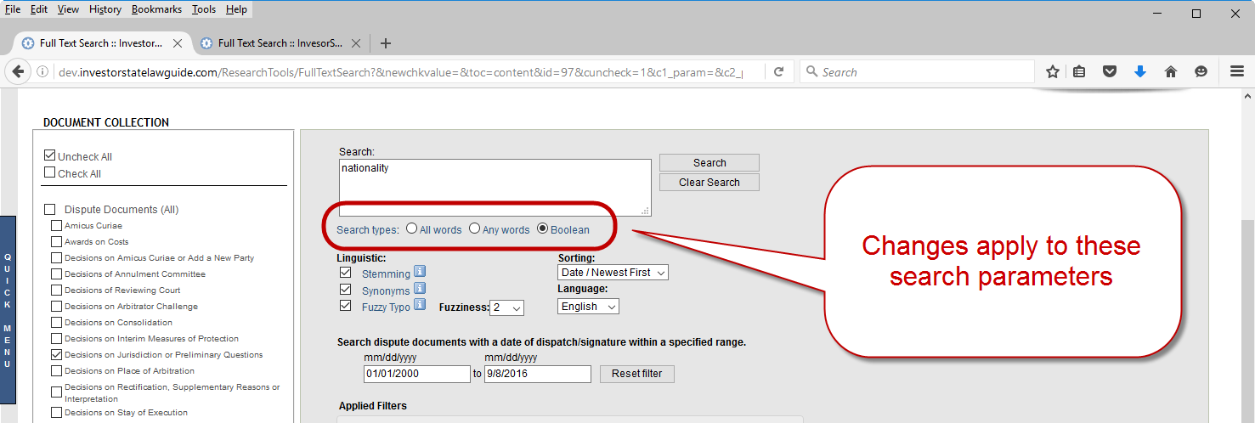
The example above should change to:
Boolean: Fuzzy Typo (2) (2000-2016) ArgentinaDecisions on Jurisdiction or Preliminary Questions+Final Awards on Jurisdiction+ Merits or Damages+Partial Awards or Decisions on the Merits+ICSID+Free Trade Agreements+ Argentina - United Kingdom BIT (1991)+Argentina - United States BIT (1991) and Protocol ICSID Arbitration Rules (1968)+ICSID Arbitration Rules (1984)+ICSID Arbitration Rules (2003)+ICSID Arbitration Rules (2006) +ICSID Convention (1965) Article 25(2)(b)
If “All words” were selected:
All words: Fuzzy Typo (2) (2000-2016) ArgentinaDecisions on Jurisdiction or Preliminary Questions+Final Awards on Jurisdiction+ Merits or Damages+Partial Awards or Decisions on the Merits+ICSID+Free Trade Agreements+ Argentina - United Kingdom BIT (1991)+Argentina - United States BIT (1991) and Protocol ICSID Arbitration Rules (1968)+ICSID Arbitration Rules (1984)+ICSID Arbitration Rules (2003)+ICSID Arbitration Rules (2006) +ICSID Convention (1965) Article 25(2)(b)
If “Any words” were selected:
Any words: Fuzzy Typo (2) (2000-2016) ArgentinaDecisions on Jurisdiction or Preliminary Questions+Final Awards on Jurisdiction+ Merits or Damages+Partial Awards or Decisions on the Merits+ICSID+Free Trade Agreements+ Argentina - United Kingdom BIT (1991)+Argentina - United States BIT (1991) and Protocol ICSID Arbitration Rules (1968)+ICSID Arbitration Rules (1984)+ICSID Arbitration Rules (2003)+ICSID Arbitration Rules (2006) +ICSID Convention (1965) Article 25(2)(b)
- Vertical bar (|) between each search filter: a vertical bar needs to be inserted between each search filter (with spaces on either side), except after search type, which will maintain the colon show above (with a space between the colon and the next filter description.
The example above should further change to:
Boolean: Fuzzy Typo (2) | (2000-2016) | Argentina | Decisions on Jurisdiction or Preliminary Questions+Final Awards on Jurisdiction+ Merits or Damages+Partial Awards or Decisions on the Merits+ICSID+Free Trade Agreements | Argentina - United Kingdom BIT (1991)+Argentina - United States BIT (1991) and Protocol | ICSID Arbitration Rules (1968)+ICSID Arbitration Rules (1984)+ICSID Arbitration Rules (2003)+ICSID Arbitration Rules (2006) | ICSID Convention (1965) Article 25(2)(b)
- Plus sign (+) between multiple selections: A plus sign (+) should only be used to connect multiple selections from the same filter (with a space on either side separating it from the filter term). Plus signs should be removed in all other contexts (i.e., replacing commas or semi-colons).
The example above should further change to:
Boolean: Fuzzy Typo (2) | (2000-2016) | Argentina | Decisions on Jurisdiction or Preliminary Questions + Final Awards on Jurisdiction, Merits or Damages + Partial Awards or Decisions on the Merits + ICSID + Free Trade Agreements | Argentina - United Kingdom BIT (1991) + Argentina - United States BIT (1991) and Protocol | ICSID Arbitration Rules (1968) + ICSID Arbitration Rules (1984) + ICSID Arbitration Rules (2003) + ICSID Arbitration Rules (2006) | ICSID Convention (1965) Article 25(2)(b)
- Final product of example with all the changes outlined above:
Boolean: Fuzzy Typo (2) | (2000-2016) | Argentina | Decisions on Jurisdiction or Preliminary Questions + Final Awards on Jurisdiction, Merits or Damages + Partial Awards or Decisions on the Merits + ICSID + Free Trade Agreements | Argentina - United Kingdom BIT (1991) + Argentina - United States BIT (1991) and Protocol | ICSID Arbitration Rules (1968) + ICSID Arbitration Rules (1984) + ICSID Arbitration Rules (2003) + ICSID Arbitration Rules (2006) | ICSID Convention (1965) Article 25(2)(b)

