This document provides a description of a problem with viewing the text entered into the Branch Name field in Source mode within the Master Tree branch editing tool.
http://dev.investorstatelawguide.com/MasterTree/index?rootNodeID=&recentAnchor=25891&expandList=1,25889,25890,25891,25892,25893&temp=#25891 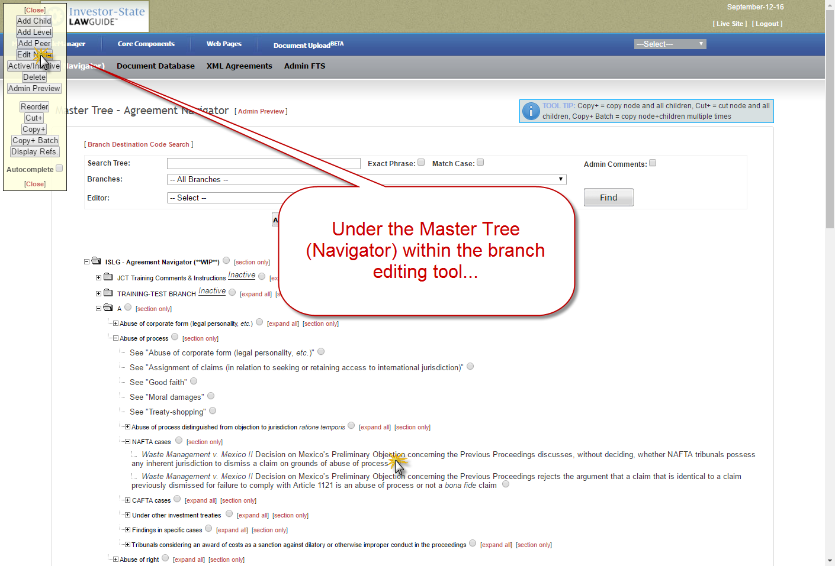
http://dev.investorstatelawguide.com/MasterTree/Addnode?toc=editNode&rootNodeID=&expandList=1,25889,25890,25891,25892,25893&nodeID=25892&parentID=25891&addLevel=&dataType=2&buttonEdit=Edit%2FRef.&nodeRadio=25892 