This document provides a description of a problem with the 50 character limit for user group names. This character limit either (1) needs to be eliminated (i.e., no character limit) or the limit increased to 100 characters and a prompt included to notify users when the character limit is exceeded and that the group name was not saved.
http://www.investorstatelawguide.com/subscribers/AddEditGroup 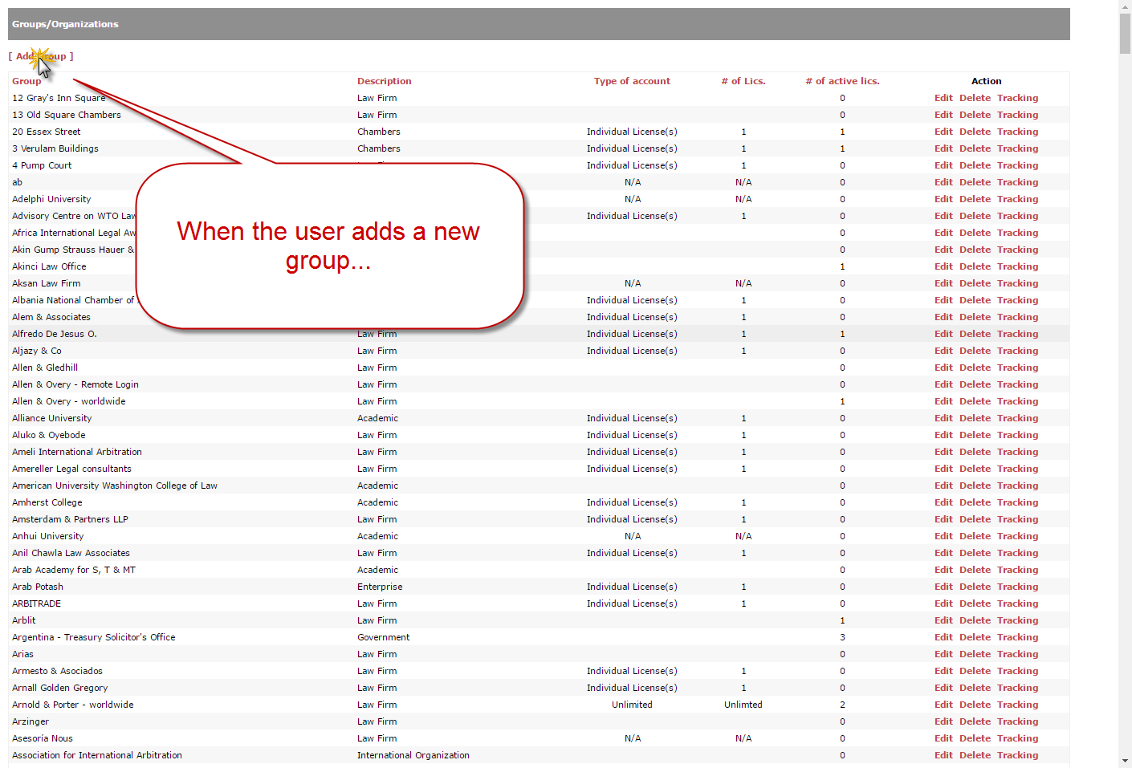
http://dev.investorstatelawguide.com/subscribers/AddEditGroup?add=1 