The document provides a description of a redundant data field in Step 2 of editing Dispute Documents, which needs to be eliminated (assuming it is not tied to displaying any information on the Members’ site).
http://dev.investorstatelawguide.com/CoreComponents/AddDocumentStep2Case3and4?docId=1055 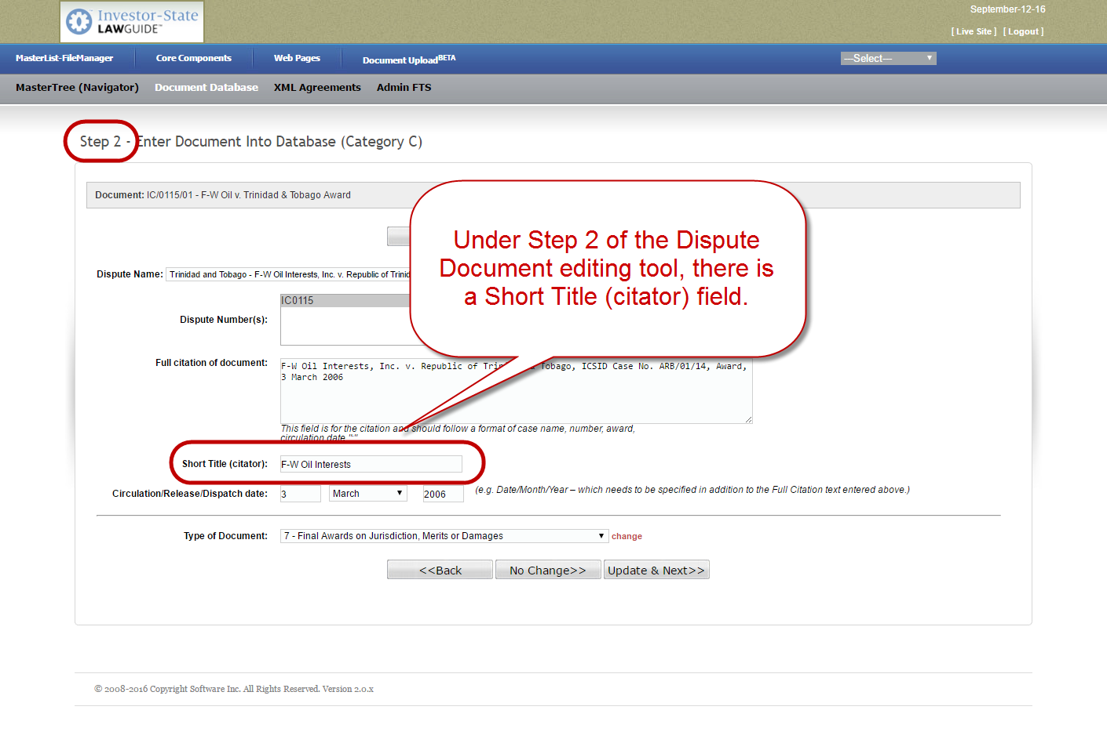
http://dev.investorstatelawguide.com/CoreComponents/AddDocumentStep3Type2?docId=1055 