The document provides information on the proposal to eliminate a data field from the Dispute Name editing tool.
IMPORTANT: Before eliminating the field (and the data associated with it), it must be determined whether the data saved under this field is being used to populate other applications.
http://dev.investorstatelawguide.com/CoreComponents/AddDisputeName?dispute_id=560109 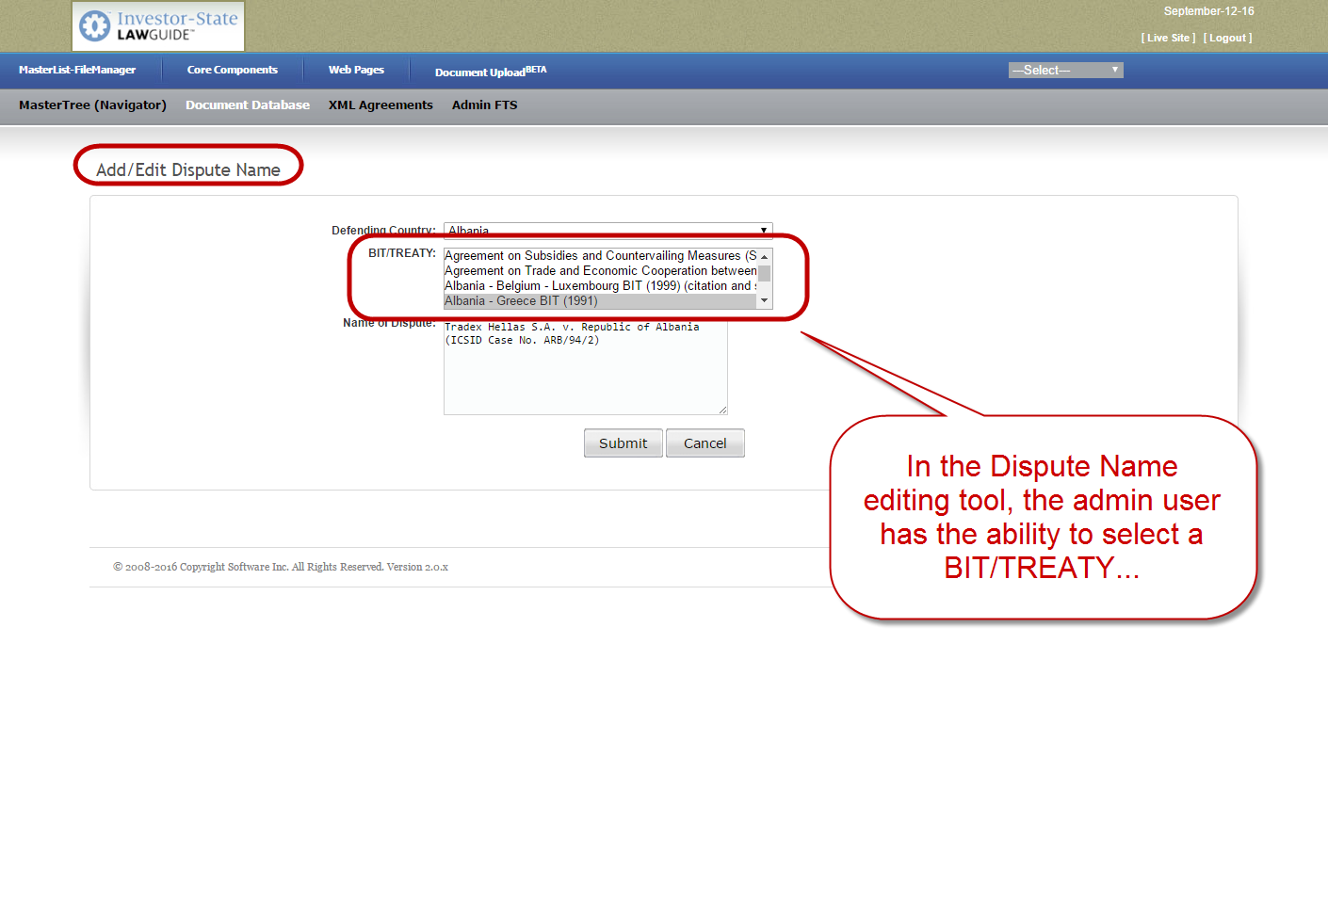
http://dev.investorstatelawguide.com/CoreComponents/AssociateDispute?dispute_number_id=103 